THE KIDNEY CENTRE (TKC)

  - Hospital Management System (HMS) Automation Project
Inventory Control Management System (ICMS)
User Manual

Table of Contents
1. OVERVIEW AND SCOPE 7
1.1. OBJECTIVE 7
1.2. AUDIENCE 7
1.3. VERSION HISTORY 7
2. INVENTORY CONTROL MANAGEMENT SYSTEM: 8
2.1. INTRODUCTION: 8
2.2. MAIN DATABASE AND TABLES: 8
2.3. FLOW DIAGRAMS OF ICS: 9
2.4. INVENTORY APPROVALS: 13
3. SETUP SCREENS: 14
3.1. DEPARTMENTS 14
3.1.1. ITEM SUGGESTION TO STORE 14
3.1.2. PROCEDURE CONSUMPTION PRE-SETUP: 16
3.2. FINANCE 18
3.2.1. HEAD OF ACCOUNTS 18
3.2.2. HEAD OF ACCOUNTS RELATION 19
3.3. PHARMACY 20
3.3.1. MASTER SETUPS 20
3.3.2. ENABLE ITEM FOR IDR SCREEN 23
3.3.3. ENABLE EXPENSIVE ITEM 24
3.3.4. VOUCHER REFUND PHARMACY 25
3.3.5. ITEM POLICY FOR PHARMACY SALES 26
3.4. STORE 28
3.4.1. ADD ITEMS FROM SUGGESTION 28
3.4.2. BATCHES ADJUSTMENT SCREEN 29
3.4.3. ITEM SEARCHING SCREEN 30
3.4.4. ITEM ENABLE DISABLE SCREEN 31
3.4.5. ITEM SPECIFICATION 32
3.4.6. ITEM TRANSFER UTILITY 33
3.4.7. MASTERS SETUPS: 34
3.5. PROCUREMENT 43
3.5.1. ITEM PURCHASE DETAILS 43
3.5.2. TERMS AND CONDITION SETUP: 44
3.5.3. SUPPLIER SETUP: 45
3.6. MAINTENANCE 47
3.6.1. LOCATION FOR BUILDING CONSUMPTIONS 47
3.6.2. START PROJECT SETUP 48
3.7. BILLING 49
3.7.1. IDR ITEM RATE POLICY 49
3.7.2. COMPANY CHARGES SETUP 51
3.8. BILLING WELFARE 53
3.8.1. ALL PHARMACY FREE MONTHLY APPROVAL 53
3.9. MIS 55
3.9.1. ASSIGNMENTS: 55
3.9.2. NON CONSUMABLE ITEMS 62
3.9.3. MASTER ICS 63
3.10. C.S.S.D. 69
3.10.1. LOAD TYPE SETUP 69
3.10.2. CYCLE TYPE SETUP 70
4. TRANSACTION SCREENS: 71
4.1. DEMAND TRANSACTIONS 71
4.1.1. DEPARTMENTAL DEMAND CREATION 71
4.1.2. DEMAND HOD APPROVAL 73
4.1.3. DEMAND ADMIN APPROVAL 74
4.1.4. DEMAND PROGRESS SCREEN 76
4.1.5. REQUESTED ITEMS 81
4.1.6. ISSUANCE SCREEN 82
4.1.7. GOODS RECEIVING FROM STORE 84
4.1.8. DEPARTMENTAL STOCK SCREEN 85
4.1.9. GOODS REFUND TO STORE 87
4.1.10. REFUND RECEIVING 89
4.2. PURCHASE 90
4.2.1. REQUISITION CREATION 90
4.2.2. REQUISITION CHECKING 94
4.2.3. REQUISITION APPROVAL 96
4.2.4. PO GENERATION 98
4.2.5. PO CREATION 100
4.2.6. PURCHASE ORDER(PO) STATUS 101
4.2.7. CREATE VENDOR/ITEMWISE QUOTATION 102
4.2.8. QUOTATION APPROVAL SCREEN 106
4.2.9. COMPARATIVE CREATION SCREEN 107
4.2.10. COMPARATIVE APPROVAL SCREEN 108
4.3. STORE TRANSACTION 111
4.3.1. GRN CREATION (VENDORS) 111
4.3.2. GRN FORWARD/UPDATE 112
4.3.3. VARIANCE APPROVAL 113
4.3.4. GOODS RETURN NOTE (VENDOR-LOCAL) 114
4.3.5. GRN FINANCE 116
4.3.6. STOCK RE-ORDER SCREEN 118
4.4. CONSUMPTIONS 120
4.4.1. DEPARTMENTAL CONSUMPTION 120
4.4.2. APPROVAL SCREEN FOR DEPARTMENTAL CONSUMPTION 122
4.4.3. PATIENT CONSUMPTION (DEPARTMENTAL) 123
4.4.4. PATIENT CONSUMPTION (OT): 126
4.4.5. APPROVAL SCREEN FOR PATIENT CONSUMPTION 130
4.5. IN-PATIENTS (IDRs) 131
4.5.1. IDR CREATION (PHARMACY) 131
4.5.2. APPROVAL SCREEN FOR IDR 133
4.5.3. CHANGE APPROVAL PASSWORD 134
4.5.4. REFUND OF IDR 135
4.6. DOCTOR PRESCRIPTION 136
4.6.1. DOCTOR PRESCRIPTION 136
4.6.2. DOCTOR PRESCRIPTION APPROVAL 138
4.7. PHARMACY 140
4.7.1. PHARMACY SALES 140
4.7.2. LP CREATION 146
4.7.3. LP APPROVAL SCREEN 148
4.7.4. LP RECEIVING 149
4.7.5. REFUND RECEIVING (PHARMACY) 151
4.8. OTHER TRANSACTION SCREENS 152
4.8.1. MAINTENANCE REQUEST 152
4.8.2. MAINTENANCE ISSUANCE 154
4.8.3. MAINTENANCE STOCK RECEIVING 155
4.8.4. UNIFORM ISSUANCE SCREEN 156
4.8.5. TKC-FORMULARY LIST 158
4.8.6. MATERIAL IN/OUT SCREEN 159
4.8.7. MATERIAL(IN & OUT) APPROVAL 161
4.8.8. DONATION RECEIVING 162
4.8.9. DONATION APPROVAL 163
4.9. C.S.S.D. 164
4.9.1. PACK CREATION 164
4.9.2. LOAD SETUP 165
4.9.3. PERSONAL REQUEST 167
4.9.4. PERSONAL ISSUANCE 169
4.9.5. PATIENT/DEPARTMENTAL REQUEST 170
4.9.6. PATIENT/DEPARTMENTAL ISSUANCE 172
4.9.7. REQUEST RECEIVING LOOKUP 173
4.9.8. CSSD RECEIVING 174
4.9.9. BROKEN/MISSING ITEMS 175
5. REPORTS 176
5.1. ITEM REPORTS(STORES) 176
5.1.1. STORE STOCK/ITEM DETAIL REPORT 176
5.2. MAINTENANCE REPORTS 178
5.2.1. MAINTENANCE CONSUMPTION REPORT 178
5.2.2. MAINTENANCE ISSUE REPORT 180
5.3. DEPARTMENTAL 182
5.3.1. DEMAND 182
5.3.2. CONSUMPTION 190
5.3.3. STOCK REPORTS 192
5.4. MIS SPECIAL 196
5.4.1. DEPARTMENTAL LEDGER 196
5.4.2. STORE LEDGER 198
5.5. STORES 200
5.5.1. ISSUE REPORT 200
5.5.2. GOOD RECEIVING REPORT 202
5.5.3. UNIFORM ISSUANCE SLIP 204
5.5.4. GOODS REFUND NOTE 206

OVERVIEW AND SCOPE

OBJECTIVE
This document covers the technical role of the Inventory Control Management System (ICMS) currently running in TKC as part of the overall automation project being developed on .Net and SQL Server 2005 for The Kidney Centre.
The role of the ICMS is defined by this document. Any business functions that are not detailed within this document are beyond the scope of our Inventory Control System.

AUDIENCE
Following departments and stores in Kidney Centre are using the system:
- General Store, Medical Store, Maintenance Store, Food Store, and all other stores.
- All departments.

VERSION HISTORY
Version Number | Date | Remarks
1.0 | 28th.11.2008
1.1 | 6th.2.2009
1.2 | 27th .2.2009
1.3 | 3rd .3.2009 | Screens and logical changes
1.4 | 24th .3.2009 | Database screen changes
1.5 | 14th .4.2009
1.6 | 18th .1.2010 | Updated due to integration changes
2.0 | 24.05.2013 | Updated due to screen changes

INVENTORY CONTROL MANAGEMENT SYSTEM:

INTRODUCTION:

The Inventory Control Management System (ICMS) is created to automate procurement and Inventory Management at various stores. The current system running in TKC is having following features.

- It consist of Inventory Control System(ICS), Departmental Inventory System(DIS) and Central Sterile Supply Department (CSSD)
- It provides accurate tracking of inventory (i.e. current state of inventory).
- It have many advanced features than previous system.
- All the stores and departments are satisfied with the efficiency of the this system.
- This system is integrated with GL.
- It provides complete coverage of inventory cycle (i.e. from demand to issuance).

MAIN DATABASE AND TABLES:
The following table is the Database and tables used in development of Security Module.
Name | Description
ICS | Database
tblDemandMaster | Master table of Demand
tblItemMaster | Master Table of Items
tblItemDetail | Details of all items
tblRequisitionMaster | Requisition Master Table
tblPOMaster | Master table of PO(Purchase Order)
tblissueMaster | Master table of issue
tblIssueDetail | Details of goods issuance
tblGRNMaster | Master table of GRN(Good Receiving Note)
tblRefundMaster | Master table of refund

FLOW DIAGRAMS OF ICS:

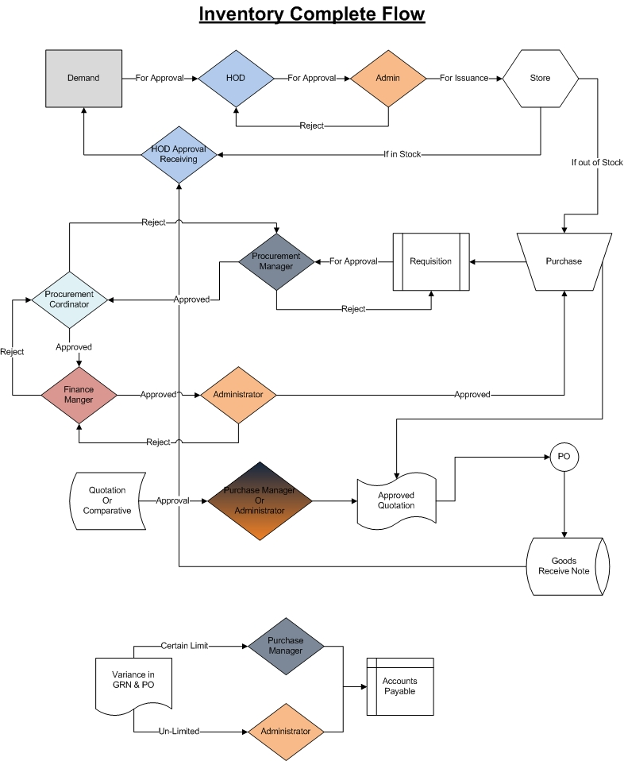

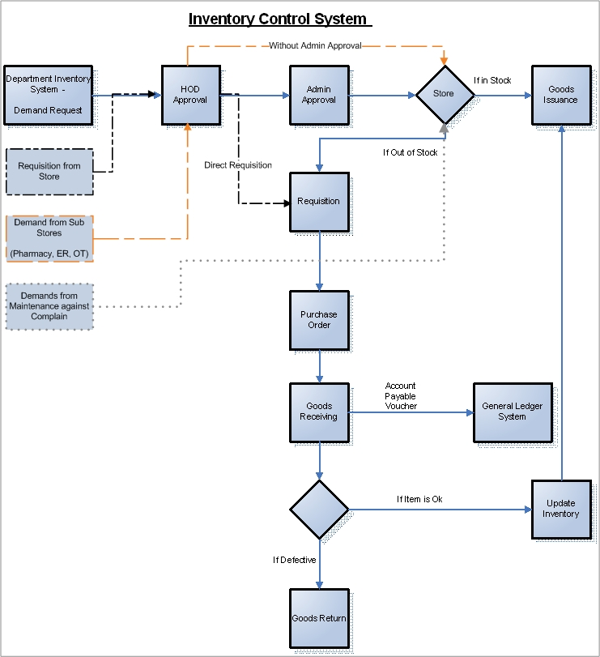

Description of Workflow of demand:

- Demand: In Inventory Control System (ICS) first of all the demand is created. The demand can be create by the following ways;
- Departmental demand: These demands are generated by all the departments, to the stores, once the demand is created by the department it will then forward for HOD approval.
- Direct Requisition: These demands are created by stores, for out of stock items. Only HOD approval is required in Direct Requisition.
- Demand from Sub-Stores: These demands are made by sub stores e.g. pharmacy is a sub-store of the medical-stores. Only HOD approval is required in these demands. It will bypass admin approval.
- HOD approval: All the departmental head will approve the demands made by their respective department. The head of one department can only view the demands made by his department’s employee. HODs will approve demand of their respective departments.
- Admin approval: Only those demands which are made by departments are needed to get approved by Administrator after HOD approval.
- Store: Sub-Store demands and departmental demands will go to store, now store will check those demands and after checking the status of the store, it will issue those items which are present in the stock, otherwise requisition will be made for out-of-stock items.
- Requisition: Requisition will be made for the items demanded in Direct-requisition and also for those items which are out-of-stock against any demand. Once the requisition created, it will then need to get approved by Procurement Manager, Finance Manager and Administrator.
- Purchase Order: Once the requisition is approved by all the approval authorities, then its Purchase Order (PO) will be generated by procurement. Its contains the information related to the supplier, and items to be purchased.
- Good Receiving: Stores will create Good Receiving on behave of PO. Whenever store receives any item, it will note the invoice and challan number of that good.
- General Ledger System: When store receives the inventory, the supplier will get paid by GL.
- Good Return: Store will create Goods Refund note to the supplier.

Workflow Departmental Stock Consumption
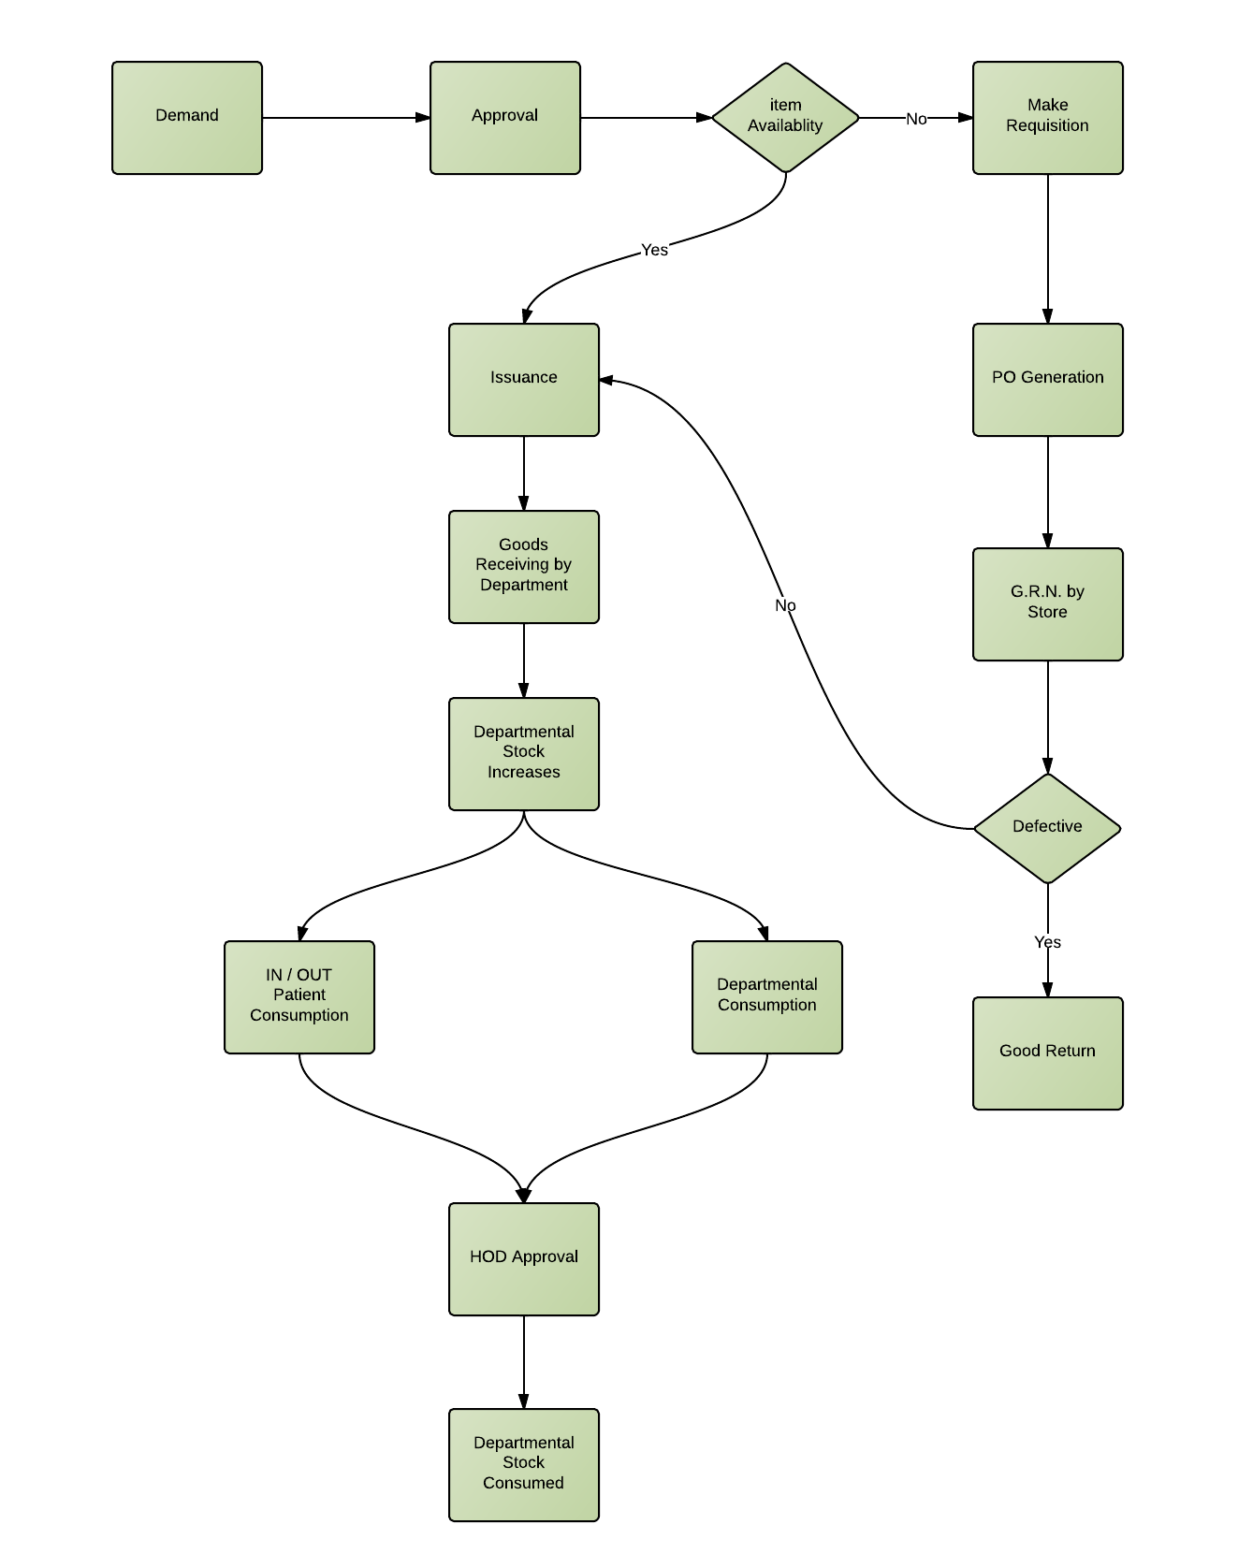

INVENTORY APPROVALS:

The following types of approvals are required in inventory control system.

S. no. | Types of Approval | Concerned Heads/Approved by
1. | Demand | Departmental head  Administrator
2. | Requisition | Procurement Manager  Finance Manager  Administrator
3. | Comparative Statements | Procurement Manager  Administrator
4. | Quotation | Procurement Manager  Administrator
5. | Variance in price of Purchase Order (e.g. variance up to 5% or Rs. 5000) | Procurement Manager  Administrator
6. | Item Discard (Write Off) | Administrator
7. | Non-formulary items (Clinical System) | Doctors approval only
8. | IN/OUT patient consumption | Departmental Head
9. | Patient Consumption | Departmental Head

SETUP SCREENS:

DEPARTMENTS

ITEM SUGGESTION TO STORE
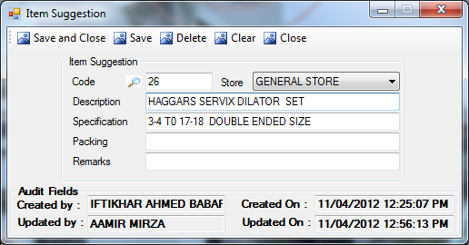
Description:
This screen is used to suggest an item to store. If any employee want some new item which is not yet present in the inventory, then he will suggest that item through this screen.
Functional Information
- User will enter the description of the new item, the code will be auto-generated upon saving.
- User will select the store from Drop-Down menu. Currently we have three stores. i.e.
- GENERAL STORE: Contains the inventory of general items (e.g. Stationary, computer items etc).
- MAINTENANCE STORE: Contains the inventory of maintenance items (e.g. fan, tube light, AC etc).
- MEDICAL STORE: Contains the inventory of Medical items (e.g. medicines, medical equipments etc).
- User will enter the specification of items.
- User will enter the packing of that item.
- User will enter the remarks for suggesting that item.
- To update the item user will enter the code of an item or press F11 for lookup screen ( as shown in Diagram 1). After entering the code of an item, its item details will be displayed in the text fields, user will edit the details and press the Save button to update the record.
- To delete the record user will enter the code of the item in code field, system will pick the details of the item automatically, by pressing Delete button the record will be marked as deleted.
Look up screen for Item Suggestion:
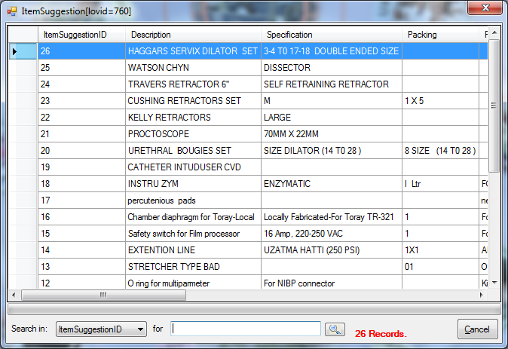
- Select the column name in which your item will be searched.
- Enter the value of that item (e.g. enter numeric value for ItemSuggestionID)

PROCEDURE CONSUMPTION PRE-SETUP:

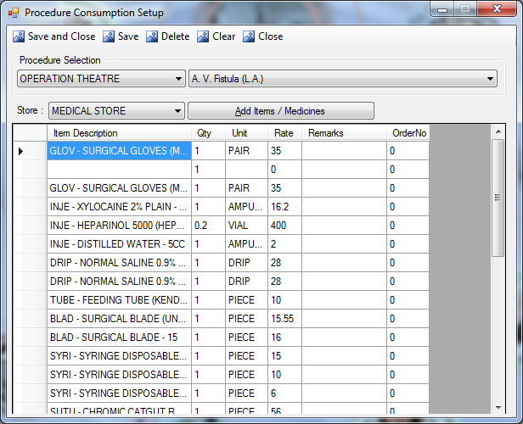
Description:
This screen is used to set the items for the selected procedure. When the procedure called in the patient consumption screen then the added items which have been saved in this screen against the service will be picked by the system automatically.
Functional Information
- User will select the department from combo in procedure selection
- User will select the services from combo.
- User will select the store from combo, selected store will populate the item in the support screen.
- When user press Add Item/Medicine button, this will open the support screen as shown in ref:1.
- Selected items will be populated in the grid, user will press save button this will save the items in selected service.
- To update/delete an item user will select the department from combo and select the service, this will populate the added items in the grid, user can add more items or delete the existing to update the record.
Add Item/Medicine
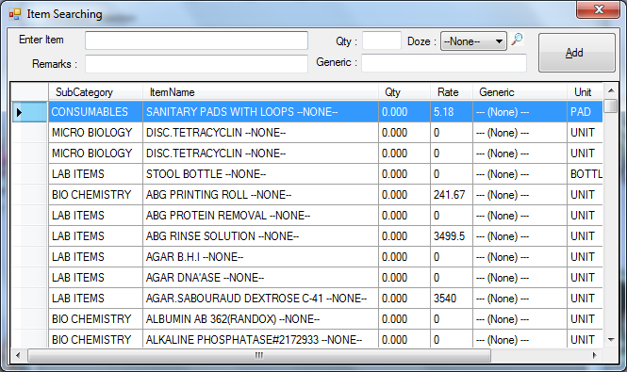
- Enter the name of the item OR just double-click the item in the list item name field will be auto filled.
- Enter the generic for medicines.
- Enter the remarks if any.
- Enter the quantity or doze(for medicine), then press the Add button.

FINANCE

HEAD OF ACCOUNTS
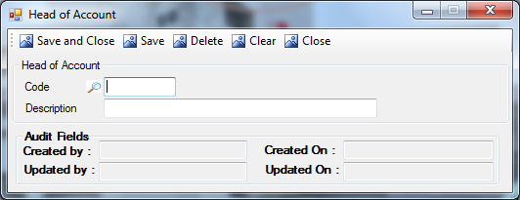
Description:
This screen is used to set/edit the head of accounts.
Functional Information
- User will enter the description of the new item, the code will be auto-generated upon saving.
- To update the record user will select the code from lookup as shown in ref:2, then user edit the description and press the save button to update the record.
- To delete the record user will select the code from lookup as shown in ref:2. Then user press delete button, this will mark the record as delete.
Lookup of Head Of Accounts:
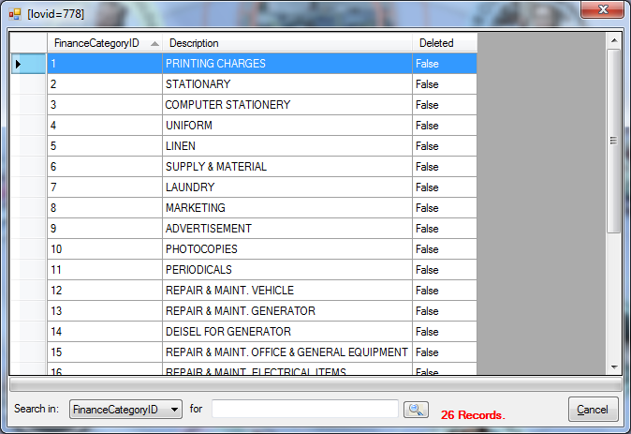
- Select the Search in column name form drop-down menu.
- Enter the value of selected column to search (e.g. enter numeric value for Finance CategoryID)

HEAD OF ACCOUNTS RELATION
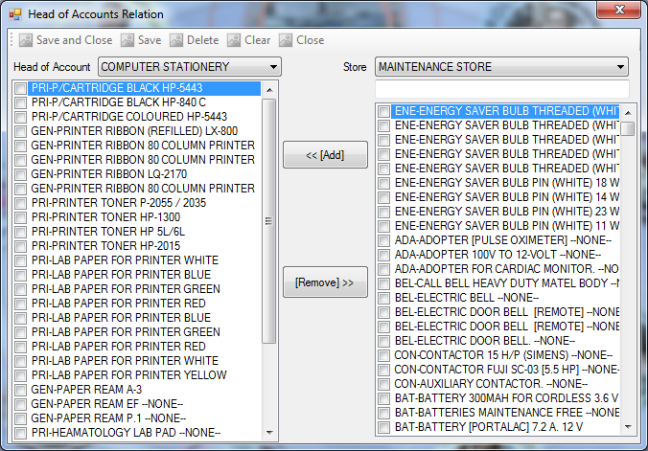
Description:
This screen is used to set/edit the items under head of accounts. USAGE?
Functional Information
- User will select the Head of Accounts from combo, which have been set in the Head of Account Setup(ref 3.2.1).
- LHS List is displaying the list of the added item under the selected Head of Account.
- RHS List is displaying the list of all items under the selected store.
- To add the item from RHS list to LHS list user will select the item from the list and press <<[ADD] button
- To remove the item from LHS list user will select the item and press [Remove]>> button.

PHARMACY

MASTER SETUPS

DOZE SETUP:
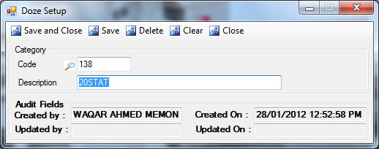
Description:
This screen is used to set the new doze or edit the existing doze.
Functional Information
- User will enter the description of the doze, the code will auto-generated upon saving the record.
- To update the record user will enter the code or press F11 for lookup screen(as shown in following diagram), then user will edit the details and press the Save button to update the record.
- User will enter the code and press Delete button to marks the record as delete.
- Kindly remove all F11 and describe only one F11 in detail. and put the reference where needed in the screens.
Lookup of Doze:

- Select the Search in column name form drop-down menu.
- Enter the value of doze to search (e.g. enter numeric value for DozeID)

GENERIC SETUP:
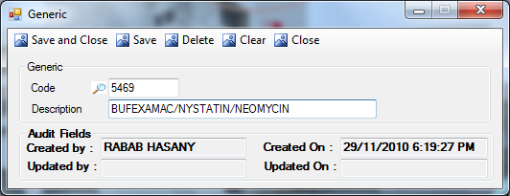
Description:
This screen is used to set/edit the generic of the medicine.
Functional Information
- User will enter the description, the code will auto-generated upon saving the record.
- To update the record user will enter the code or press F11 for lookup screen(as shown in following diagram), then user will edit the details and press the Save button to update the record.
- User will enter the code and press Delete button to marks the record as delete.
Lookup:

- Select the Search in column name form drop-down menu.
- Enter the value of selected column to search (e.g. enter numeric value for Generic ID)

FORMULARY ITEM SETUP
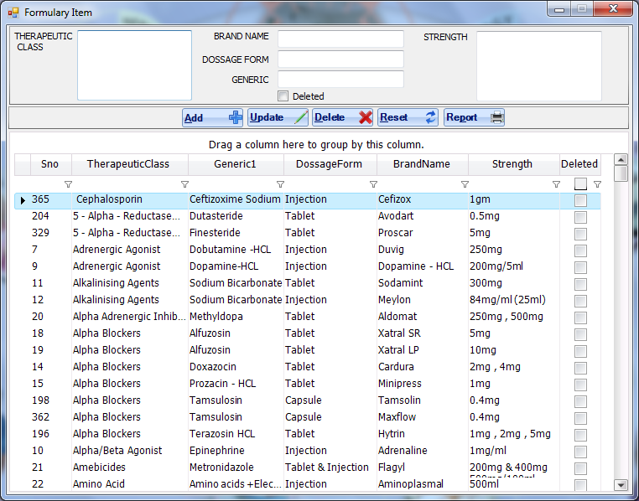
Description:
This screen is used to add, update, delete formulary items.
Functional Information
- To add an item enter therapeutic class, brand name, dosage form, generic and strength and then click on the Add button.
- To update an item user will select an item from the grid, then after edit the information user will press Update button.
- To delete an item, user will select the item from the list and press the Delete button.
- Reset button will reset/clear all the textboxes.
- To preview report, click on the Report button.

ENABLE ITEM FOR IDR SCREEN
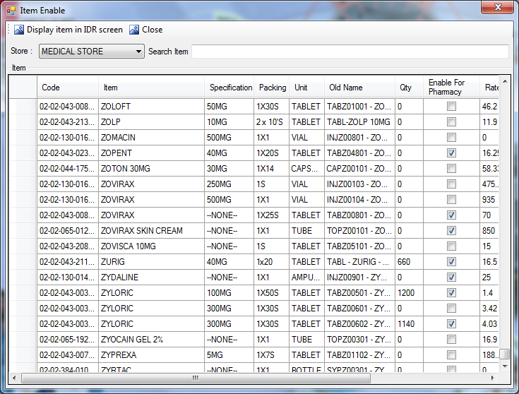
Description:
This screen is used to set the items, which will be displayed in the IDR-creation screen. Put this screen where necessary (Before IDR Creation) Mentions the Audience/ User of this screen
Functional Information
- User will select the store from combo.
- User can search an item by entering its description/name.
- To enable the item in IDR screen user will select the item through the checkbox.
- Only selected items will be displayed in the IDR screen, when user press Display Item in IDR Screen button.

ENABLE EXPENSIVE ITEM
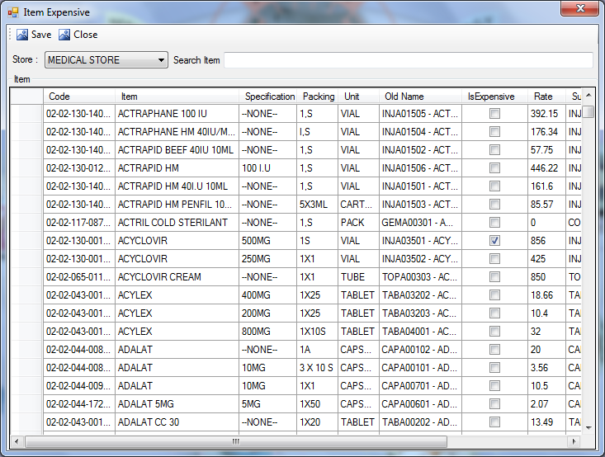
Description:
This screen is used to mark the item as expensive. User can filter expensive items in the report.
Which report? From Where report can be called?
Functional Information
- User will select the store from combo.
- User can search an item by entering its description/name.
- To mark the item as expensive user will select the item through the checkbox.
- By pressing save button system will save the selected item as expensive.

VOUCHER REFUND PHARMACY
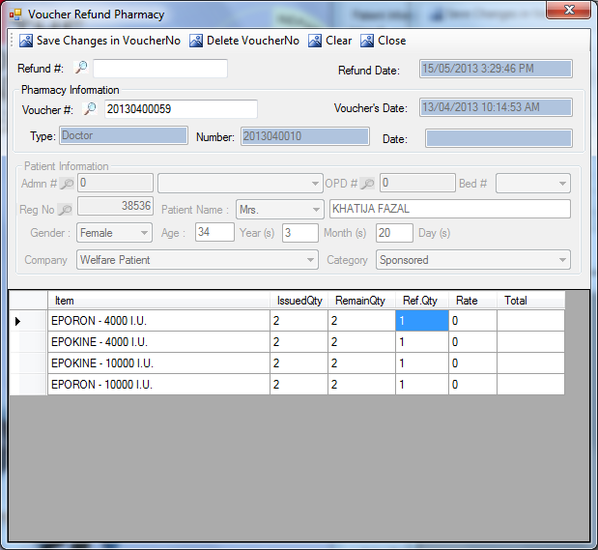
Description:
This screen is used to refund the items to pharmacy. The documents saved in pharmacy sales(of source type doctor and cash) will be called by their reference number and the stock of the pharmacy get increased upon saving the record. After Pharmacy Sales
Functional Information
- User will select voucher# from the lookup, this lookup is populated with the values which have been saved in pharmacy sales screen.
- When user select the voucher from lookup, the type and number(only if type is doctor) will be picked by the system.
- System will also pick the patient information (read-only)
- Item details will be displayed in the grid, user will enter the refund quantity and press the save button, this will make an entry of refund items and the pharmacy stock will increases equal to with refund value.
- Unique Refund # will be generated and Refund Date will be picked by the system, upon saving the record.

ITEM POLICY FOR PHARMACY SALES
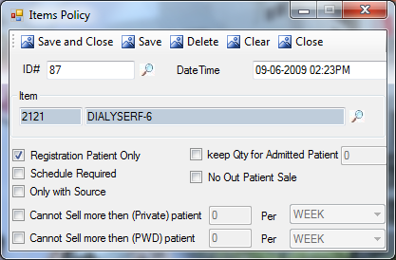
Description:
This screen is used to set the policy of the item at pharmacy sales for registered, admitted and out-patients. At the time of Pharmacy Sales.... and user of this screen
Functional Information
- User will select the service from lookup, (as shown in following diagram)
- To select the policy for the selected item user will select the following options by checkboxes
- Registered Patients Only: Medicine can only sale to registered patients.
- Keep Qty for Admitted Patient: entered quantity should always be kept for admitted patients.
- Schedule Required: schedule or doctor prescription required for sale of the item
- No Out Patient Sale: Item cannot sale to FC-patients or outsiders.
- Only with Source: Item can only sale to the patient having any of source type i.e. IDR or Doctor.
- Cannot Sell more then (Private) patient: User will enter the number of items in the text field and select the duration (i.e. from week, year, two weeks, month, or day) from combo.
- Cannot Sell more then (PWD) patient: User will enter the number of items in the text field and select the duration (i.e. from week, year, two weeks, month, or day) from combo.

Item Lookup:
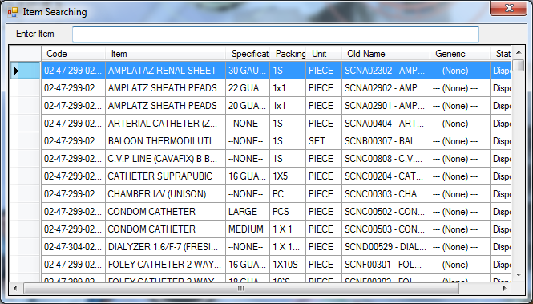
Define only once in detail and put the reference where needed.

STORE

ADD ITEMS FROM SUGGESTION
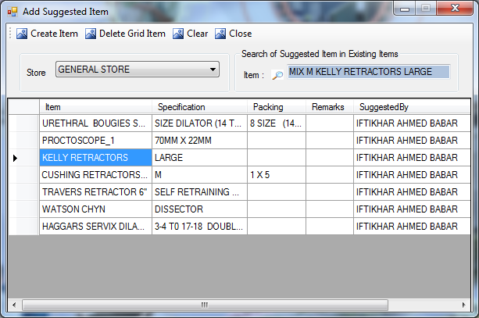
Description:
Good One
Functional Information
- User will select Store from combo. From where the Items came? Which Screen? Why this screen is here?
- User can search the suggested item in the existing items lookup as shown in ref:3. Selected item from grid will be displayed in the text field.
- Suggested items are populated in grid, according to the selected store.
- User will delete an item from the grid by pressing the Delete Grid Item button after selection of the item from grid.
- If user wants to create the new item he will select the item from grid and press Create Item, this will open the item creation screen(as described in ref:4)

BATCHES ADJUSTMENT SCREEN
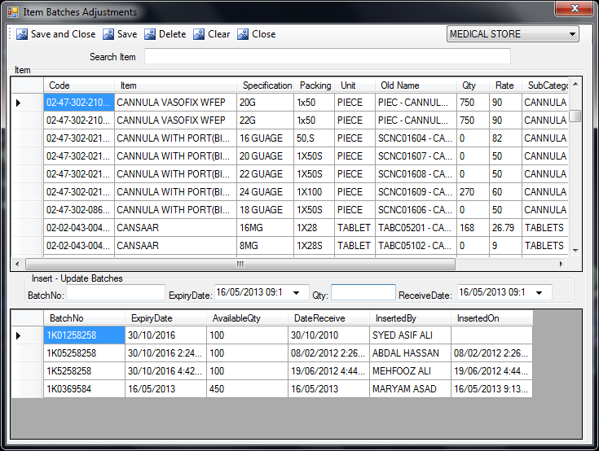
Description:
This screen is used to enter or delete the details of the batches in the system. WHY?
Functional Information
- User will select the store from the combo.
- Items in the first grid will be populated according to the selected store.
- User can search the item by entering its name in Search Item text field.
- Upon selection of any fields from first grid, the batch detail of the item will be displayed in the second grid.
- To enter the new batch user will enter the batch number, enter the received quantity, select the expiry and received date from date picker, then press save button.
- To delete the batch user will double-click on the batch, its details will be picked by the system in respective text fields, then user will press delete button.
- To update the available quantity, user will double-click on the batch, its details will be picked by the system, user will edit the quantity and then press save button, this will update the quantity.

ITEM SEARCHING SCREEN
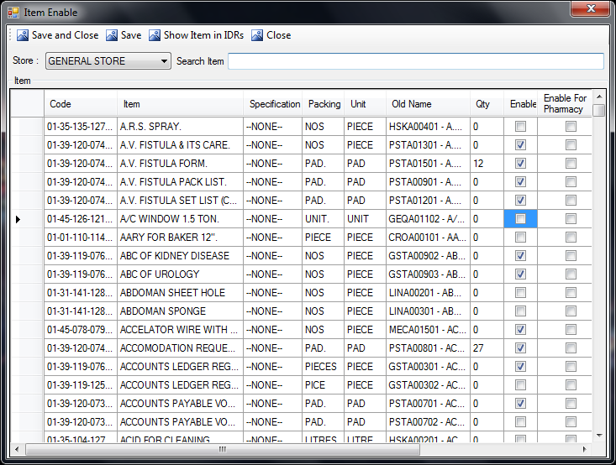
Description:
This screen is used to search for an item in the system.
Functional Information
- User will select the Store from combo.
- Grid will display the list of the items, system will display the item according to the selected store.
- To search the item user will type the description of the item in search item field.

ITEM ENABLE DISABLE SCREEN
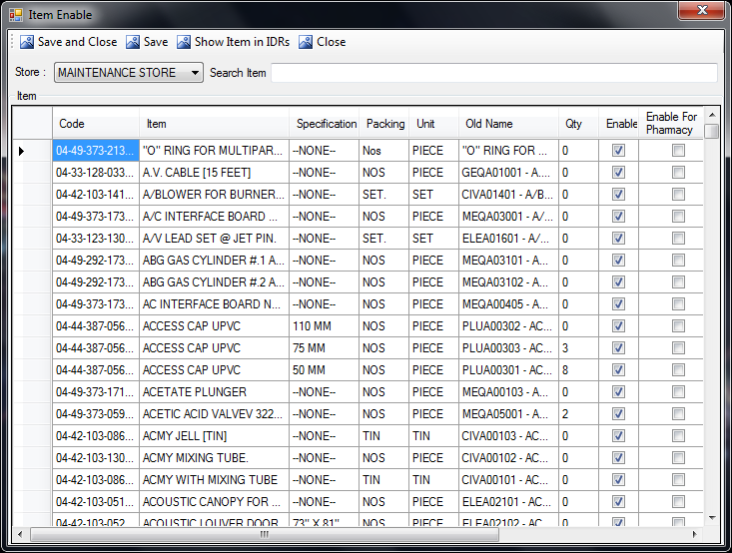
Description:
This screen is used enable/disable the items in the demand creation screen.
Functional Information
- User will select the Store from combo.
- Grid will display the list of the items, system will display the item according to the selected store.
- To search the item user will type the description of the item in search item field.
- To enable/disable the user will mark the item by checkbox and press save button. Marked items will be shown in demand creation screen.

ITEM SPECIFICATION

Description:
This screen is used to set/edit the specification of the item.
Functional Information
- User will enter the description, the code will auto-generated upon saving the record.
- To update the record user will enter the code or press F11 for lookup screen(as shown in following diagram), then user will edit the details and press the Save button to update the record.
- User will enter the code and press Delete button to marks the record as delete.
Lookup:

- Select the Search in column name form drop-down menu.
- Enter the value of selected column to search (e.g. enter numeric value for SpecificationID)

ITEM TRANSFER UTILITY
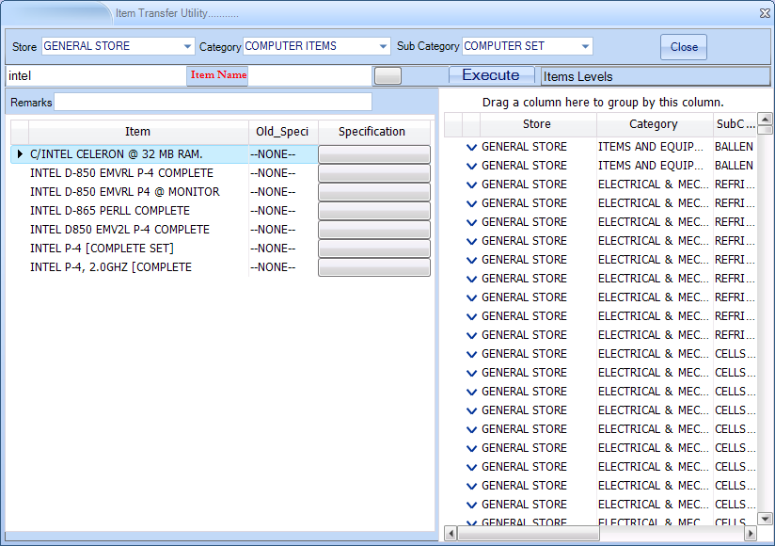
Description:
This screen is used transfer the items, from one store to another.
Functional Information
- User will select the Store from combo.
- User will also select the Category and Sub-Category from combo.
- This will populate all the items in LHS grid.
- User can further filter the items by entering the name of the item in text field(behind item name)
- If user want to change the name then user will enter the new name of the item, or user can select from lookup, by pressing the button.
- User can change the specification of the item by clicking specification buttons.
- After changing the specifications when user clicks the Execute button, it will save the new specification against the item.
- RHS grid will show the items grouped by their stores and category.

MASTERS SETUPS:

CATEGORY SETUP:
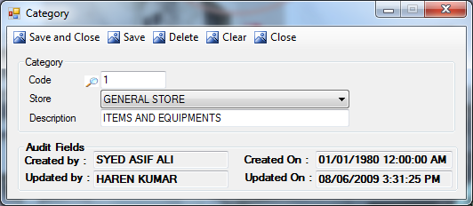
Description:
This screen is used to set new category of an item in inventory. How to create Store?
Functional Information
- To set new category user will enter the description of the category, then select the store from the Drop-Down and press Save button then the code will be auto-generated.
- To update the record user will enter the code or press F11 for lookup screen () then the description of the category will be picked by the system, user can edit the description and selection of store to update the existing category.
- To delete the record user will enter the code, the description will be picked by the system upon pressing the Enter button from keyboard, then by pressing Delete button the record will get deleted.

Lookup:

- Select the Search in column name form drop-down menu.
- Enter the value of selected column to search (e.g. enter numeric value for CategoryID)

SUB-CATEGORY SETUP:
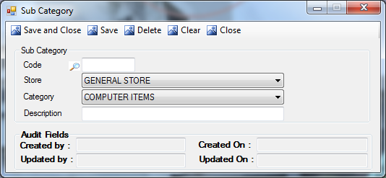
Description:
This screen is used to set new sub - category in inventory. Where these subcategory will be used?
Functional Information
- User will select the store from combo.
- User will select the category from the second combo.
- User will enter the Description of the sub-category, then the code will auto-generated upon saving the record.
- To update the record user will enter the code or press F11 for lookup screen (as shown in the following diagram). This will show the details of the sub-categories in respective fields. User will edit the details and press Save button to update the record.
- To delete the record user will enter the code and press enter to populate the details in the respective fields, then press Delete button to delete the record.

Lookup:

- Select the Search in column name.
- Enter the value of Sub-Category to search (e.g. enter numeric value for Sub-Category ID)

MANUFACTURER SETUP:
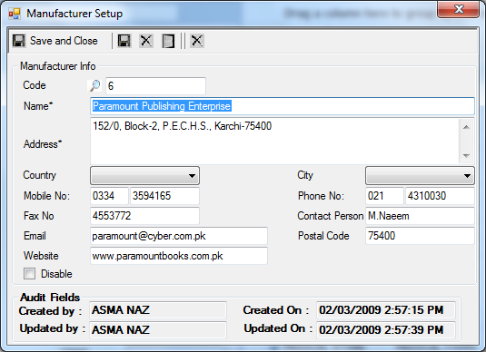
Description:
Manufacturer Setup screen is used to enter the data of the new manufacturer or user can also update the existing manufacturer information through this screen. USAGE? Where these manufacturere are used? Why to create them?
Functional Information
- User will enter the Name of the manufacturer.
- User will enter the Address of the manufacturer.
- User will select the Country and City from the Drop-Down.
- User can enter the contact information of manufacturer in Mobile No., Phone No, Fax No, name of the Contact Person, E-mail, Postal Code and Web-site fields
- Disable: this checkbox is used to activate/deactivate the manufacturer.
- The Code will be auto-generated upon saving the record.
- User can view the code from F11 lookup for update/deletion of record.
NOTE: Name and Address are mandatory fields.

UNIT SETUP:

ITEM CREATION SCREEN:
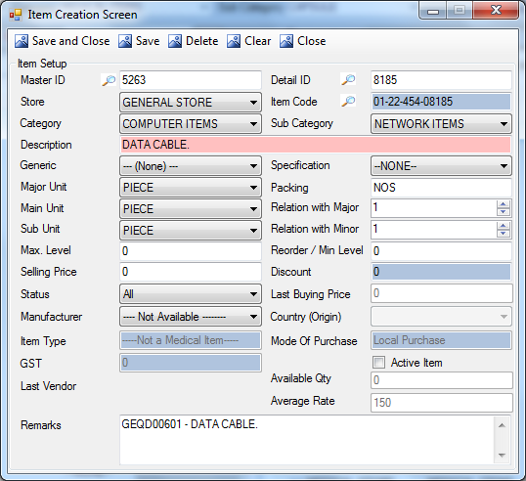
Description:
This screen is used to CREATE updateset/edit the details of the items.
Functional Information
- Master ID lookup will display all the data of the items created as shown in lookup.
- Detail ID will display the values under the selected master ID.
- ITEM CODE FORMAT:
- Code : 01-22-454-08185 (ST-CA-SUB-ITEMS)
- ST for STORE Code
- CA for Category Code
- SUB for Sub Category Code
- Item for Item Code

- User will select the store, Category and Sub Category from drop-down. how to create new?
- Item description will be populated in text field.??? Populate from WHERE?
- User will select the Generic, Specification, major unit, minor unit and sub unit from combo. Demand is created according to sub-units.
- User will enter the Packing details in the text field e.g. pieces, KGs etc. this will be appear at the time of Purchase Order Creation and Stock Screens.
- Relation with major/minor: these fields will display the relation as packing wise for the item e.g. if 1000 items are demanded but packing wise they came in 10 packets then the relation with major display 10 and relation with minor display 1000. With this packing system will calculate the packing of the item. This will then be available in Purchase Order Creation.
- User will enter the major level and re-order level that will be used to maintain the inventory of that item.
- User can enter the selling price of the item.
- Discount: is set in Item Purchase Detail screen. Reference missing?
- User will select the status from combo (i.e. All, Medicine, Disposable). Why Working?
- User will select the manufacturer from combo. how to create new manufacture?
- User will enter the and country origin from combo.

- .??

- mention Mandatory Fields
- LAST VENDOR?

Master , Detail & item Lookup:

No need of all F11 Screen. kindly breifly describe it on one place and use reference.

PROCUREMENT

ITEM PURCHASE DETAILS
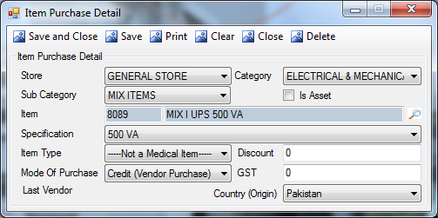
Description:
This screen is used to set the details of the purchase of the items like mode of purchase, Discount, GST etc.
Functional Information
- User will select the store, category and sub-category from combo. (It will be automatically selected if Item is selected from Lookup screen.)
- User will select the item from lookup, after selection pf the item, its details will be populated in text fields of code and description.
- User will select the specification of the item from combo.
- User will select the item type, i.e. either the item in medical, non-medical or both.
- User will select the mode of purchase i.e. credit (vendor purchase), Bank L/C or local purchase. WHY TO SELECT?
- User will enter the discount and GST(Goods Service Tax) values.
- User will select the country from the combo, this will save the item with the entered purchase details.

TERMS AND CONDITION SETUP:

:

SUPPLIER SETUP:
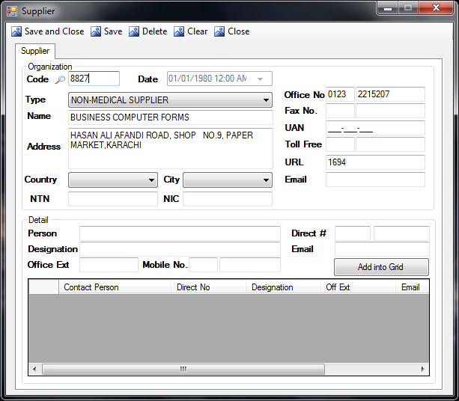
Description:
This screen is used to maintain the supplier setup in the system.
Functional Information
- To insert the information about new supplier;
- User will select the type from combo (i.e. both, medical supplier, non medical supplier)
- User will enter the Name of the supplier.
- User will enter the Address and select the Country and City from combo.
- User will enter the NTN and NIC of the contact person.
- User will enter the contact information of the supplier by entering its Office No., Fax No., UAN, Toll Free No., URL and e-mail.
- To add any employee information of that organization, user will enter the person Name, his Designation, Office No., Mobile No., Direct# and Email address of employee. And then user will press Add into Grid button.
- When user press the save button the code will be auto generated.
- User can add the multiple employee’s contact details of single company.
- To update the record user will enter the Code of the supplier or select the code from lookup(as shown below). All the other information of the supplier will be picked by the system, user can edit the information and press save button, this will update the record.
- To delete the record user will enter the Code of the supplier or select the code from lookup(shown below). All the other information of the supplier will be picked by the system, user will press delete button, this will mark the record as delete.
Supplier Code Lookup:

- To search an organization from lookup select the search-in column from combo, this combo will be populated with all the column names of the combo.
- User will enter the values of the selected column to search in text field.

MAINTENANCE

LOCATION FOR BUILDING CONSUMPTIONS

Description:
This screen is used to set/edit the different locations of TKC, which are mainly used by maintenance department for item consumption at different areas.
Functional Information
- User will enter the description, the Code will be auto-generated upon saving the record.
- User can view the code from F11 lookup for update/deletion of record.
Lookup:

- Select the Search in column name from combo.
- Enter the value of selected column to search (e.g. enter numeric value for LocationID)

START PROJECT SETUP
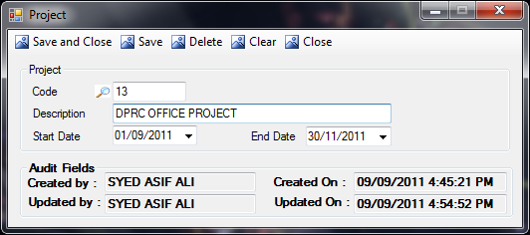
Description:
This screen is used to set/edit the project information. Where this is needed?
Functional Information
- User will enter the Description of the project, and select the start and end date (by default the system will select the current date). Then by pressing the Save button the code will auto-generated and new record will be saved.
- User can view the code from F11 lookup for update/deletion of record.
Lookup:

- Select the Search in column name from combo.
- Enter the value of selected column to search (e.g. enter numeric value for ProjectID)

BILLING

IDR ITEM RATE POLICY

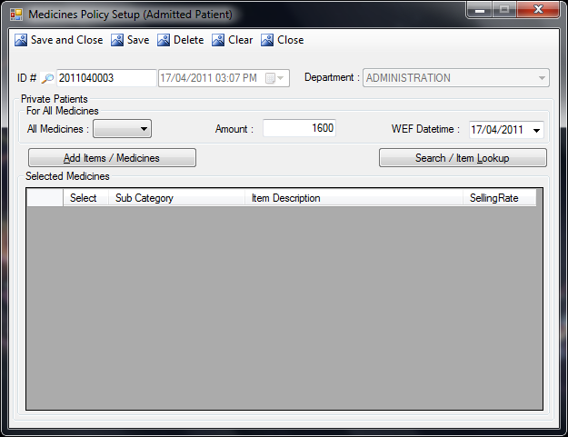
Description:
This screen is use to set the policy for the items. WHY Function
Functional Information:
- User will select the operational operator from the drop-down, and enter the amount in textbox.
- User will select the WEF Date from date picker, system will show current date by default.
- User will add the items by pressing Add Items/Medicine button(as shown in ref:5), added items will be displayed in the grid. On these selected items billing approval will not be required.
- To search an item user will click on Search/Item lookup button(as shown in ref:6).
- User will press save button, Date/Time will be picked by the system, and ID# will generate automatically upon saving record.
Add Item/Medicine Lookup:
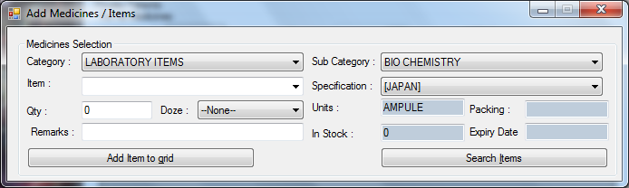
- To add the item user have to specify;
- Category of the item.
- Sub-category of the item.
- Description/name of the item.
- Specification of the item.
- Quantity or doze(for medicines)
- User can also enter the remarks.
- Units, packing, in-stock and expiry date will be pick by the system.
- User will press the button, Add Item to Grid. This will add the specified item in the grid of main screen.
- User can also search the item by pressing Search Item button. This will open the following screen.

COMPANY CHARGES SETUP

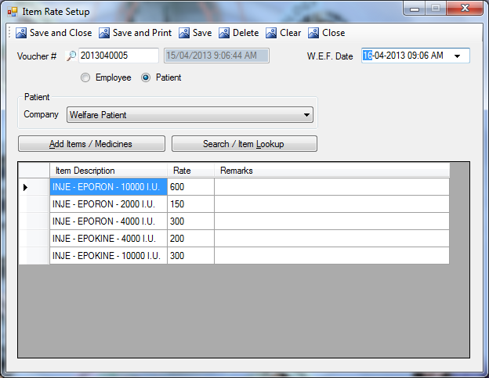
Description:
This screen is use to set the policy for the items. AND WHY TO SET RATES?
Functional Information:
- User will select the person on which policy is going to be applied i.e. from Employee and Patient by radio buttons.
- If patient is selected then User will select the Company of the patient from combo.
- User will select the WEF Date from date picker, system will show current date by default.
- User will add the items by pressing Add Items/Medicine button(as shown in ref:7), added items will be displayed in the grid. User will enter the rates of the entered items. User can also enter the remarks(if any)
- To search an item user will click on Search/Item Lookup button(as shown in ref:6).
- User will press save button, Date/Time will be picked by the system, and unique Voucher# will generate automatically upon saving record.

Item lookup:
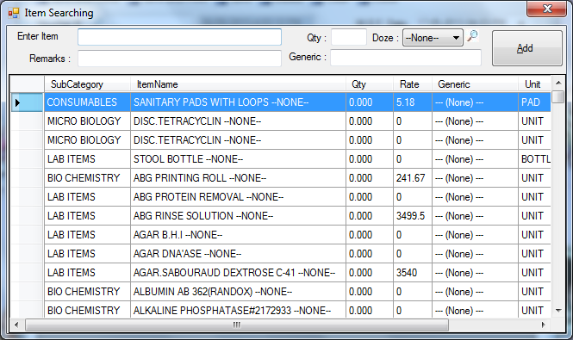
- Enter the name of the item, and enter the code OR just double-click on the item in the list code and item field will be auto filled.
- Enter the generic (for medicines).
- Enter the quantity, then press the Add button.

BILLING WELFARE

ALL PHARMACY FREE MONTHLY APPROVAL
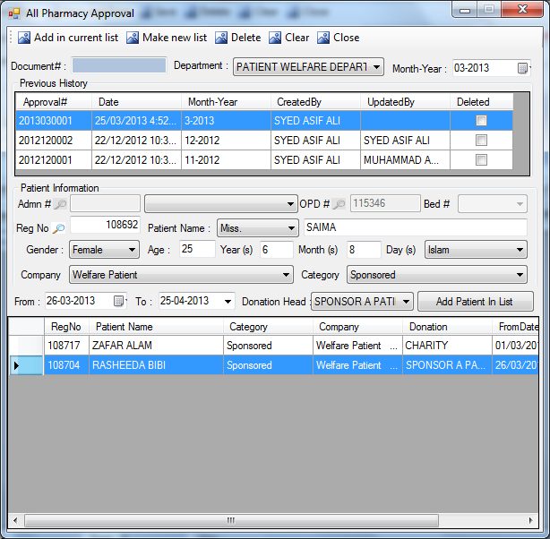
Description:
Some patients take monthly medicines from pharmacy of TKC. The details of those patients will be maintain in this screen. (Many patients take monthly medicines so why to add them here? if a patient is not added here cant he take monthly medicines? USAGE of this screen is not clear
Functional Information
- Month and year will be automatically picked by the system.
- Monthly history of the patients will be displayed in first grid.
- By clicking any field in the first grid, user can view the list of the patients in second grid.
- User can either add a patient in the same list or he can make a new list for the patients.
- To add new patient user will enter the Reg No or to select the patient from lookup user will press F11.
- It will pick all the other information of the patient.
- User will select the Donation head from the drop down only if the department is PWD.
- To add the selected patient in the list user will press Add Patient In List button.
- This will add the new patient in the list and it will generate unique Document #.
- The details of the patients will be saved and can be picked by pharmacy sales screen, to sale the monthly medicine to the patients.
- Patient will not charge against the medicine issued by pharmacy, its corporative bill will be created.

MIS

ASSIGNMENTS:

HOD ASSIGNMENT:
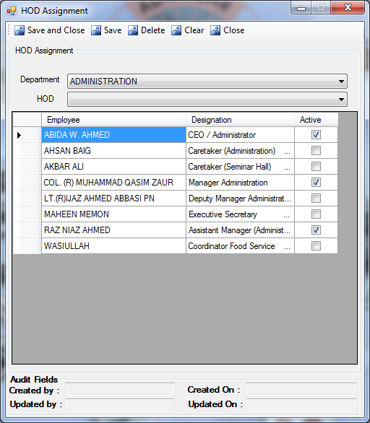
Description:
This screen is used for the assignment of the HOD rights. The selection will be made from all the employees of that department.
Functional Information
- User will select the department from combo. This will populate all the employees of that department in the grid.
- User will select/deselect the HOD from list of employees, if the employee is not present in the list of employees shown by grid, then user can add employees by selecting the code from HOD combo.

DEPARTMENT ASSIGNMENT:
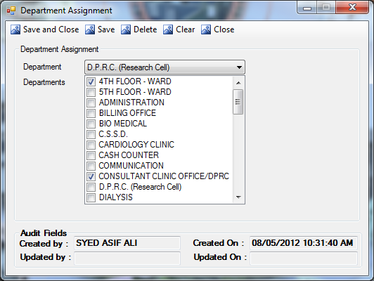
Description:
This screen is used to assign the departments to one department. The department to which the other department has been assigned can create the demand for assigned departments.
Functional Information
- User will select the department from combo.
- List will display all the departments of TKC, user will select/deselect departments by checkboxes.
- Selection of assigned departments will get saved upon pressing save button.

SUB-STORE ASSIGNMENT SETUP:
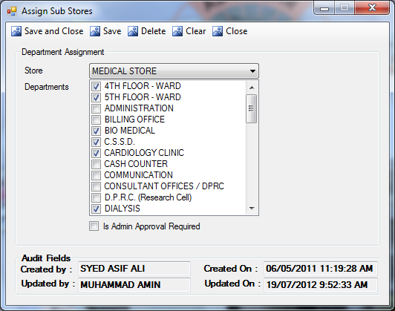
Description:
This screen is used to assign the departments to store. and what are sub departments? Why needed? where it is used?
Functional Information
- User will select the store from combo.
- List will display all the departments of TKC, user will select/deselect departments by checkboxes.
- Selection of assigned departments to store will get saved upon pressing save button.
- Selected sub-stores can issue the items on the behalf of the store.
- If “Is Admin Approval Required” check box is checked then it will not allow the issuance without admin approval.

EMPLOYEE DEPARTMENT ASSIGNMENT:
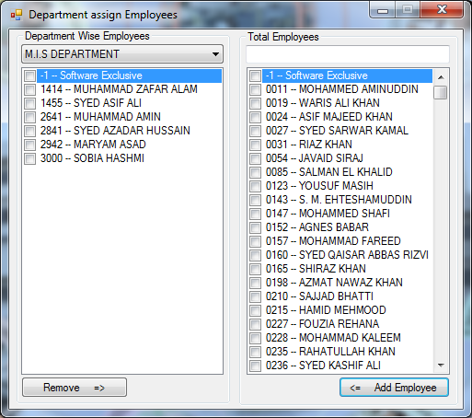
Description:
This screen is used to assign the employees in the department. Why needed? where it is used?

Functional Information
- RHS List will display all the employees of TKC, user can search employee either by entering the code or the name of the employee.
- LHS List will display the employees in the selected department.
- User can add the employees in the department by selecting an employee from RHS list and pressing Add Employee button.
- To remove the employee from LHS list user will press Remove button.

CHANGE DEPARTMENT EMPLOYEE
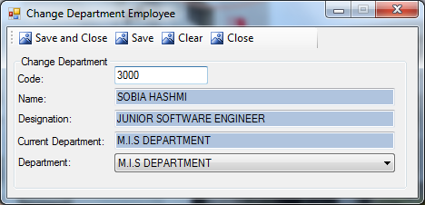
Description:
This screen is used to change department employee. . Why needed? where it is used?
Functional Information
- User will enter the code in the text field.
- System will pick name, designation and current department.
- User will select the department for the employee and press save button, this will save the selected department for the employee.

ROLE ASSIGNMENT

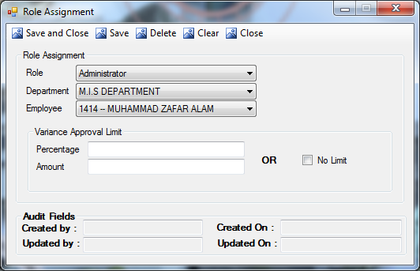
Description:
This screen is used to assign the role of the employees in the system e.g. if a person has the assigned the role of admin then only he will approve the departmental demands. DEFINE EACH ROLE AND THEIR FUNCTIONS
Functional Information
- User will select the Role of the employee from the first drop-down.
- User will select the department from the second drop-down, and employee of that department from the third drop-down.
- User can assign a variance approval according to its role. It will be in Amount and in Percentage or it has no limit. For amount and percentage user will enter the values and for no limit user will check the checkbox.
- After entering the information user will press the Save button, this will save the role of the employee.

DEPARTMENT RECIPE SETUP

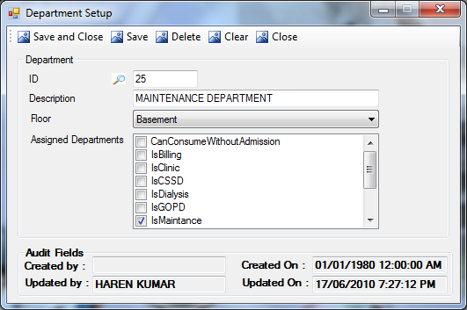
Description:
This screen is used to set/edit the department information. usage
Functional Information
- User will enter the description of the department.
- User will select the floor of the entered department.
- User will select the role of the department from Assigned Departments list.
- ID of the department will be auto generated upon saving the record.
- The code of the new record will auto-generated upon saving.
- If user want to update the record, then he will press F11 for the code. After entering the code the saved details of the department will be populated in the screen. User will select/deselect assigned department by check boxes and then press Save button to update the record.
- To delete the store user will enter the code of the store and press Delete button.

NON CONSUMABLE ITEMS
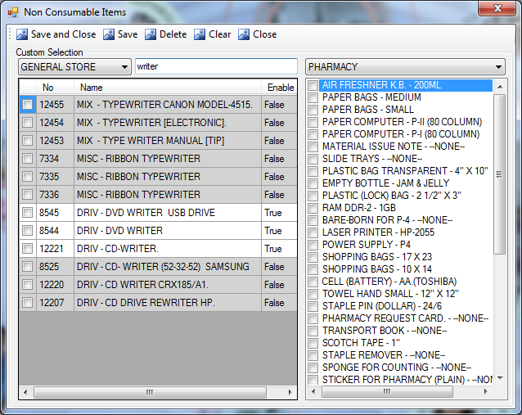
Description:
This screen is used to assign the non-consumable items to departments. USAGE?
Functional Information
- User will select the store from combo.
- LHS grid will display the list of items in the selected store. The items marked as ‘False’ in enable column are non-consumable and highlighted in grey color, and the items marked as ‘True’ in enable column are consumable items.
- User can search the item by entering its name in the text field.
- User can make some of the department unable to consume the selected items, for this user have to select the department from combo and to add the department from LHS list user just click on the checkbox, this will add the item in RHS list.
- To remove the item from RHS list, user will click on the item, it will get removed from the list.
- By pressing save button, assigned items will get saved against department.

MASTER ICS

STORE CREATION
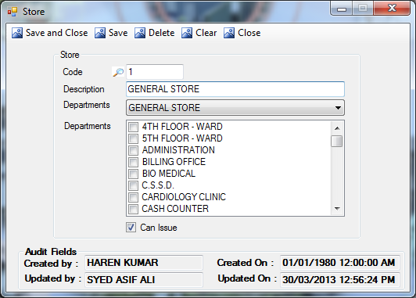
Description:
This screen is used to create the new store in the current running system. And user can assign the sub-stores to new created stores. This should be before Item Creation
Functional Information
- User will enter the description of the new store.
- User will select the department from the Drop-down menu, then sub-departments will displayed in the grid.
- If user check the can issue textbox, then it will appear at the time of demand and issuance.
- After entering the details of the new store, user will press the Save button.
- The code of the new record will auto-generated upon saving.
- If user want to update the existing store by assigning new departments to the store, then he will press F11 for the code of the existing store .After entering the code the saved details of the store will be populated in the screen. User will select/deselect sub-stores by check boxes and then press Save button to update the record.
- To delete the store user will enter the code of the store and press Delete button.

NEW ITEM ENTRY FOR IDR
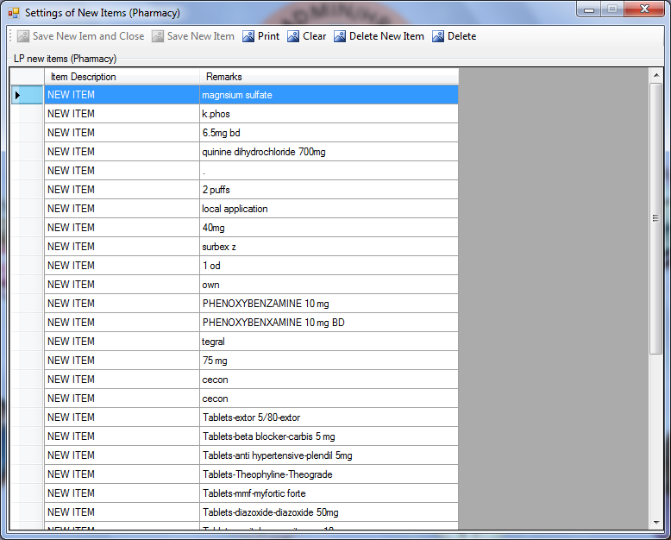
Thank you for providing screen shot.

SUPPLIER TYPE

:

- Select the Search in column name from combo.
- Enter the value of selected column to search (e.g. enter numeric value for SupplierTypeID)

MODE OF PURCHASE

- Select the Search in column name from combo.
- Enter the value of the column to search (e.g. enter numeric value for ModeOfPurchaseID)

ACTION COMBO SETUP

Description:

- Button1: ???????????
Lookup:

- Select the Search in column name from combo.
- Enter the value of the selected column to search (e.g. enter numeric value for ActionID)

DEMAND STATUS SETUP

C.S.S.D.

LOAD TYPE SETUP

- nter the value of the selected column to search (e.g. enter numeric value for LoadType ID)

CYCLE TYPE SETUP

:

- Select the Search in column name from combo.
- Enter the value of the selected column to search (e.g. enter numeric value for StatusID)

TRANSACTION SCREENS:

DEMAND TRANSACTIONS

DEPARTMENTAL DEMAND CREATION
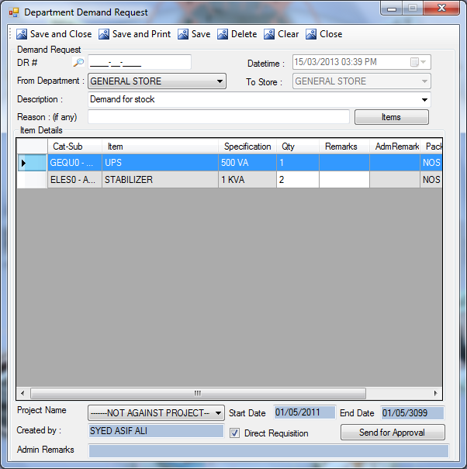
Description:
This screen is used to create the departmental demand request for any good. Demand can either be generate directly from this screen or user can also generate demand by Departmental Stock Screen. as shown or reference? Direct Requisition check will only avaiable when a store is creating a demand.
Function of Direct Requisition If store creates a demand for inventory items, then store can select the Direct Requisition check box. After approval from HOT it will directly go to the requisition creation screen.

Functional Information
- System will pick assigned department. If user is assigned multiple department then user can select the department form the Drop-down list.
- User will add the Description or can select the most commonly used description from the same dropdown..
- User can specify the Reason of demand, if necessary this field is not mandatory.
Item Selection
- Select the store from the Drop-Down menu of To Store.
- Items will be populated against selected store.
- Once item is added in the list. User cannot change the Store.
- One demand can be created only for one store.
- To add an item click on the Items button this will pop up the screen which is shown in the figure(Add Items).

- User will specify the name of the project if user demanding an item against any project. User will also enter the start and end date of that project.

- Or if demand is ready to send for approval user can only press send for Approval button. It will save the demand and then it will forward the demand to its assigned HOD.
- User can save the demand at any time. for this user has to press SAVE button. It will only save the demand and it will not be forwarded to HOD approval. Once demand is save it will generate the DR# (Demand Request Number).
- User can recall the number by pressing F11 on DR# field and select the demand.
- TO SEND HOD APPROVAL
- Once Demand is completed user can save and send it to HOD by pressing the button SEND FOR APPROVAL. **Once demand is send for approval user cannot change / update in this demand.

- If the Direct Requisition checkbox is checked then the demand will only need the approval of HOD and after approval its requisition will be created.
- After sending the demand for approval, it can’t be updated.

DEMAND HOD APPROVAL
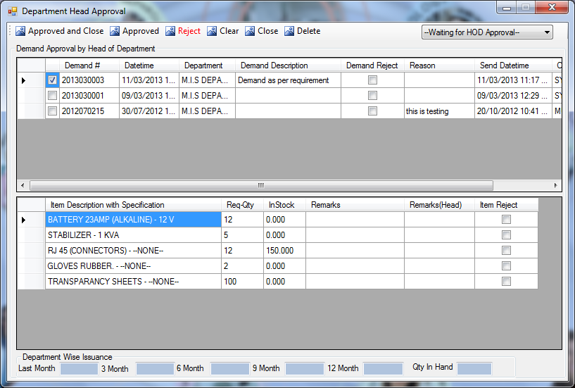
Description:
This screen is for all departmental heads (HODs) to approve the departmental demands. All the requests created by user will be shown in this screen to their respective HODs.
Functional Information
- HOD can view the items by clicking on any of the field in first grid.
- HOD can approve or reject the demand or any item.
- HOD can enter the remarks.
- HOD can also change the quantity requested.
- HOD can also view the history of the issuance by clicking the item. It will show the aging of issuance.
- HOD cannot add any item in the list.
- HOD can view those demands which are rejected by admin, by his selection of Drop-Down menu at the top of the screen, (which is currently showing –Waiting for HOD Approval--).
- When HOD clicks on the Approved or Approved and Close button then the demand will be approved and will be no more display in this screen.
- HOD can also reject the demand, but he has to specify the reason of rejection. Rejected demands will displayed on initial demand creation screen.

DEMAND ADMIN APPROVAL
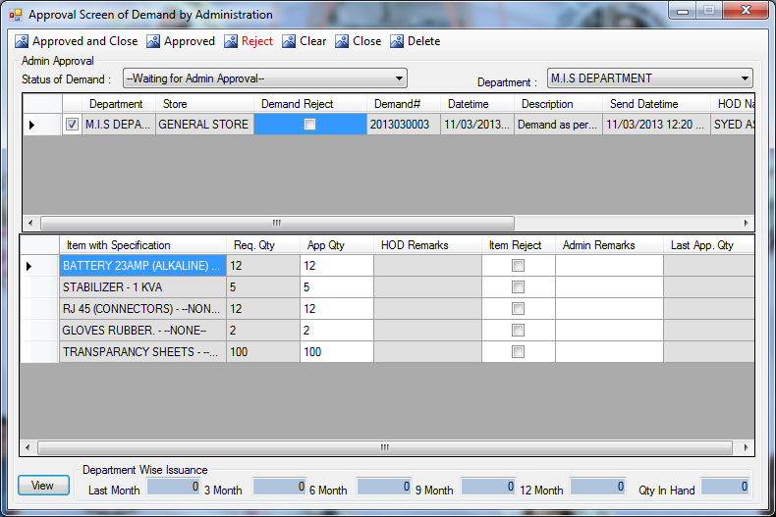
Description:
This screen is used by administrator to approve the demand made by all departments of TKC. Only administrator have rights to view this screen. This screen will display all HOD approved demands.
Functional Information
- Admin can view the items by clicking on any of the field in first grid.
- Admin can approve or reject the demand or any item.
- Admin can enter the remarks.
- Admin can also change the quantity requested.
- Admin can also view the history of the issuance by clicking the item and then clicking the view button. It will show the aging of issuance for that selected item.
- Admin cannot add or remove any item from the list.
- Admin can also view those demands which are approved by admin, by his selection of Drop-Down menu at the top of the screen (which is currently showing --Waiting for Admin Approval--).
- When Admin clicks on the Approved or Approved and Close button then the demand will be approved.
- Admin can also reject the demand, but he has to specify the reason of rejection. Rejected demands will displayed in HOD approval screen.

DEMAND PROGRESS SCREEN
This screen is divided into following three tabs;
- Demand Information
- Issue Information
- Requisition Information

Demand Information:
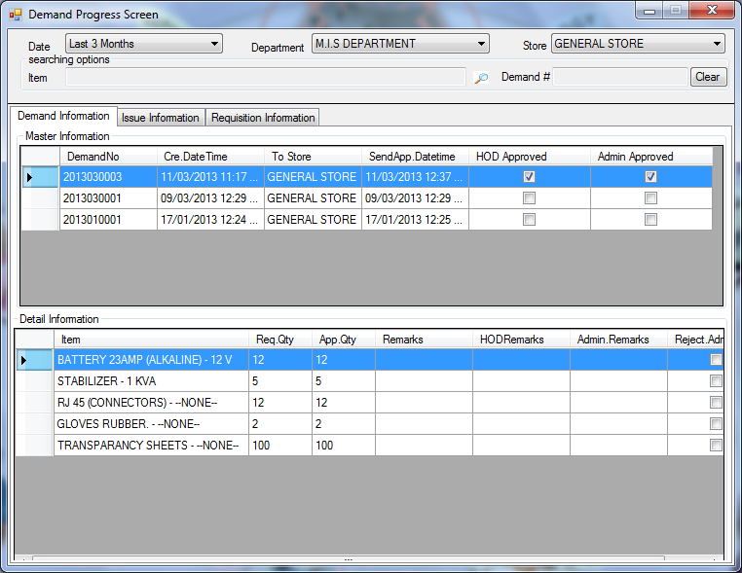
Description:
This is the screen to view the information related to progress/status of the demand i.e. either it is approved by HOD or not and either it is approved by admin or not. If the request is approved then the checkboxes in the grid will be checked, otherwise the checkboxes will be unchecked.
User can also view the changes made in the requested quantity and remarks written by Admin and HOD against any item.
Functional Information:
- User can filter the demand by entering his choice in the Date Drop-down menu (i.e. last 3-months, last 6-months, last 9-months, last 12-months).
- User can also filter the demand by selecting the Department, from which the demand have been made.
- User will select the Store to which that department made the demand.

Issue Information:
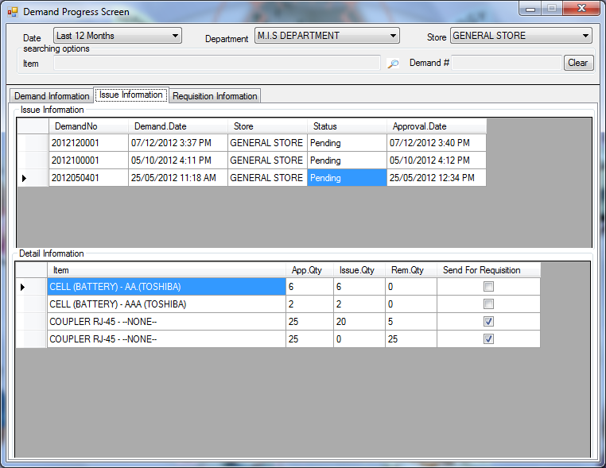
Description:
Issue information will be viewed by this screen. If the demanded items are not issued or issued partially then the status will be pending. In detail information user can also view that those items which are not issued completely are send for requisition or not.
Functional Information:
- User can filter the demand by entering his choice in the Date Drop-down menu (i.e. last 3-months, last 6-months, last 9-months, last 12-months).
- User can also filter the demand by selecting the Department, from which the demand have been made.
- User will select the Store to which that department made the demand.

Requisition Information:
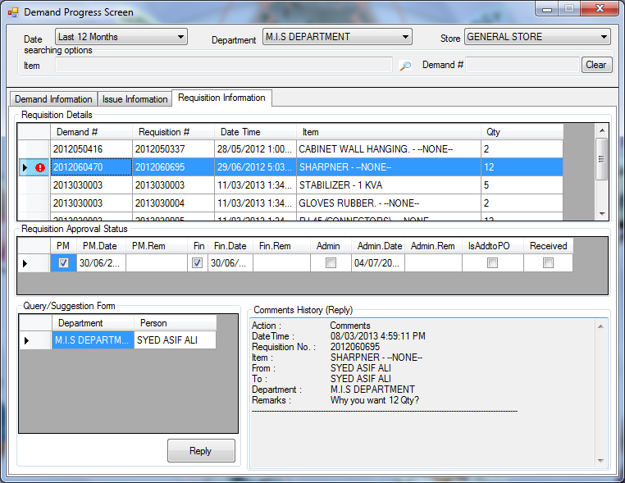
Description:
Requisition Information tab will displayed the information related to the status of the requisition.
Functional Information:
- Requisition Details grid will display Demand #, Requisition #, Date Time, Item, Qty.
- Requisition Approval Status grid will display the current status of the requisition i.e. PM(Procurement Manager approval status), PM. Date(PM approval date), PM. Rem(PM remarks), Fin(Finance Manager approval status), Fin. Date(F.M. approval date), Fin. Rem(FM remarks), Admin(Administrator approval status), Admin. Date(Admin approval date), Admin.Rem(Admin remarks),IsAddtoPO(demand is added to Purchase Order), Received(either requested items are received or not)
- In Query/Suggestion form by clicking on Reply button the user can reply of that message which has been send by any of approval authorities. By pressing reply button another support screen will be opened as shown below.
Action Screen:
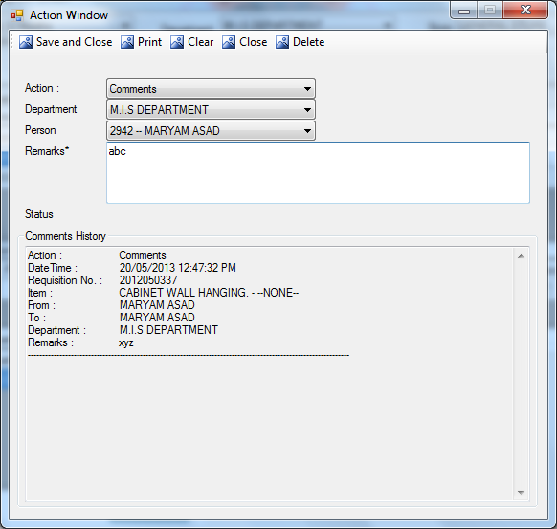
Functional Information:
- User will select the Action from combo, i.e. reply, suggestion, explanation etc.
- User will select the Department from the combo.
- User will select the Person from combo, this combo will be populated according to the selected department
- In remarks text field, user will enter the message according to the selected Action from the first combo.
- If any comment history present in the selected requisition then it will displayed in Comment’s History field.

REQUESTED ITEMS
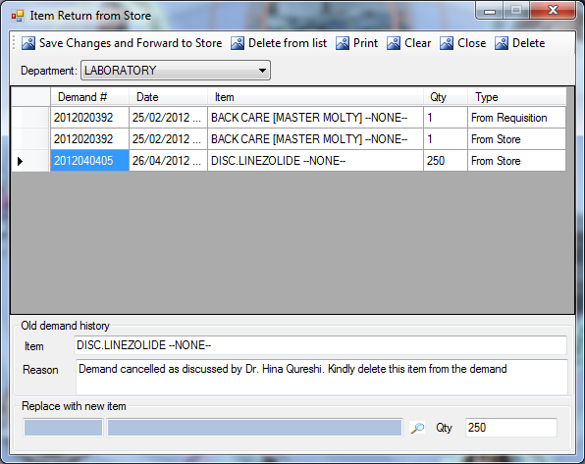
Description:
This screen will display the items returned from store, user can view the remarks against the cancelation of the demand, or user can also forward the demand back to store by replacing that item with another one.
Functional Information:
- User will select the Department from combo.
- The first grid will display the details demands and its items which are returned from store. The demands will be populated according to the selected department.
- Upon selection of the demand from the grid, the details will be populated in the text boxes, of Old Demand History.
- Total quantity of the canceled item will be displayed in grid as well as in Qty textbox at the bottom of the screen.
- To replace the cancelled item, user will select the item from lookup(as shown in ref:8) and its code and description will be picked by the system.

ISSUANCE SCREEN
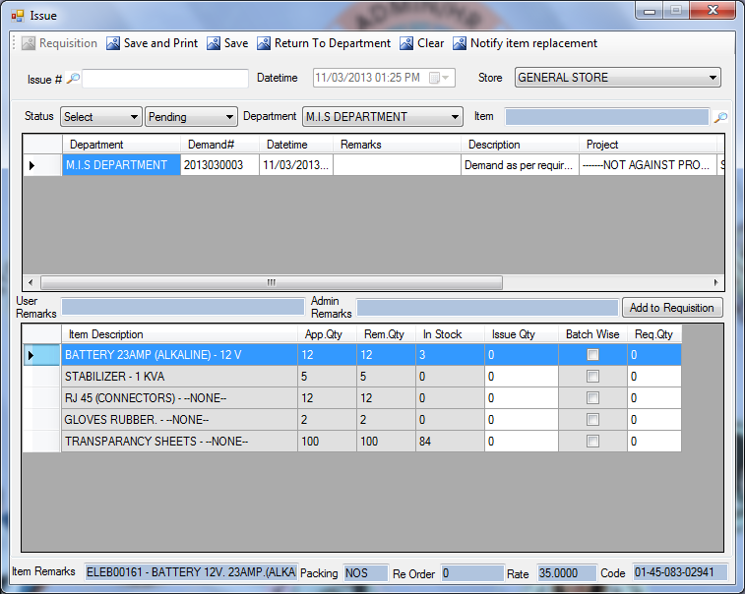
Description:
This screen is for issuance of demands approved by HOD / Admin. If demand is not approved any of the approval authority it will not be shown in this screen.
Functional Information
- User can select the Stores from the Store Drop Down list as assigned.
- User can also filter the demand by selecting Department from Drop Down list, and by enter the description of Items or press F11 for lookup as shown in figure(Item Searching)
- User can see the pending/partially issued or issued demands by selecting from the Status Drop Down menu.
- User can also select the time period from the Status drop down.
- User can view the Admin Remarks from this screen, and user can also view the User Remarks(the person who created the demand).
- Store cannot increase the approved quantity of any item.
- Store can issue batch wise, by pressing F10 as shown in figure(Batch Records).
- Store can replace the item by pressing F9 key this will pop-up the screen which is shown in figure(Item Replacement), store have to notify about the replacement of that item by pressing Notify Item Replacement button. User has to enter the reason for replacement. If demand is returned to departments, then only HOD have rights to replace the items.
- Store can return complete demand by pressing “Return to Department Button”. User has to enter the reason. Once demand is return to department it again requires all the approvals.
- User can create Requisition for any items or Item which are out of stock.
- To create requisition user have to add required quantity of selected item and press Add to Requisition Button.
- User cannot add issue quantity more than approved quantity in requisition.
- Item Remarks will be displayed at the bottom of the screen, when user selects any item.
- When the status is changed from pending to issued then user have to complete the status of demand by pressing Complete Status Button (last column of the first grid).
- Issue# and Date/Time will be picked by the system, when user save the demand.
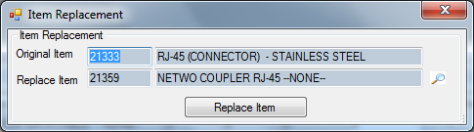
figure (Item Replacement)

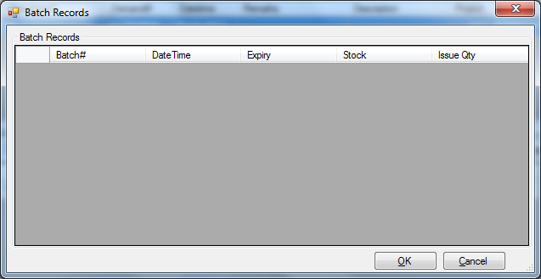
figure (Batch Records)

GOODS RECEIVING FROM STORE
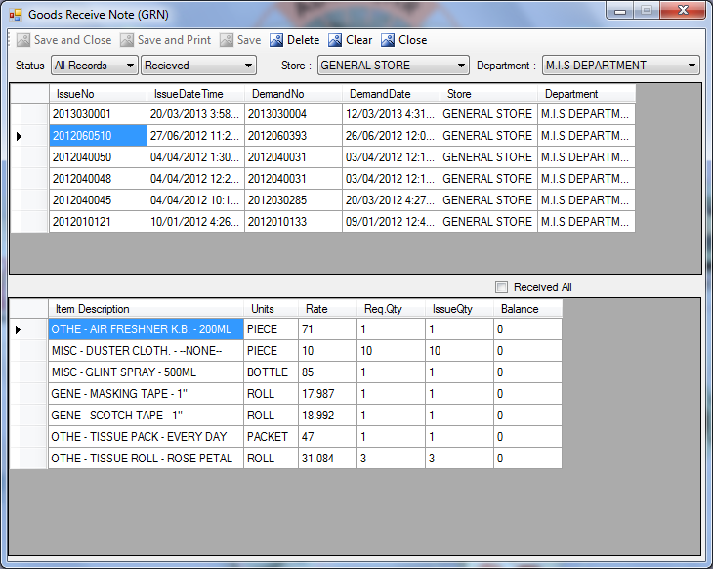
Description:
Once Item is issued from store user has to receive the items which were demanded by the department. Then this screen is used to receive goods issued from the stores. Upon receiving stock of department will be increased. User can then consume the items or can make refund back to store.
Functional Information
- System will pick respective department. If user is assigned multiple department then user can select the Department form the combo.
- User will also select the Store from combo.
- To filter GRN user have to specify Status(i.e. last 30 days, last 3-month, last 6-month, last 9-month, All records) and form the next combo user will select the Received Status(i.e. pending, received, partially received).

DEPARTMENTAL STOCK SCREEN
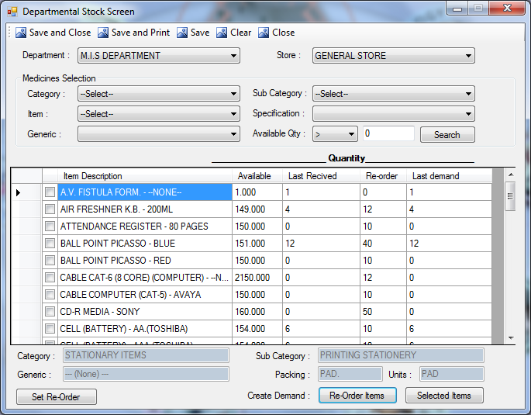
Description:
This screen is used by departments to view the stock of the item and this screen can also be use create demand for departments. Departments can also set Re-Order levels to the items to create demand for Reorder items.
Functional Information
- User will select Department and Store from the Drop-down menu.
- User can also filter by selecting Category, Sub-category or Item’s name, Specification and Generic from the Drop-Down.
- User can also filter the items by setting available quantity using operators in available quantity field.
For example:
To select items equal to zero user has to select ‘=’ equal operator from the list and enter the value 0, then it will show items which have available quantity equal to zero.

To select items greater than zero user has to select ‘>’ greater operator from the list and enter the value 0, then it will show items which have available quantity greater than zero.
- After entering the criteria of search in all fields user will press Search button, it will populate the items in the grid according to the criteria.
To set Re-Order Level
- To set the reorder level for any item click and enter re-order level quantity and then click on the Set Re-Order button.
Creating Demand Methods
There are two buttons to create the demand
- Re-Order Items
- Selected Items
- Re-Order Items:
by clicking this button the demand for those items which have available quantity below to their reorder level will by generated automatically.
- Selected Items:
by clicking this button the demand of those items will be generated which are selected by textboxes.

- After selecting any of the above demand creating method it will open the Demand creation screen. User can change the quantity and can also add or delete the items from the demand screen.
- The text boxes at the bottom of the screen are displaying the details of the selected item from grid, i.e. Category, Sub-Category, Generic, Packing and Units.

GOODS REFUND TO STORE
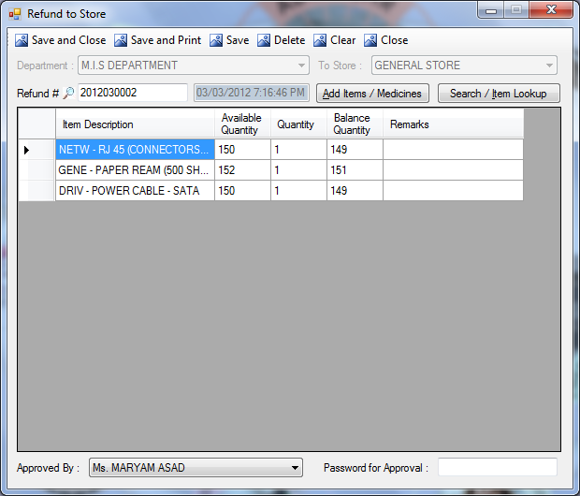
Description:
User can refund any goods/items to store for this purpose this screen is used by departments to refund the goods / items.
Functional Information
- To refund an item that item must be in stock. User can check the stock from Departmental Stock Screen.
- If item is issued and not received user has to receive the item before making the refund. To receive items use Good Receiving from store Screen.
- To make the refund of an item/Items click Add Item/Medicines Button. working of this button is shown in support screen of Add item/Medicines. This will show all the items available in the stock.
- Items will be populate as selected Store.
- User can search the item and add the quantity to refund.
- User can add one or more items in the grid.
- Once item is added in the grid Department and Store will be disabled it cannot be change.
- User can make single refund to single department and store only.
- Entered Quantity cannot be greater than available stock.
- To Send to Selected Store: User has to enter the Approval Password of Approval Person.
- User can add / Change the items if approval password is not entered.
- Once Approval Password is entered correctly upon saving it will be forwarded to store

REFUND RECEIVING
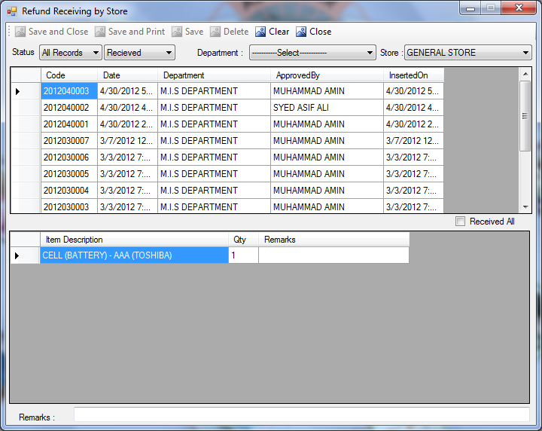
Description:
This screen is used by Stores to receive the goods which have been returned from any department.
Functional Information
- User will select the Status of the refund request from last 6-months, last 9-months and All Records.
- From the next combo, user will select the Status that either request is pending/received.
- User will select the Department from the Drop-down list.
- User will select the Store from the drop down list.
- If the request is pending then user will select the request and press the Save button.
- To receive all the refund items user can select Receive All checkbox.
- User will enter the receiving quantity, at the time of refund receiving.
- User can also enter the remarks on receiving good.

PURCHASE

REQUISITION CREATION
This screen is divided into following three tabs;
- New Requisition
- Return From Purchase
- Make Demand

New Requisition:
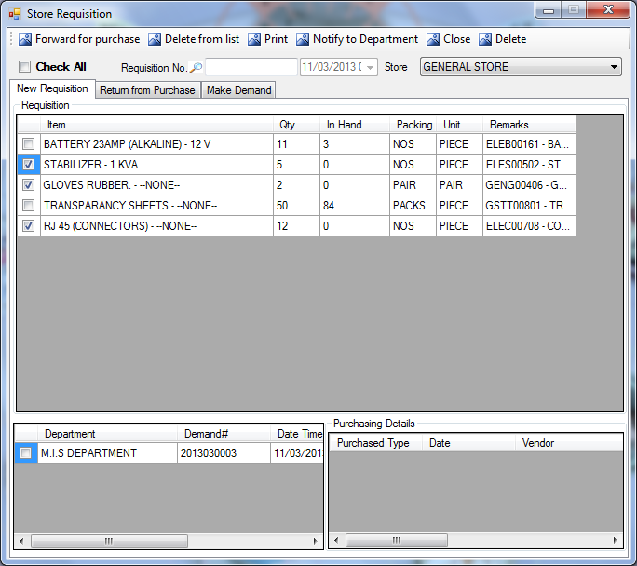
Description:
The item which are added to requisition by store or direct requisition created from Demand Screen will displayed in this screen.
Functional Information
- In this screen first grid is sorted item wise. And the departments who requested that item will be shown in second grid. By clicking on the item from 1st grid, user can view departments in the second grid.
- User will select the Store to filter the Requisitions.
- To forward an item for purchase, user will select the item from first grid and department from second grid by checking the checkboxes and then forward that item for purchase, by clicking the Forward For Purchase button.
- When requisition will forward for purchase then changes can’t be made in that requisition.
- The requisition number will be auto-generated, and the date will be automatically picked by the system.
- If store want from department to make changes in the demanded items, then it should Notify to Department. But the reason for notification is also needed by store.
- The third grid in the screen is showing the purchase history (i.e. vendor’s details, purchase type, date, qty, price etc) about that item.

Return From Purchase:
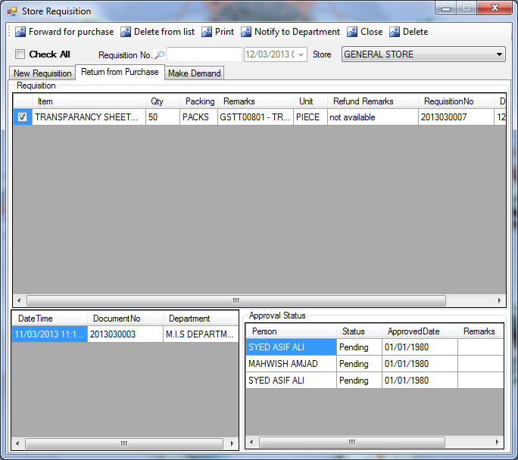
Description:
Those items which are return back to store from purchase will displayed in this screen.
Functional Information
- The first grid is displaying those Requisition which have been returned from purchase.
- In second grid(LHS) the Departmental Demand Details will displayed.
- Third grid is showing the Approval Status of requisition by all the approval authorities.
- The reason for sending back the demand will be displayed in Refund Remarks column.
- The demand with its refund remarks is then Notify to Department, to make changes in those items which can’t be purchase, for the given reason.
- To delete the item from list user will press Delete from List button.

Make Demand:
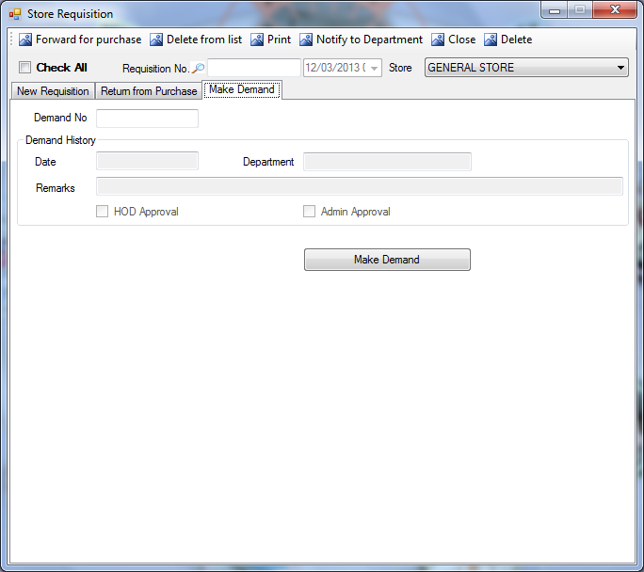
Description:
This screen is used to make a demand that unintentionally goes for requisition.
Functional Information
- User will enter the Date of that demand.
- User will enter the department.
- This screen will also display the status, that either your demand is approved by HOD and Admin or not.
- After entering the information user will press the Make Demand button, unique Demand No will be auto-generated and then system will then re-create that requisition, a demand.

REQUISITION CHECKING
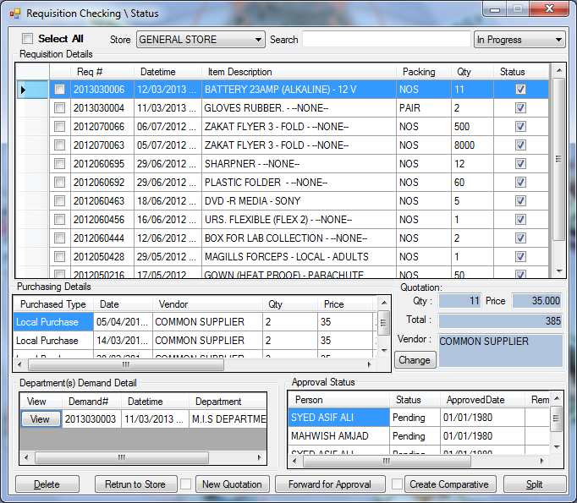
Description:
All requisition made by Store will displayed in this screen. User can view requisition status by this screen.
Functional Information
- To select all requisition user will check the Select All checkbox.
- User will select the Store from the drop-down menu.
- To search any requisition, type its item’s description in the Search field.
- To filter the requisition select the requisition status from combo(i.e. either the requisition is in progress or pending).
- By clicking any of requisition from the list, user can view its Purchasing Details (the previous details of the purchasing of selected item) and Quotation(the existing quotation of the item, user can also change the quotation of the item by pressing Change button).
- Last two grids will display the Department(s) Detail(user can view the multiple departments in the grid, who demanded the selected item) and Approval Status(the status of the different approval authorities).
- To view the report of the department demand details, user will press the view button in the Department Detail grid.
- No Quotations can be made for approved requisitions.
- After selecting a requisition from the list in the first grid user can perform all those actions which are defined on the buttons at the bottom of the screen.(i.e. Delete, Return to Store, New Quotation, Forward for Approval, Create Comparative and Split)
- To delete the requisition, user will press the Delete button.
- To return that requisition back to the store, user will press the Return to Store button, but those requisitions which are already send for approval cannot return back to store.
- To enter new rates of quotation user will press New Quotation button, this will pop-up the screen described in sec(New Quotation).
- To forward the selected requisition for approval from procurement manager, press Forward for Approval button.
- To create comparative statement press Create Comparative button, as described in sec(Create Comparative).
- If the free of cost(FOC) item is added in inventory then user have to split the whole quantity of items in cost and free of cost items. To divide the total quantity, press Split button.
Change:
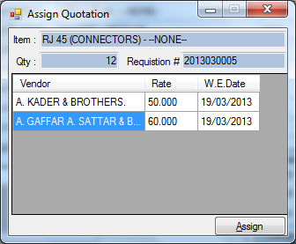

REQUISITION APPROVAL
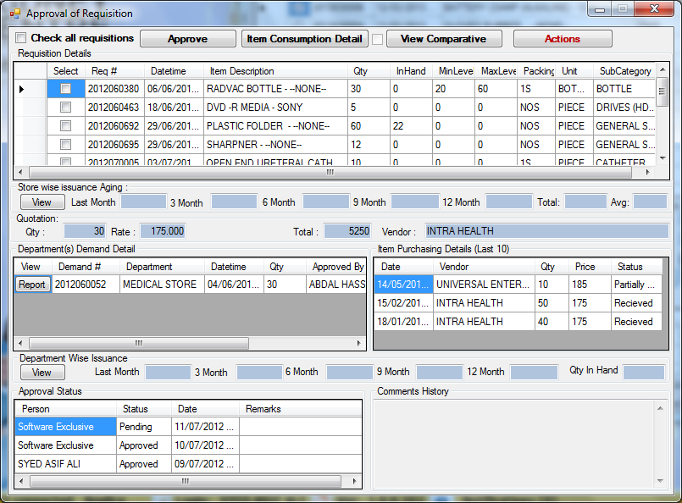
Description:
By this screen, approval authorities (i.e. procurement manager, procurement coordinator, finance manager and Administrator) can approve the requisition.
Functional Information
- To select all requisition user can check the Check All Requisition checkbox.
- To approve the requisition user will select the requisition from grid and click on the Approve button.
- To view consumption detail of the item, user will click on the Item Consumption Detail button.
- To view the comparative statement of the rates, click on View Comparative button.
- User can also perform few action, by clicking the Action button as shown in figure(Action).
- Requisition Details will displayed in the first grid.
- User can view the Store Wise Issuance Aging by clicking the View button.
- When user clicks any one of requisition then its Quotation details, Departmental Demand Details, Approval Status and Item Purchasing Details will displayed in their respective grids.
- User can also view the Department Wise Issuance Aging by clicking the View button.

PO GENERATION
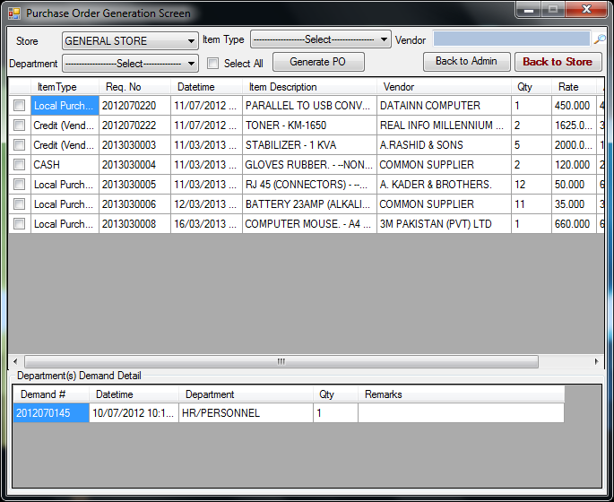
Description:
This screen is used to generate Purchase Order. Only approved requisition from all the approval authorities will be shown in this screen.
Functional Information
- To filter user’s respective requisition user can select the Store, Item Type and Department from the drop-down menus.
- To filter the POs vendor wise user will select the Vendor name from lookup screen (as shown in figure(suppliers list)).
- To select all requisition check the Select All checkbox.
- First grid will show the Requisition Details and second grid will display the Department Demand Details.
- Select the requisition from the list and press the Generate PO button, this will create the PO with its unique PO#.
- To send back the requisition to administrator for re-consideration, click on the Back to Admin button.
- User can also send the requisition back to store by pressing Back To Store button.
Supplier:
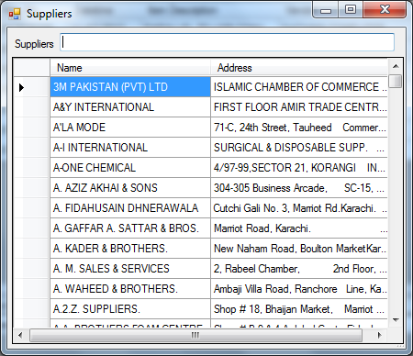

PO CREATION
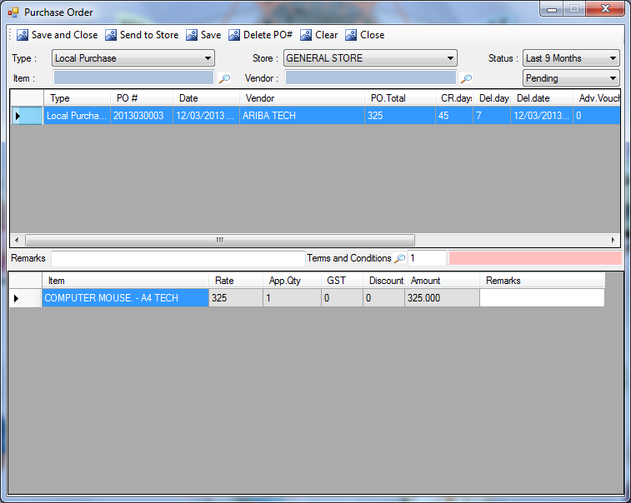
Description:
This screen is used to create PO. All the generated POs will displayed in this screen.
Functional Information
- To filter POs user will specify Type(local purchase, credit purchase vendor, Bank L/C), Store(from the list of all the stores), Status(9-month, 6-month,All records).
- User will select the Item from lookup screen.
- User will select the Vendor from lookup screen.
- User will select from the combo that either the PO is Pending or Send to Store.
- When user filtered his respective PO then for sending the PO to store user have to select the PO from first grid and press Send to Store button.
- Upon the selection of PO from first grid its item details will be displayed in second grid.
- User can also select the terms and conditions from lookup.
- User can enter the remarks (if any)
- And if user want to delete any purchase order then after selecting the PO click on the Delete PO# button.

PURCHASE ORDER(PO) STATUS
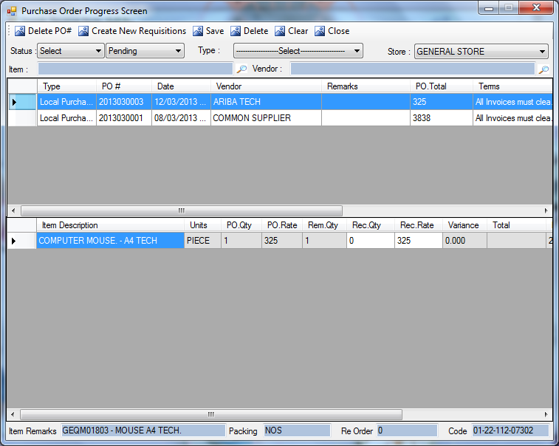
Description:
The PO which has been send to store will be displayed in this screen. This screen is used to view the current status/progress of the Purchase order.
Functional Information
- User can delete PO from this screen.
- User can create new Requisition.
- User can save the changes.
- User can clear all fields.
- To filter POs user have to specify Status(9-month, 6-month,All records) and form the next combo select the Received Status(i.e. pending, received, partially received), Type(local purchase, credit purchase vendor, Bank L/C), Store(from the list of all the stores).
- Enter the Vendor Name and Item description for further filtration or press F11 for lookup screen.
- PO will displayed in first grid and item’s detail will displayed in second grid.
- After selecting the items the remarks about that item in the text field placed at the bottom of the screen.

CREATE VENDOR/ITEMWISE QUOTATION
This screen contains following three tabs;
- Item Wise
- Vendor Wise
- Sending for Approval
Item Wise:
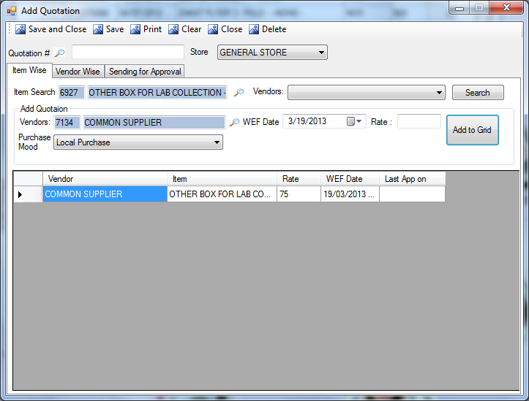
Description:
This screen is used to create new quotations for the items (item wise).
Functional Information
- To filter the items user will select the Store from Drop-Down menu.
- User will select the description of the item from lookup screen as shown in figure(Item Searching).
- User will select the vendors from drop-down.
- If the quotation is already made, then user will press Search button to show the details in the grid.
- To add new quotation user will select the name of the vendor from lookup screen as shown in figure(Supplier).
- User will select WEF(With effective from) date, means the new rates will be effective from the date given.
- User will enter the rates of the products provided by suppliers.
- User will select the Mode of Purchase from Drop-Down menu.
- By pressing Add to Grid button, new quotation will be displayed in the grid.
- When user save the quotation it will then displayed in Sending for Approval tab.
- Unique Quotation# will be generated upon saving the record.
Vendor Wise:
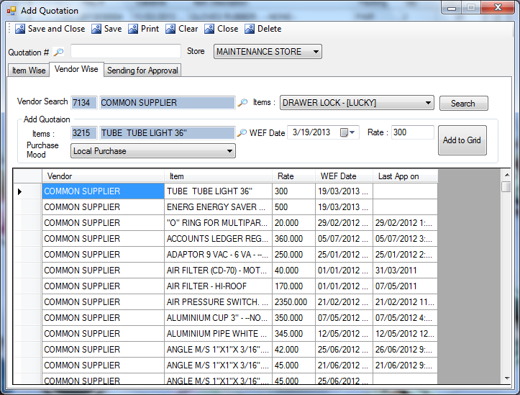
Description:
This screen is used to create new quotations for the items(vendor wise).
Functional Information
- To filter the items user will select the Store from Drop-Down menu.
- User will enter the name of the vendor or press F11 for lookup screen as shown in figure(Supplier).
- If the quotation for that vendor is already made then the items will displayed in the Items Drop-Down menu, user can select items from there.
- User will press Search button after entering the data, this will display the items in the grid.
- To add new quotation user will select the description of the item from lookup screen as shown in figure(Item Searching).
- User will select WEF(With effective from) date, means the new rates will be effective from the date given by the suppliers.
- User will enter the rates of the products provided by suppliers.
- User will enter the Mode of Purchase from Drop-Down menu.
- User will press Add to Grid button, then the new quotation will be displayed in the grid.
- When user save the quotation it will then displayed in Sending for Approval tab.
- Unique Quotation# will be generated upon saving the record

Sending For Approval:
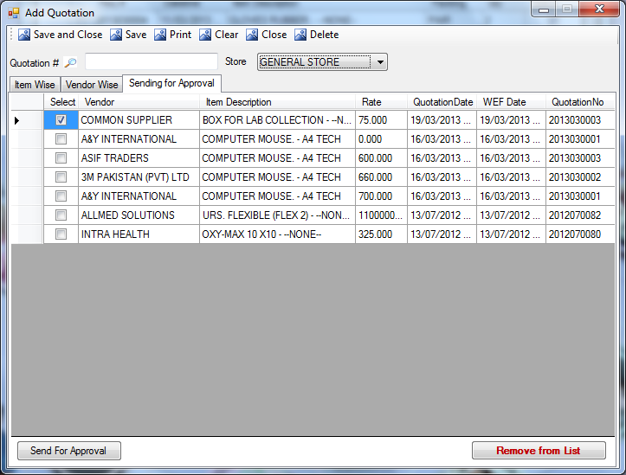
Description:
This screen is will displayed all the created quotations which are not yet send for an approval.
Functional Information
- To filter the items select the Store from Drop-Down menu.
- From the list of quotations, user can Remove the quotations by pressing Remove From List button.
- To send the quotation for approval, user will select the quotation from the list and press Send For Approval button.

QUOTATION APPROVAL SCREEN
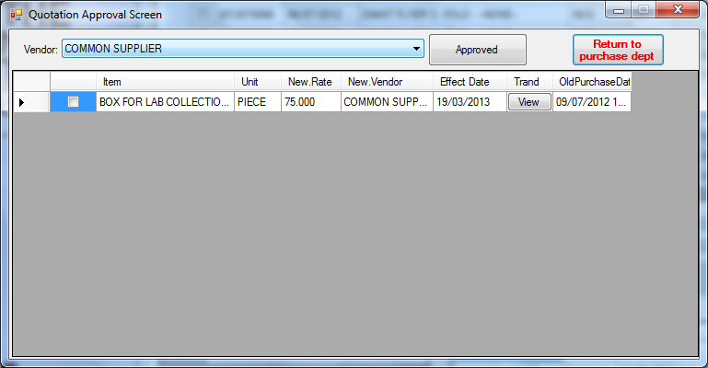
Description:
This screen will display all the quotations which had been send for approval. Quotations needs to get approved by procurement manager and administrator, therefore only these two persons have the rights to view this screen.
Functional Information
- To filter the quotations vendor wise, user will select the Vendor from Drop-Down menu.
- To return the quotation back to the purchase department, user will select the quotation and press Return To Purchase Department button.
- To view the purchase history, user will click the View button in the trend column of the grid.
- If user want to approve the quotation then after selecting that quotation, click on the Approved button.
- Once the quotation get approved, it will not display in this screen any more.

COMPARATIVE CREATION SCREEN
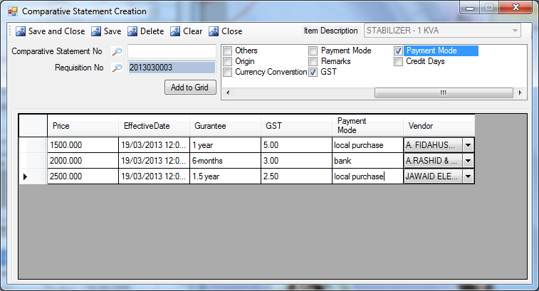
Description:
This screen is will displayed all the quotations which are created for a particular item. A comparative of those quotation will be created and approval authorities will compare the details of the vendors and then approve the best from all.
Functional Information
- User will enter the requisition number or press F11 for lookup screen.
- By pressing Enter user will be able to view the created quotations.
- To enter more columns in the requisition table, user will select the fields from the list displayed at right-top of the screen, and after selection, user will press Add to Grid button.
- User have to enter the data in the added columns manually.
- After adding data, press Save button, unique Comparative Statement No will be auto-generated and comparative will be forward for approval.

COMPARATIVE APPROVAL SCREEN
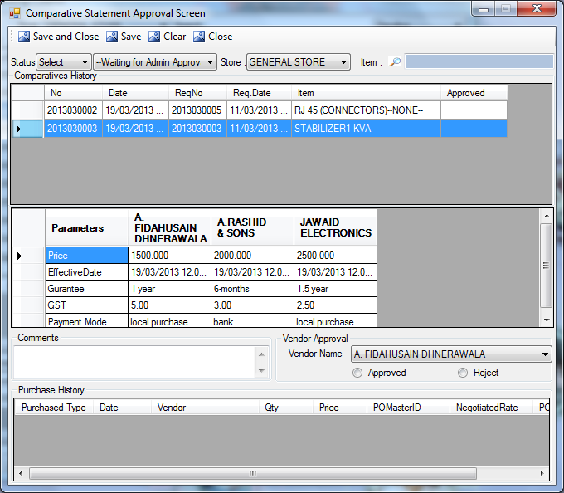
Description:
This screen will use by approval authorities to approve the comparative statements.
Functional Information
- To filter the status user will select the period(by month) from the status, and select the approval that either comparative statement is waiting for admin approval or approved by admin.
- For further filtration, user will select the store from the drop down menu, and select the item description from lookup screen as shown in figure(Item Searching)
- First grid will display the comparatives history, and the second grid will display the details of the vendors/suppliers.
- User can view and compare the details of the vendors.
- If the item is purchased before by the same vendor then the purchase history will b displayed in the last grid.
- User will select the vendor from drop down menu, and then approve or reject the vendors by the selecting any one of radio buttons.
- User can add comments for approval or rejection.
- After approval / rejection the user will save the comparative statement.
- First grid will display all the GRN, when user clicks on the GRN its item detail will be displayed in the second grid.
- To receive the items individually user will check the Receive textbox, user can also receive all the items by a single checkbox of Receive All.
- After the selection of received items, user will press save button, this will save the receiving note of the items.

STORE TRANSACTION

GRN CREATION (VENDORS)
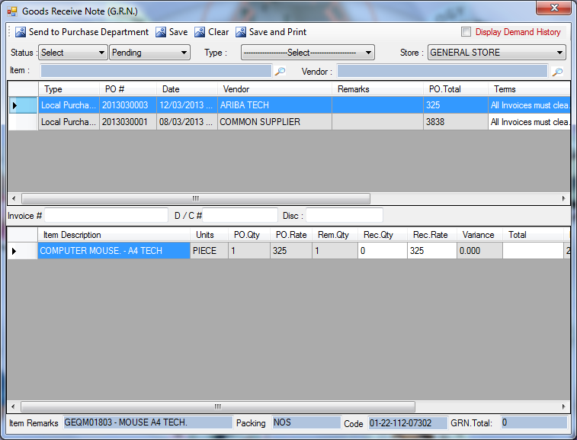
Description:
This screen is used create the good receiving note. All the PO, which are not received till now will displayed in this screen.
Functional Information
- To filter GRN user have to specify Status(9-month, 6-month,All records) and form the next combo select the Received Status(i.e. pending, received, partially received), Type(local purchase, credit purchase vendor, Bank L/C), Store(from the list of all the stores).
- User will select the Vendor Name and Item description by pressing F11 for lookup screen.
- If user received the approved quantity, then user have to write the number of item received in Rec. Qty. And invoice#, D/C#(Delivery Challan number) of the item, and discount(if available) then save the G.R.N.
- After saving the GRN (by pressing save button), the record will be saved and it will no more displayed in this screen.
- User can also send the GRN to purchase department.

GRN FORWARD/UPDATE
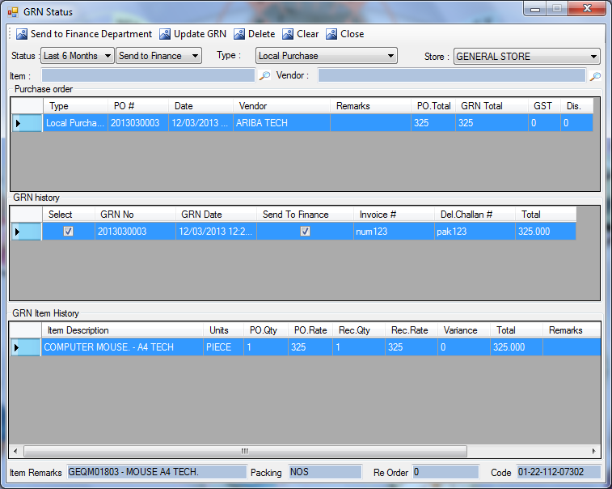
Description:
This screen will display the Status of the GRN.
Functional Information
- User will enter the Status(i.e. Last 6-Months, Last 9-Months, All Records) to filter the GRN.
- From the next combo user will select from drop-down menu that your goods are Partially Received, Received or Send to Finance.
- From Type Drop-down menu user will select the type of the vendor (i.e. Bank L/C, Credit(Vendor Purchase), Local Purchase).
- User will select the Store from Drop-Down menu.
- For further filtration user will enter name of the Item and Vendor, by pressing F11 for lookup screen for item and vendor.
- First grid will display the PO details, Second grid will display the GRN history, and the third grid will display the GRN Item History. Remarks about item will displayed in the text fields placed at the bottom of the screen.

VARIANCE APPROVAL
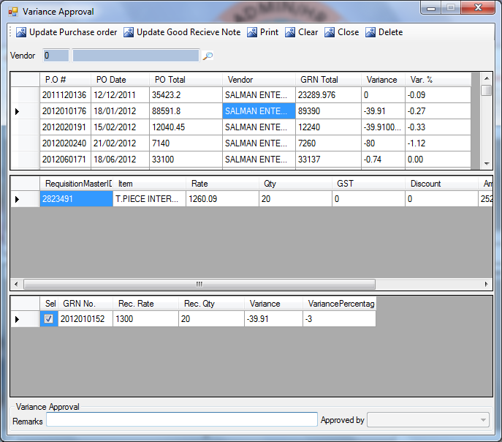
Description:
This screen is used to approve the variance, which is calculated when the received rate of the GRN is exceeded some fixed percentage with the original rates.
Functional Information
- User will select the vendor from lookup, this will filter the GRN/PO vendor-wise.
- First grid will display the list of all the GRN/PO in which variance approval is required.
- Upon the selection of any GRN/PO from the grid its item details can be viewed in the second grid. And GRN details will be viewed from third grid.
- To approve the GRN/PO user will select the PO from first grid and press Update Purchase Order button. For GRN approval user will press Update Good Receiving Note button.

GOODS RETURN NOTE (VENDOR-LOCAL)
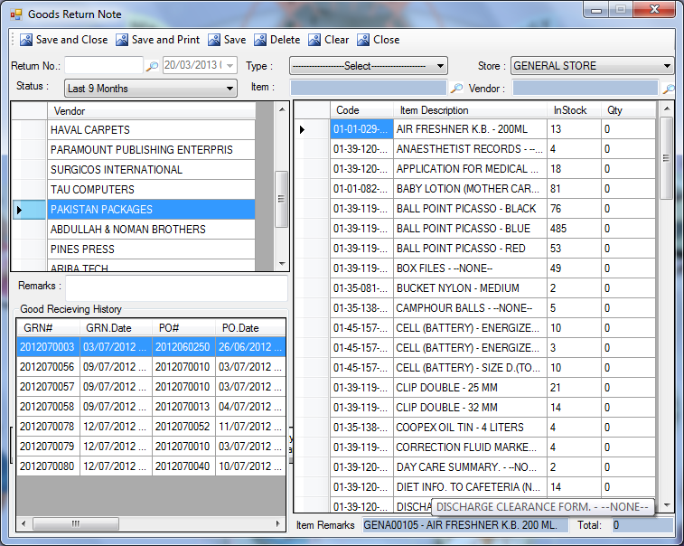
Description:
This screen is used by stores to return defective goods to supplier.
Functional Information
- For filtration user have to select the Type of purchase(local purchase, Bank L/C or Credit(Vendor Purchase)), Store, and Status(last 6-months, last 9-months, All Records) from Drop-Down list.
- User will select the Item’s Description by pressing F11 for lookup screen.
- User will select the vendor’s Name by pressing F11 for lookup screen.
- The first grid at the left side displayed the Vendor’s names.
- The second grid will display the Good’s Receiving History of the selected vendors from first grid.
- The third grid on right side will display the list of items purchased from selected vendors.
- The remarks of the selected item will be displayed at the bottom of the screen.
- To return an item user have to select the item and type its return quantity in Qty column.
- User can also enter remarks (if any) for returning the good.
- To complete the process of returning, the user have to press Save button on the top of the screen. Then the record of goods return will be saved successfully.
- Date will be automatically picked by the system, at the time of saving the record.
- User have to type Return No. Or press F11 for lookup screen to view/update/delete the previous return notes.

GRN FINANCE
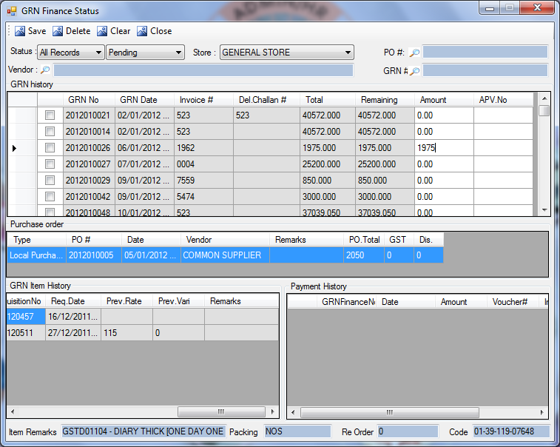
Description:
This screen is used to display the finance status of the GRN. Those GRN which have been forward to finance department will displayed in this screen.
Functional Information
- Unpaid GRNs will displayed in this screen.
- User will select the Status(i.e. Last 6-Months, Last 9-Months, All Records) to filter the GRN.
- In the next combo user will select from drop-down menu that user’s item status is Pending/Paid.
- User will select Store from Drop-Down menu.
- For further filtration user will select the name of the Vendor, PO# and GRN#, by pressing F11 for lookup Screens.
- First grid is displaying all the paid/pending GRN, according to the selected status. Upon selecting any of the GRN from first grid its details can be viewed in all the other grids, i.e. second grid is displaying the PO details, third grid(LHS) is displaying the GRN history, and the payment history can be viewed in the last grid.
- When the user is going to pay the bill to supplier, then after selecting that GRN from first grid he have to enter the amount in the Amount column.
- And press save, it will make the remaining amount equal to zero and then your paid GRN will not displayed again in this screen any more. It will then displayed in Paid GRNs in GRN status screen.

STOCK RE-ORDER SCREEN
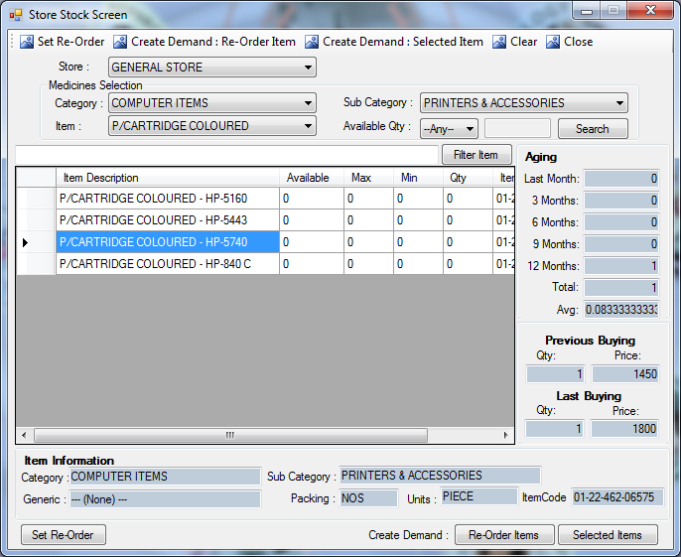
Description:
This screen is used by stores to reorder the goods for store, or departments can also view the current status of goods in the store.
Functional Information:
- User will select the store from the Drop-down menu.
- User will select the Category, Sub-category and item’s name/description from the Drop-Down menu to filter the search for user’s respective item.
- Furthermore, user will select the operational operator in available quantity field and enter the numeric value in the next textbox for comparison for available quantity(e.g. select ‘=’ equal operator from the list and enter the value 0, then it will search those items which have available quantity equal to zero). Then user will click on Search button to view only the filtered items in the list.
- From the filtered items when user click on any one of the item then on the screen user can view that item’s details in item information section and its history in Aging section.
- For further filtration, user will enter the item description in the textbox and click on the Filter Item button.
- To set the reorder level for any item user will click on the item and enter re-order level in Min field and then by clicking Set Re-Order button, entered re-order levels will be set against an item.
- Store can make demand in two ways;
- Re-Order items: by clicking on this button the demands for those items will automatically generated which reach to or below by their re-order levels.
- Selected Items: Select the items from the list of items in the grid and press this button, this will create the demand for selected items.

CONSUMPTIONS

DEPARTMENTAL CONSUMPTION
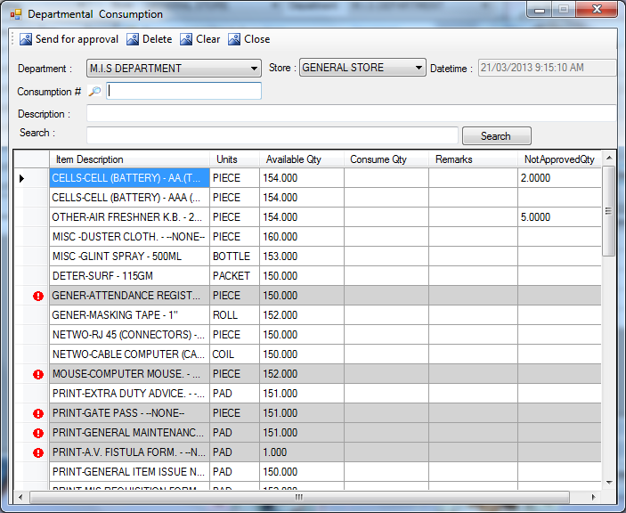
Description:
This screen is used by departments to view and request for approval of the consumed items in the department.
Functional Information
- User’s Department will be picked by the system, if user is assigned with multiple department then user will select the department from drop-down.
- User will select the Store from the Drop-down menu.
- Items available in the department will be populated in the grid according to the selected store, colored items in the grid are non-consumable items.
- To make new consumption;
- User will enter the quantity in consumed quantity column of the grid.
- Enter the Description of the consumed items.
- To filter the items from grid user have to enter the item’s description in the Search field, then press Search button to search user’s respective item.
- Then user will press save button, this will save the record by generating unique consumption#. And date/time will be picked by the system.
- Until the consumption is not approved it will not less the Available Qty from stock.
- User can view the consumed quantity batch wise by pressing F12. It will show the batch number of the current item selected.
- To open the document in update mode if it is not been approved yet, then user will enter the Consumption# or press F11 for lookup screen as shown in the following figure. User can edit the quantity, enter the remarks and then press save, the record will updated.
- Record can also get deleted if it is not been approved yet, user will select the consumption number from lookup, then user will press delete button, this will mark the record as deleted.
Consumption# lookup:
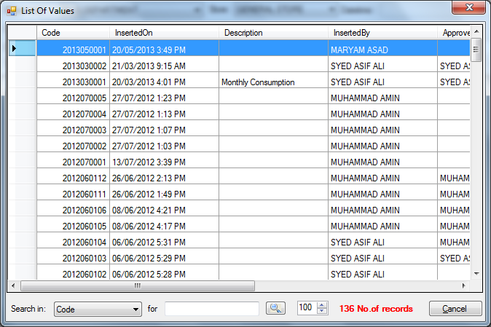
- Select the Search in column from Drop-Down menu.
- Enter the value of the selected column (e.g. enter the integer for Code of item).

APPROVAL SCREEN FOR DEPARTMENTAL CONSUMPTION
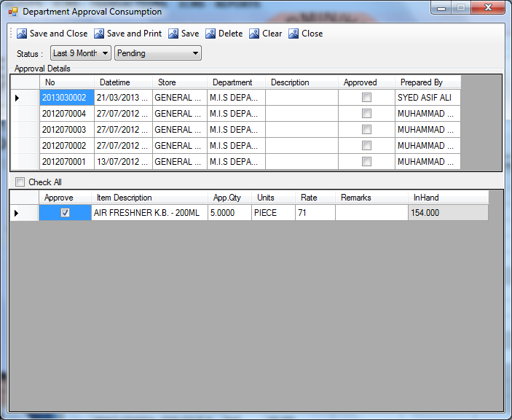
Description:
This screen is used by departmental heads to approve the departmental consumption.
Functional Information
- User will select the Status by month from the first combo(last 2-months, last 6-months, last 9-months, All Records).
- User will select the receiving Status(i.e. Pending, Approved).
- First grid will display all the non-approved consumption from department according to the selected status.
- The approved consumption will be marked as approved in the first grid.
- When user select any consumption from first grid, the item in the consumption will be displayed in the second grid.
- To approve the item, user will check the Approved checkbox and save the consumption.
- Upon pressing save it will generate the unique number, then the request will get approved by HOD.
- To view the approved consumptions, user will change the status from pending to approved.

PATIENT CONSUMPTION (DEPARTMENTAL)
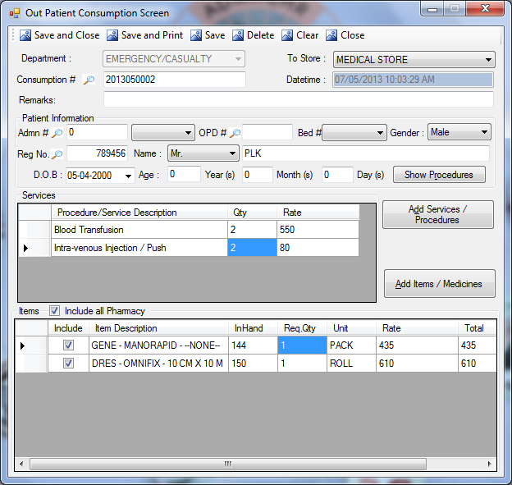
Description:
Some departments which consume their stocks on the patients of TKC are used this screen for making the consumption of the stock.
Functional Information
- System will select the Department of the user or user can also select the department from the assigned departments populated in the combo.
- Selected department will populate the services accordingly in Add Service/Procedure Button.
- Select the Store from the Drop-Down menu, selected store will populate the items accordingly in Add Items/Medicine Button.
- User will select the Admn# from lookup, all the other details will be picked by the system.( NOTE: procedures(services/medicine) can only be added for the admitted patients).
- User can view the given procedures to admitted patients by pressing Show Procedure button.
- User can add Services and Procedures by clicking Add Services/Procedure button. This will show the screen which is shown in figure(Add Services). All the added services will displayed in first grid
- To add the items or medicine user will press Add Items/Medicines button. This will display the screen shown in figure(Add Items). The added items will be displayed in the second grid.
- User can enter the quantity in the grid as well.
- Include Pharmacy: This check can only be viewed if the emergency department is selected from the departments, if this check is not checked then the pharmacy will not be included in the consumption i.e. some of the pharmacy is included in the services, user should exclude that pharmacy otherwise the service will be charged twice.
- User can save the consumption, by pressing save button. This will generate the unique number. And Date/Time will be automatically picked by the system, upon saving the record.
- If the consumption is not yet approved by HOD, then user will open the document in update mode by entering the consumption# or press F11 for lookup screen as shown in the following diagram. User will edit the Qty, add more services/ items or user can delete the existing one. Then by pressing save button, the record will get updated.
- To delete the record if it is not approved by HOD, user will select the consumption # from lookup and then press delete button, it will mark the record as delete.

Consumption# lookup:

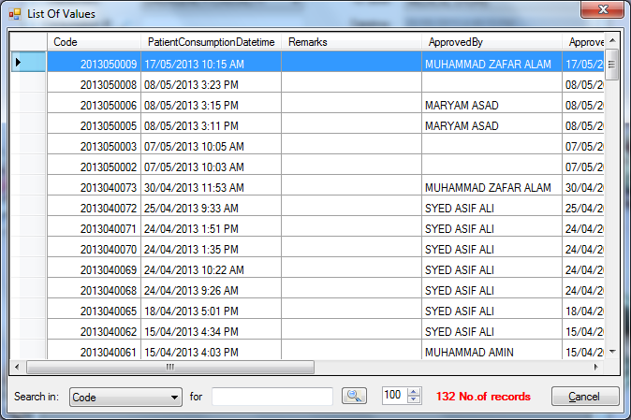
- Select the Search in column from Drop-Down menu.
- Enter the value of the selected column (e.g. enter the integer for Code of item).
Add Services:
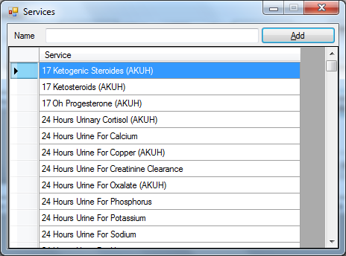

PATIENT CONSUMPTION (OT):
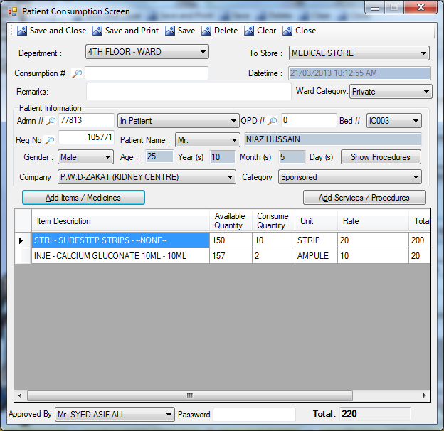
Description:
This screen is used by those departments which consume their stocks on the patients of TKC, usually used in OT.
Functional Information
- System will select the Department of the user or user can also select the department from the assigned departments populated in the combo.
- User will select the Store from the Drop-Down menu.
- User can enter the remarks about the patient.
- User will select the Admn# from lookup, all the other details will be picked by the system.
- User can add Services and Procedures by clicking Add Services/Procedure button. This will open the support screen which is shown in figure(Add ser/procedures). All the added services will displayed in grid
- To add the items or medicine user will press Add Items/Medicines button. This will display the screen shown in figure(Add Item). The added items will be displayed in the grid.
- User can enter the quantity in the grid as well.
- Approval person can enter the password in the same screen to approve the consumption, so it will less the quantity of items from departmental stock.
- User can save the consumption, by pressing save button. This will generate the unique consumption#, and Date/Time will be automatically picked by the system.
Add Services/Procedures:
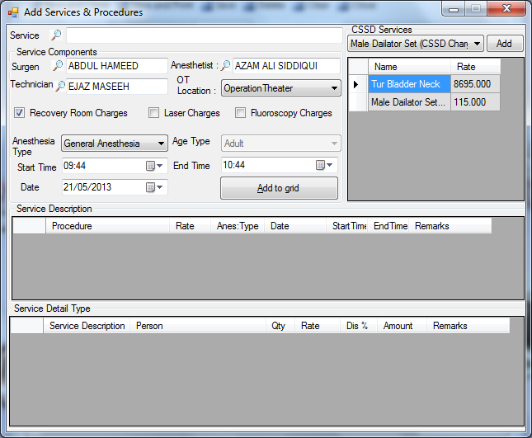
Functional Information
- Enter the services or press F11 for lookup screen which are shown in figure(add services).
- To add the C.S.S.D. Services, select the service from the drop-down menu, and press Add button. This will add the services in the grid.
- To add the Surgeon enter his name or press F11 for lookup screen as shown in figure(Surgeon).
- To add Anesthetist enter his name or Press F11 for look-up screen which is shown in figure(Anesthetist)
- To add Technician enter his name or Press F11 for look-up screen which is shown in figure(Technician)
- Select the OT Location i.e. from Operation Theater or Dressing Room.
- User will select other charges like Recover Room Charges, Laser Charges, Fluoroscopy Charges by checkboxes.
- User will select the Anesthesia Type i.e. from General Anesthesia / Local Anesthesia / Spinal Anesthesia.
- User will select the Start Time and End Time of the operation.
- User will select the Date of the operation.
- Then press the Add to Grid button, this will add the services in the grid.
Surgeon:
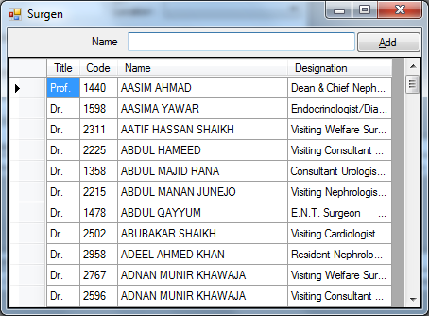

Anesthetist:

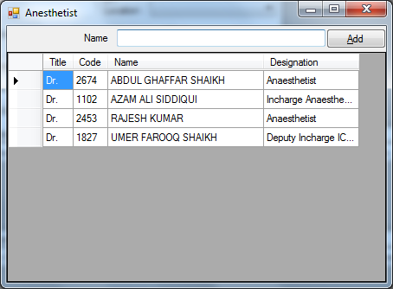

Technician:

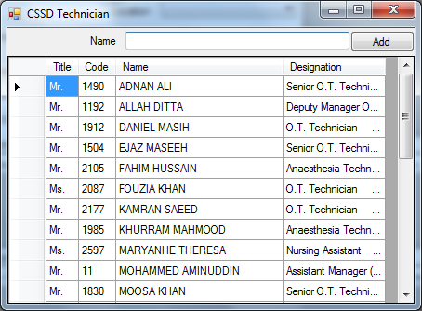

APPROVAL SCREEN FOR PATIENT CONSUMPTION
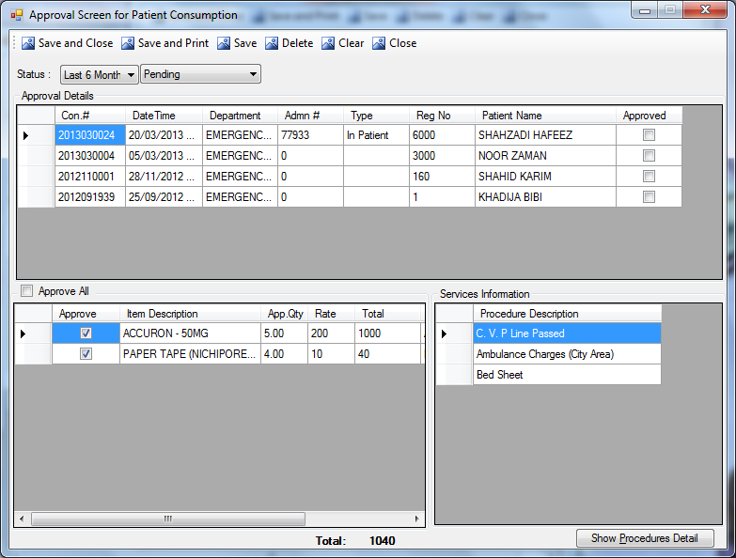
Description:
This screen is used by departmental head to approve the consumption of those departments which consume their stocks on patients. Approval authorities can approve the patient consumption at the time of creation of consumption or from this screen.
Functional Information
- User can select the Status month wise or by approval from the drop-down menu.
- The consumption will displayed in the first grid according to the selected status.
- When user select any field from the first grid, it will populate item detail and service details in second and third grid respectively.
- The approved consumption will be marked as approved in the first grid.
- To approve the consumption user have to select the consumption and press the Save button. It will generate the unique number.
- Then the consumption get approved by HOD and it will displayed when we select the status Approved instead of Pending.
- Once the approval is saved it will less the items from the departmental stock.
- The amount will be charged from patient.
- If the patient is discharged its patient consumption cannot be approved.
- User can view the procedures and services of the admitted patient by pressing Show Procedure button.

IN-PATIENTS (IDRs)

IDR CREATION (PHARMACY)
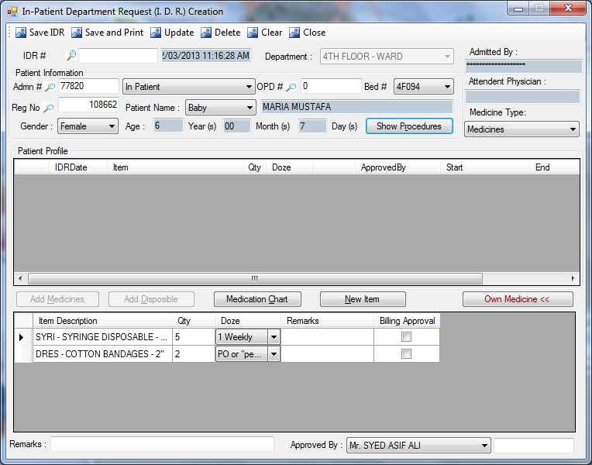
Description:
This screen is used for demand from pharmacy. This will need approval of departmental heads and doctors
Functional Information
- User will enter the patient information by entering Admission number, system will pick the rest of the patient information and also fill the Admitted by and Attendant Physician fields.
- User can also view the performed procedures/services on admitted patient by Show Procedures button, it will open the support screen of show procedures .
- First grid will display the history of the patient i.e. the medicines given to him.
- User have to select the Medicine Type from the Drop-Down list(i.e. medicine , disposable or All).
- To add medicine in the grid user will click the Add Medicine button. This will open the support screen as shown in figure(Add medicine)
- To add disposable in the grid user will click the Add Disposable button. This will open the support screen as shown in figure(Add Disposable)
- Added medicines/Disposables will be shown in grid.
- User can view the medication report of the patient by pressing Medication Chart button
- If user did not find his respective item in Add Item list then he can add New Items to add the items in the list. By pressing New Item button, it will open support screen as shown in figure(New Item).
- User can add the own medicine of the patient in the grid, by pressing Own Medicine. When user press the button Add Own Medicine it will open the screen which is shown in figure(New Item).
- User can add the Remarks against any request.
- User can select the approval person and enter the password in the same screen to send this Demand to Pharmacy, by pressing Save IDR button.
- If patient is discharged IDR cannot be created.
- If IDR is approved then it will Update the IDR but it must required a password from same screen.
- If the IDR is approved and it is issued as well it cannot be updated again.
- If items items/medicines are selected from 1st grid and if it is not approved then it will pick the IDR number and on save it will update the IDR.
- User can Add / Delete the items/medicines only from not approved medicines..
- If patient is discharged IDR cannot be created.
- Items that need billing approval will be highlighted, in the second grid.
New Item:
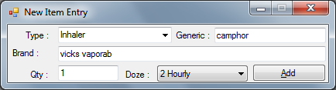
- User will select the type from combo(i.e. tablet, capsule, injection, inhaler etc).
- User can enter the Generic and Brand of the medicine.
- User can enter the quantity and doze, then press Add button, this will add the medicine in the main screen.

APPROVAL SCREEN FOR IDR
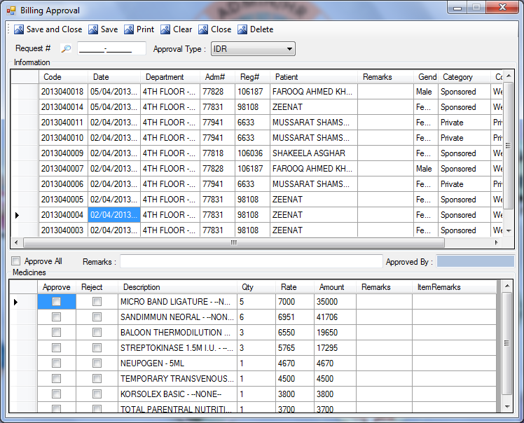
Description:
This screen is used by approval authorities to approve the IDR, Manual Services and OT service requests.
Functional Information
- User can select the approval type fro, combo. There are three types of approval;
- IDR: It is acronym of In-Patient Departmental Request, all the departmental requests of in-patients will be populated by selecting this option.
- Manual Services: manual services added in billing for final bill generation will get populated by selecting this option.
- OT Request: this option will populate all the OT requests of the patient.
- First grid will display all the requests according to the selected approval type.
- Upon selection of any request from the grid, its item details will be displayed in the second grid.
- User can approve or reject the request with the help of checkboxes.
- User can also select the Approve All checkbox, to approve all the items at once.
- User can also enter the remarks if any.
- Then by pressing save button IDR gets approved and the Request# will be auto-generated.
- When document opens in update mode user can view the name of the approval person in Approved By text box.

CHANGE APPROVAL PASSWORD
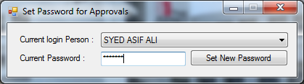
Description:
This screen is used to set new password for approval
Functional Information
- System will pick the current login person
- User will enter the new password.
- Then user will press Set New Password button. This will save the entered password and accepts the new(changed) password for approval.

REFUND OF IDR
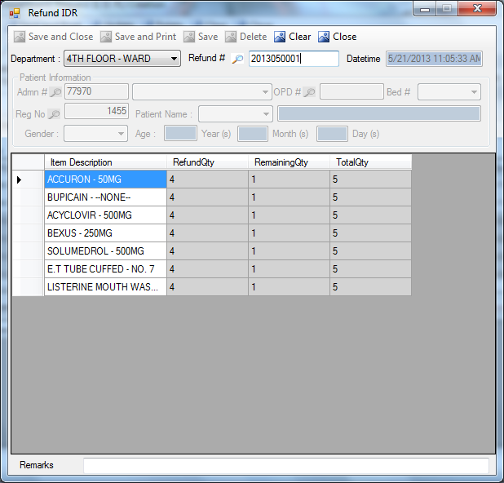
Description:
This screen will be used to refund the items to pharmacy.
Functional Information
- System will pick the user’s department but if user is assigned with multiple departments then user have to select the Department from combo.
- User will enter the Patient’s Information and then only Items related to entered patients will be populated in the grid.
- User can enter the remarks (Optional).
- User will enter the refund qty and save the record.
- On save a unique number will generate and items with qty will be available in Pharmacy.
- Once pharmacy received the items it cannot be updated.
- Upon receiving it will less the charges from patient by billing.
- User can refund the items batch wise on pressing button F12.
- If batches are not entered it will be refunded as FIFO system.

DOCTOR PRESCRIPTION

DOCTOR PRESCRIPTION
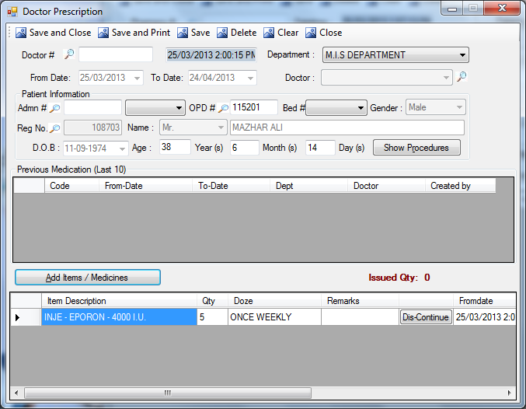
Description:
This screen is used by doctors to prescribe the medicines to the patients.
Functional Information
- User will select the department from the Drop-Down menu.
- User will select consultant name from the Doctor’s combo or he can also press F11 for lookup screen.
- From date and To date will display the interval of whole month from current date. Because doctors are use to prescribe the medicine for the whole month.
- User will enter the patient information by entering any number (Admission number or
OPD number or Select Bed or Registration number).
- It will show the Name, Gender, DOB, Age and Type of Patient fields.
- User can view the given services and procedures to admitted patients by pressing Show Procedure button.
- Last 10 medications of the selected patient will be displayed in the first grid.
- To add the medicine for registered patients press Add Items/Medicine button. This will open another support screen as shown in ref:1.
- After adding the medicine press save button. This will forward the prescription for approval.
- Doctor # will be generated automatically upon saving and Date/Time will be also picked by the system.

DOCTOR PRESCRIPTION APPROVAL
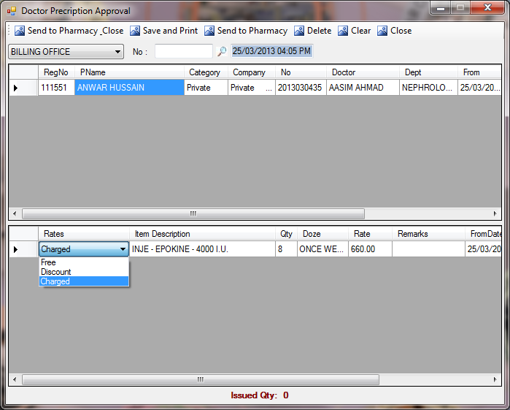
Description:
This screen is used by approval authorities to approve the Doctor’s prescription. All the prescription made by any department will get approved through this screen.
Functional Information
- If Billing Office is selected in department then user will view only private company patients.
- If PWD is selected from department then user will view sponsored patients.
- In case of PWD user will select the donation head from drop-down (i.e. from Charity, Donation, Sponsor a Patient, Zakat).
- User will select the Welfare Approval Type from drop-down. There are two types of welfare approval;
- Normal Approval: given to registered patients and then the bill will be created in bill creation screen.
- OPD Approval: is given to FC-Patients and then the bill will be created in consolidated bill creation screen.
- Filtered prescriptions according to the department will be displayed in first grid.
- User can view the item’s details in the second grid by clicking any prescription of the first grid.
- User can select the rate type from the Drop-Down menu according to the company of the patient. There are three types of rates;
- Free: Patients can take the free of cost medicines from the pharmacy.
- Discount: Patient will get fixed percent of discount on the selected medicines, as set in item rate policy setup.
- Charged: Patients will pay the whole amount of the medicines to the pharmacy.
- To approve the prescription, the approval authority will send the selected prescription to the pharmacy.
- Prescription number will be auto-generated, and Date/ Time will be picked by the system at the time of the saving of record.

PHARMACY

PHARMACY SALES
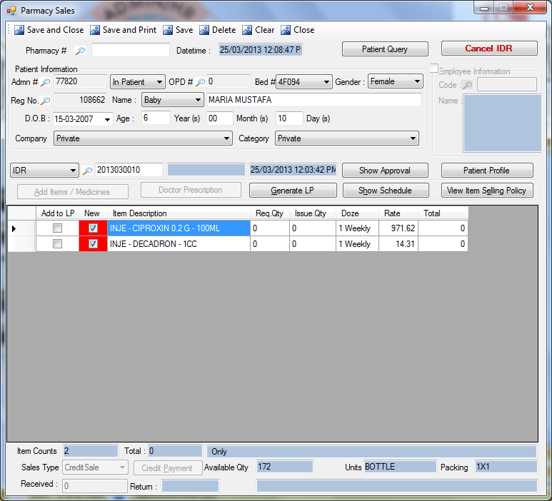
Description:
This screen is used by pharmacy to sale In-stock items.
Functional Information
This screen is a multifunctional screen. A detail working of this screen is mentioned as follows
- Pharmacy# will be auto-generated, and Date/Time will be automatically picked by the system at the time of saving the record.
- To view the details of the daily dosage given to a patient, user can press Patient Query button.
- User can cancel IDR by pressing Cancel IDR button.
- User will enter the patient information by entering any number (Admission number or
OPD number or Select Bed or Registration number).
- System will automatically pick the Name, Gender, DOB, Age ,Type of Patient, Company and Category fields.
- If user want to sell an item to an employee of TKC then he can enable the Employee Information by checking the checkbox. This will disable the patient’s information.
- User have to enter the employee code or press F11 for lookup screen, the name will be automatically picked by the system.
- User have three options to select the source;
- Doctor Number: some medicines needs doctor’s prescription to sell by pharmacy.
- IDR: the demanded items of In-Patient will be issued in IDR.
- No source type selected: when no source type selected, user can sell the general medicine(e.g. panadol) to out-patients and employees of TKC.
- Working of SOURCE TYPE combo
    - If patients information is entered i.e. Registration number, Admission number, Bed # and any of the following Source is selected it will displayed the related patient’s numbers on pressing F11 button.
    - If no patient information is entered and any of the following source is selected it will show all the record on pressing F11. It will then pick the patient’s information upon selecting the number.
- No Source Type Selected
- Sales type will be cash or credit.
- No prescription of Doctors is needed to sell these medicines.
- These medicines will be sell by pharmacy to the Out-patients and TKC’s employees.
- The items can be added by pressing Add Items/Medicines button.
- Doctor Number
- Sales type can be credit or cash.
- Doctors of TKC prescribed the medicines to patients can be entered in this field.
- It can be searched through F11 Screen.
- Medicines prescribed to the patient will be populated in the grid.
- Items will be add and get replaced generic wise if quantity is not available (Out-of-Stock).
- IDRs Number
- Sales type will be credit.
- In Patient Departmental Request Number (IDR #) can be entered in this field.
- It can be searched through F11 Screen.
- It will get all the information of Medicines.
- Items will not be added in IDRs they will just get replaced by pressing F11 as shown in figure(IDR replacement).
- Those items which are exceeded by fixed amount need billing approval. These items will not be sell by pharmacy until get the approval from billing.
To Add Items/Medicines:
- Items can only added if no source type is selected. To add the items or medicine user will press Add Items/Medicines button. This will display the screen shown in figure(Add Item). The added items will be displayed in the grid. (if any of the source is selected user cannot add / delete item). User can issue less than added quantity and user can also delete the selected items by pressing Delete from keyboard and re-add the item by same procedure.
- When user will enter the registration number of the patient who have free monthly approval, then after selecting Doctor from source type Doctor Prescription button will be enabled. User will view another support screen by pressing that button, this screen is shown in figure(Doc Prescription).
- While adding medicines their policy can be checked in the support screen by clicking View Item Selling Policy Button. It will show the selected items policy in Disable or (Read Only) Mode.
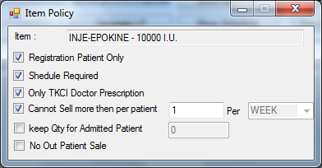
- User can view the report of the scheduling of the patient by pressing Show Schedule button, this can only viewed by pharmacy when the source type will be Doctor Number.
- If Source Type is IDR and department demanded the New Item, Pharmacy can issue the new item or its replacement if it is present in the stock (this can be view by pressing F11, after selecting an item), otherwise LP of Out-Stock item will be generated.
Working of LP Generate Button
- User can add the items to LP by marking items as LP then user can press the button Generate LP.
- This LP Generation can be done without saving the record.
- These Items will be appearing in LP Creation Screen for purchase.
- Upon receiving the items user can issue the items.
Note:-LP can be create only if the source type is IDRs and it can be created without saving the record. If record is already saved and particular item is fully issued It will not generate the LP of that item.
- By pressing add to LP it will mark the items and add the items in the LP order. Only items which are against IDR will be applied as LP.
- User will enter the Issue qty in the grid. On saving it will less the stock from the pharmacy. User can also issue the qty against Batch wise.
- It will show batch numbers of the current item selected.
- User can enter qty to issue for any batch.
- If items are not issued according to batch it will be issued FIFO wise.
- The total qty to issue will appear in Pharmacy screen.
- Batches with Qty in Hand not equals to 0 will be visible.
- User can view the profile of the In-patients by Patient Profile button.
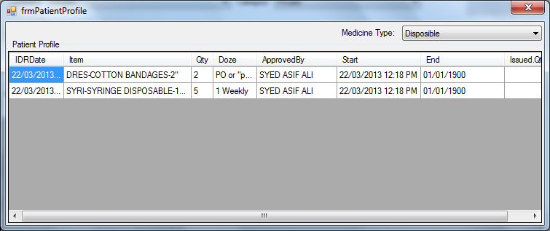
- The text fields at the bottom of the screen will display the added item’s details.
- User can select the Payment Mode by Sales Type combo.
- Sales Type Combo will display the following values;
- Cash Sales
If sales type will be cash Sales then user will collect the amount in cash.
- In this number Field will be disabled.
- User can leave all the fields of patient information and directly issue the medicines from the Add Items support screen.
- User have to type the Received amount and the Return will be calculate by the system

- Credit Sales
Only registered patients can pay the credit amount. If user selects Sales type as Credit Sales then Credit Payment button will be enabled. By clicking that button a new window of Credit Payment Receiving will open. Credit payment will have three modes;
- Cash Counter: to take the amount from cash conuter, user will note the voucher number.
- Credit Card: user have to enter the credit card number of the patient and expiry date.
- Cheque: user have to enter the cheque#,Cheque date,Bank name with its branch and city.
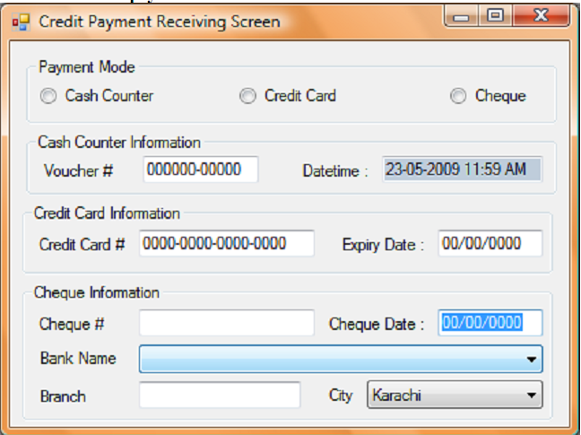
Doctor Prescription:
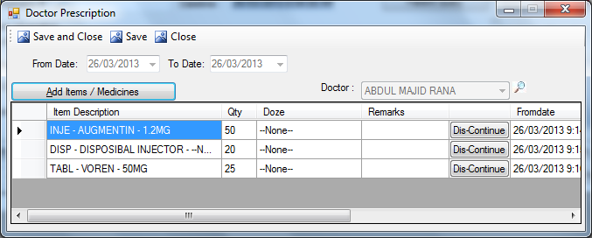
- This screen will be used to add items for Pharmacy Monthly registered patients.
- Date will be picked by the system.
- User will select the doctor from F11 lookup.
- To add medicine press Add Items / Medicine button, this will open support screen for add items.
- After adding items press Save button.
IDR item replacement lookup:
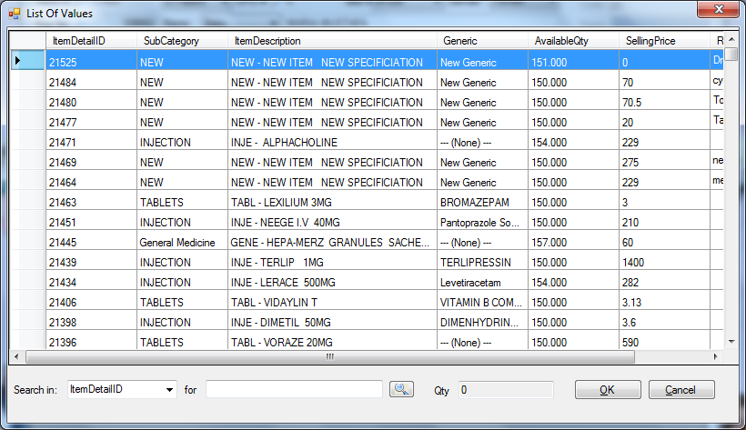
- User will select the search-in column, from the combo.
- User will enter the value for search-in column in the textbox(i.e. integer will be enter for ItemDetailID)

LP CREATION
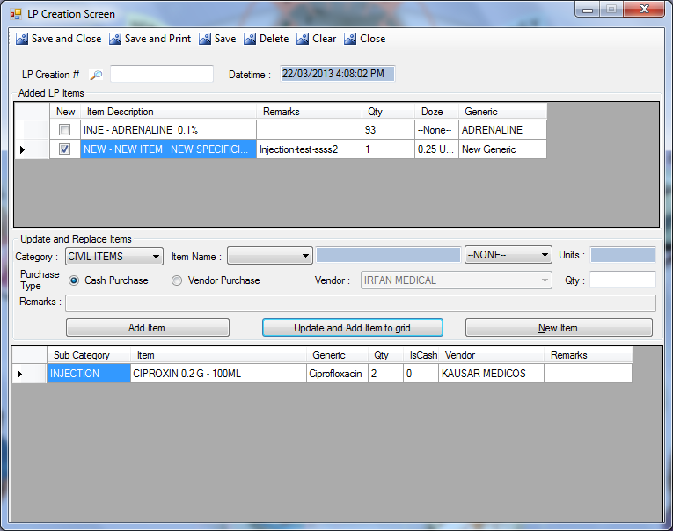
Description:
This screen is used to create LP(Local Purchase). When user press Generate LP from Pharmacy Sales Screen. selected items will be appeared in this screen.
Functional Information
- User can select the items from the first grid to create the LP.
- User will select the Category, item’s Name and its specification from the Drop-Down. The selected name will be displayed in the textbox. Units will displayed in Unit’s text field.
- User will enter the required qty. and select the purchase type. If purchase type is Vendor then user will select the vendor name from the Vendor Combo else it will treat as cash purchase.
- To add an item for local purchase user will press Add Item button, this will open another support screen shown in figure(Add Items). Added item’s details will be picked by the system in their respective fields.
- To add the selected item in the second grid user will press the Update and Add Item to Grid button.
- Once item’s details get updated, then on its receiving it will change the details of item in Pharmacy Sales screen.
- Local Purchase (LP) for only those items will be created which are present in the second grid.
- User can delete the items from the first grid anytime, it will not delete the item from the pharmacy sales screen.
- To add new item which is not present in the Add Item list then press New Item button. As shown in figure(New Item)
- After adding the desire items user will press save button.
- Upon pressing save button it will generate unique number, and save the current date and time also.
- Once the LP is created it will unmark LP from pharmacy and removed from this screen.

LP APPROVAL SCREEN
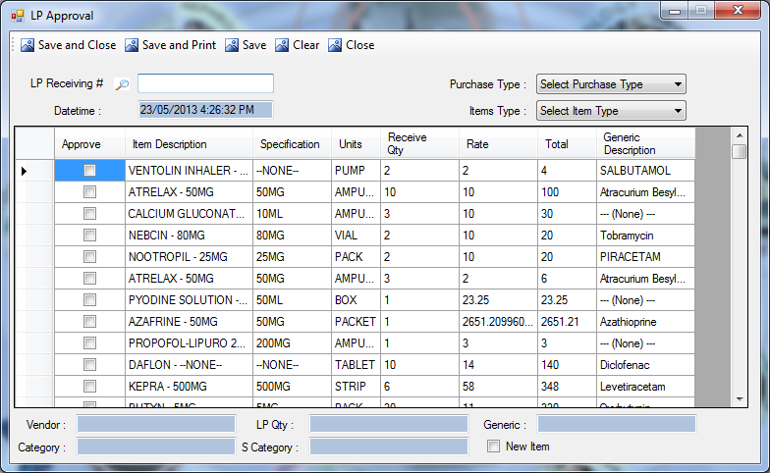
Description:
This screen is used to approve the LP(Local Purchase), created un Generate LP screen.
Functional Information
- User will select the Purchase Type and Item Type from combo.
- Unique LP Receiving# will be generated and date/time will be picked by the system upon saving the record.
- Grid is populated with all the generated LP’s, upon selection of any item, its details will populated in the textbox present at the bottom of the screen.
- User will select the item from the grid and after check the approve checkbox press the save button. This will approve the LP and user can view the received Qty in pharmacy sales screen.

LP RECEIVING
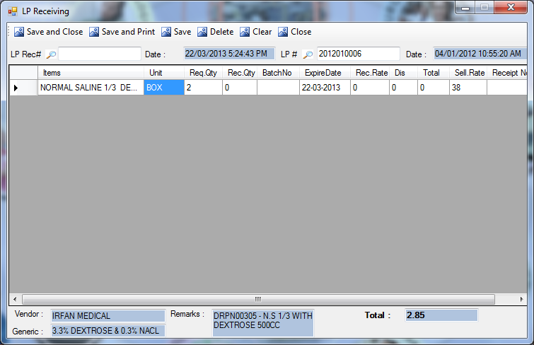
Description:
This screen will be used to receive the items against generated LP.
Functional Information
- User will enter the LP# or press F11 for lookup screen as shown in figure(LP#).
- The respective items against the LP number will be displayed in the grid.
- To receive the LP user have to enter the received quantity and Rate. Total will be calculated automatically.
- When user Select the items Its Vendor (If not Cash Item), remarks ,Generic of item and total amount will be displayed in the fields at the bottom of the screen.
Upon saving
- It will increase the stock of the pharmacy.
- It will generate a unique number of LP Receiving against creation.
- System will also pick the date/time of the document.

LP Number:
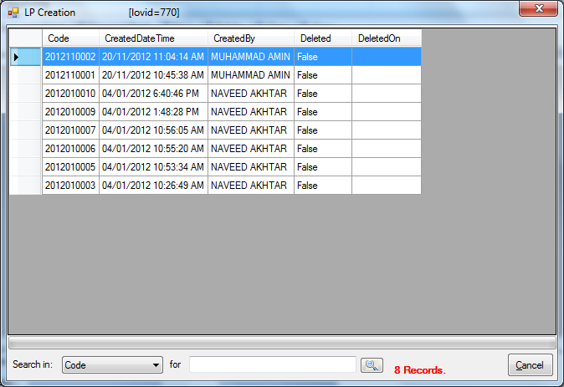

REFUND RECEIVING (PHARMACY)
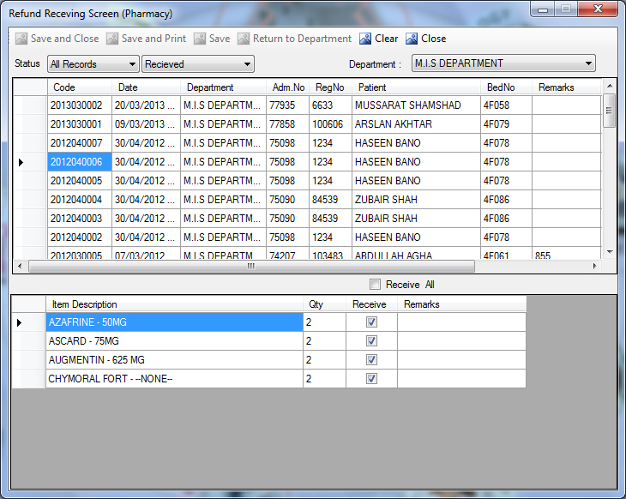
Description:
This screen will be used by pharmacy to received the refunded items.
Functional Information
- User will select the Status by month from the first combo(last 30-days, last 3-months, last 6-months, last 9-months, All Records).
- User will select the receiving Status(i.e. Pending, Received).
- User will select the Department from the Drop-Down menu.
- The filtered refund requests will be populated in the first grid.
- When user selects any field from the first grid, its item’s detail will be displayed in the second grid.
- User can receive an item by checking the checkboxes one by one or by checking Received All Checkbox.
- Then press the save button, it will generate the unique number.
- User can view the refunding items by changing the status from pending to received.
- When the items will received by pharmacy it will less the charges on patient at the time of billing.
- If items not received against batch wise Pharmacy will enter the Batch number and it enter the qty received.
- On receiving it will increase the Qty in Pharmacy Stock.

OTHER TRANSACTION SCREENS

MAINTENANCE REQUEST
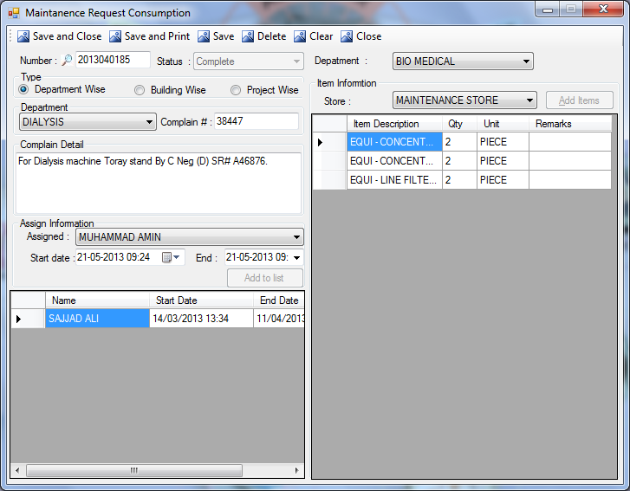
Description:
This screen is used by maintenance department, to write the complains/requests of any department.
Functional Information
- User will select the Department as assigned from combo.
- User will select the Type of consumption request(i.e. Department Wise, Building Wise, Project Wise) through radio buttons. If user select department wise then user have to select Department from combo and enter the complain #. If user select building wise then user have to select Location from combo. If user select project wise then user have to select project from combo.
- In Item Information section user will select the Store, then press Add Items button, to add the items in the grid, which maintenance department is going to consume on the selected department/location/project.
- User will write the details of the complain in Complain Detail grid.
- To add an employee of the selected department user will select the name of the employee from Drop-down menu and select the start and end date of the request, then press Add to List button. User can add multiple employees in the list.
- Number will be auto-generated, upon saving the record.
- After assignment of items to the person of one department change the Status from pending to complete and then Save the request.

MAINTENANCE ISSUANCE
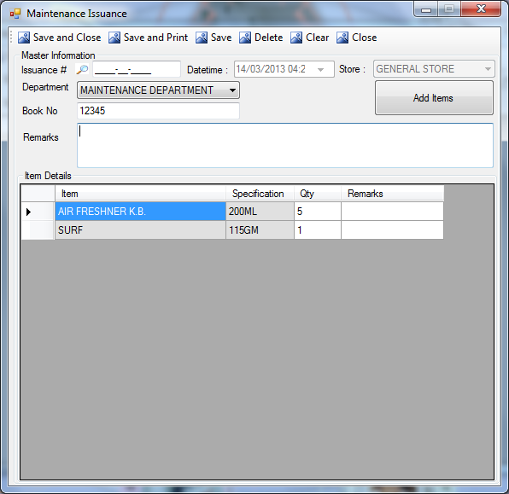
Description:
This screen is used to issue the items from general store to the other departments(like maintenance and bio-medical).
Functional Information
- System will select the current date/time, and store i.e. general store.
- User will select Departments i.e. either maintenance or bio-medical department.
- User will enter Book No from maintenance department’s register.
- To add the items in the list press Add Items button, this will open the support screen as shown in figure(add items). Added items will be displayed in Item Details grid.
- When user clicks on the save button then unique Issuance # will be generate automatically.

MAINTENANCE STOCK RECEIVING
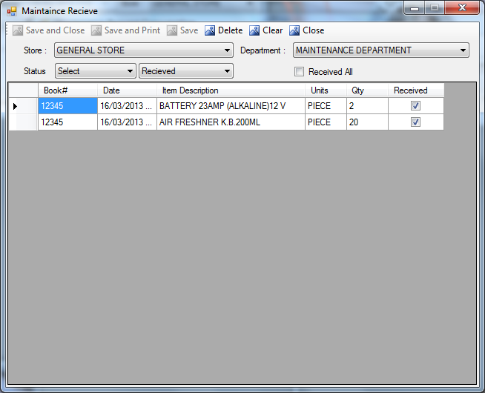
Description:
This screen is used to acknowledge the general store that the demanded items have been received, the maintenance issued items will displayed in this screen.
Functional Information
- User will select the Store, from the drop down menu.
- User will select the Department, which receives those items.
- To filter records user will select from Status(9-month, 6-month, All Records) and form the next combo user will select the received status(i.e. Pending/Received).
- Then in the grid user can view book#, Date, Item Description, Units, Qty(Quantity), Received.
- If user receives the item then in received column, after checking the checkboxes or by selecting Receive All checkbox
- Then user will press the save button on the top of the screen. After saving these received item will displayed if we select the received from the combo instead of pending.

UNIFORM ISSUANCE SCREEN
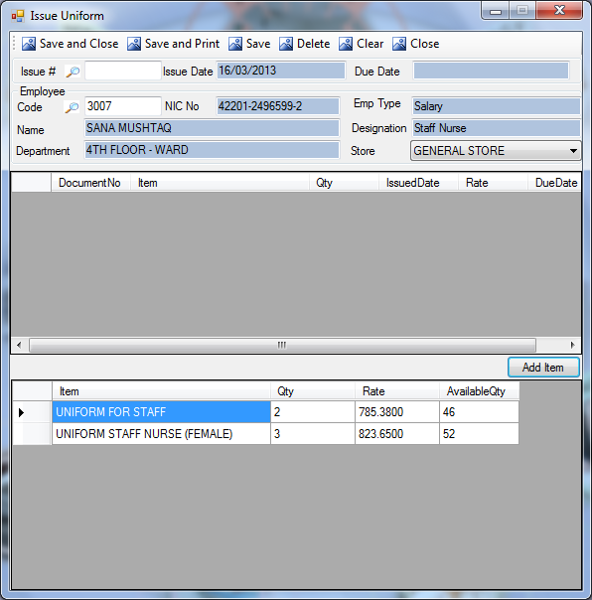
Description:
This screen is used to issue uniform to the employees who wear uniform in TKC.
Functional Information
- In the Issue Date field the current date will be picked by the system and user have to check Due Date before the issuance of uniform. Due date text field maintains the record of the employee, i.e. system calculates the due date of taking uniform from the last issuance of uniform.
- User will enter Employee Code, or press F11 for lookup screen.
- When user enter the code, the other details (i.e. NIC No, Name, Department, Emp Type, Designation) will be automatically picked by the system.
- User will select the Store (i.e. for the selection of uniform from items select the general store from stores).
- To add the items in the grid press Add Items button, this will open the support screen as shown in figure(add items).
- After adding the item user will press Save button this will generate unique Issue #.
- User will enter the Issue # or press F11 for lookup screen, for update/deletion of the record.

TKC-FORMULARY LIST
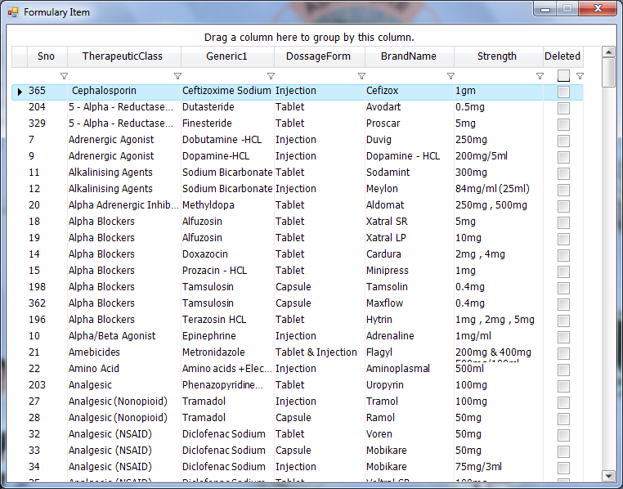
Description:
This screen will be used to display the formulary items as set in formulary item setup.
Functional Information
- User can view the items from this list of formulary items.
- User can view the details of each and every item as shown in the list.
- User can also group the items under any of the column headind by dragging the column at the top of the screen.

MATERIAL IN/OUT SCREEN
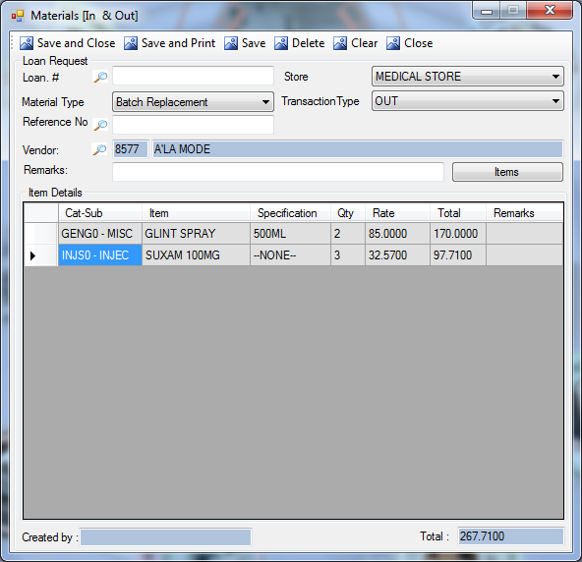
Description:
This screen is used to add/delete items from inventory.
Functional Information
- User will select the Store from the Drop-Down List.
- User will select the Material Type, there are following types of material for IN/OUT;
- Loan
- Batch Replacement
- Item Replacement
- Short Expiry
- User will select the Transaction Type (i.e. IN/OUT) from the Drop-Down menu.
- User will enter the Reference No for example to OUT the loan from the system, user will enter the IN loan# as reference.
- Type the Vendor’s Name or press F11 for lookup screen.
- Enter the Remarks for your transaction of any material.
- To add the items for replacement, press the Items button, this will open another support screen as shown in figure(Add Items).
- After adding all the items the total cost of items will displayed in the textbox at the bottom of the screen.
- To generate the record, press Save button, on the top of the screen.
- Type the Loan # or press F11 for lookup screen.

MATERIAL(IN & OUT) APPROVAL
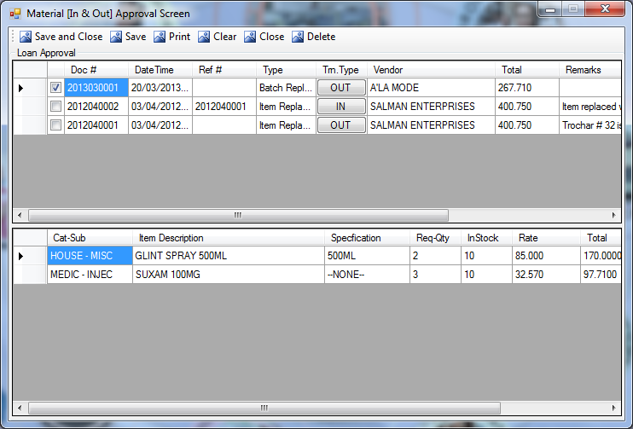
Description:
This screen is used by approval authorities to approve the request of material IN/OUT.
Functional Information
- First grid will display the material IN/OUT requests details.
- User will select any request its items will displayed in the second grid.
- To approve the material IN/OUT request, user have to select the request and press the save button from the top of the screen, then the request will be approved.

DONATION RECEIVING
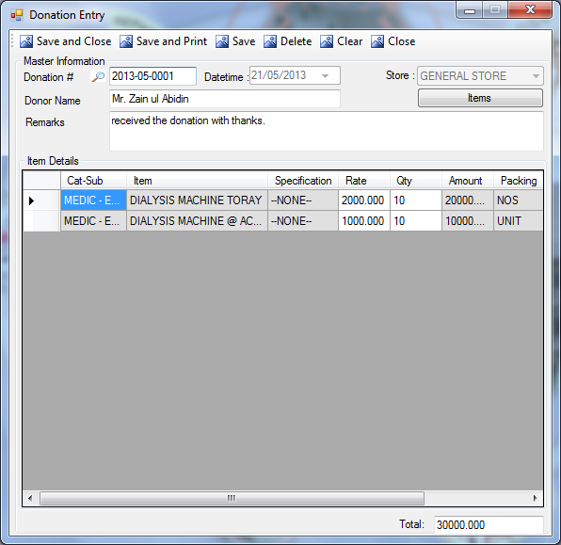
Description:
This screen is used by Stores to receive the donations.
Functional Information
- User will select the Store from the combo.
- User will enter the name of the donor.
- User will enter the remarks (optional).
- To select the Item form the support screen, user will press Items button, this will open the support screen as shown in figure(add items). Added items will be displayed in the grid.
- User will enter the rate of the added items and the Total field at the bottom of the screen will display the Total Amount.
- By pressing save button unique Donation# will be generated and date will be picked by the system.
- User can open the document in update mode only if the document is not approved.

DONATION APPROVAL
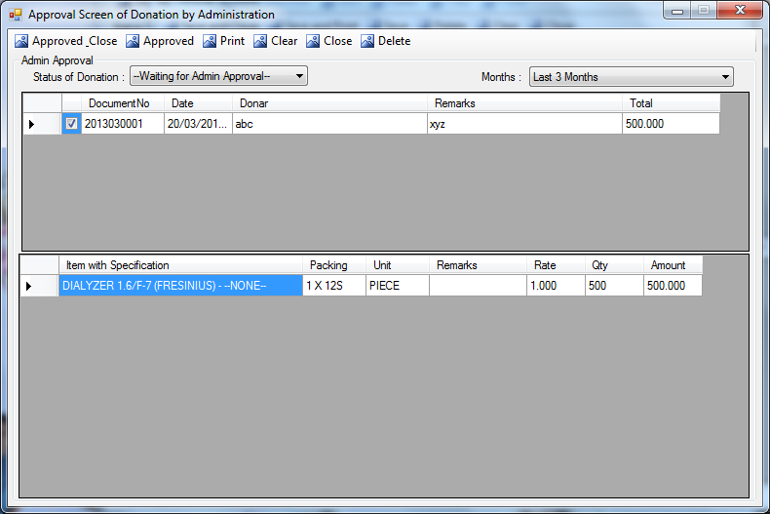
Description:
This screen is used by approval authorities to approve the donation.
Functional Information
- To filter approval wise select the Status of Donation(i.e. either Waiting for Admin Approval or Approved by Admin).
- To filter month wise select the Months from Last 3 Months, Last 6 Months, Last 9 Months and All Records.
- If user select any donation from the first grid then second grid will display the item’s details.
- To approve the donation user have to select the donation and press Approved button at the top of the screen.

C.S.S.D.

PACK CREATION
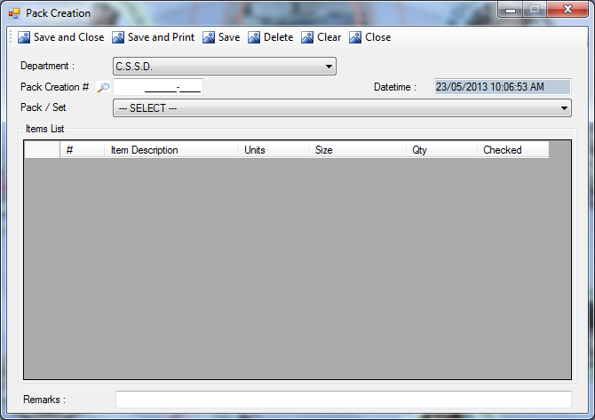
Description:
This screen is used to create the packing for the Pack/Sets in a system. These packets will then requested by different Department.
Functional Information
- User will select the Department from the combo, this combo is populated with the departments who create packets in TKC.
- User will select the created Pack/Set from the combo, the values in this combo will be set in pack setup.
- Item details of the selected pack/set will be displayed in the grid.
- User can also add remarks (if any).
- Unique Pack Creation # will be auto-generated, and Date/time will be picked by the system, upon saving the record.

LOAD SETUP
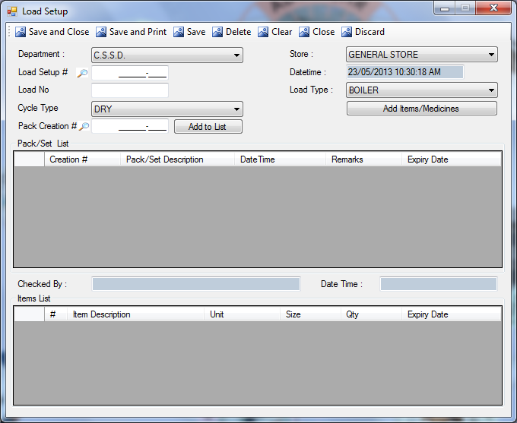
Description:
This screen is used to load the created packs/sets.
Functional Information
- User will select the Department from the combo, this combo is populated with the departments who create packets in TKC.
- User will select the Store from the combo.
- User will enter the load NO. in the text field.
- User will select the select the load type from combo, this combo is populated with the values as saved in load type setup.
- User will select the select the cycle type from combo, this combo is populated with the values as saved in cycle type setup.
- To add the items in the grid user will press Add Items/Medicine button, this will open another support screen as shown in figure(Add Items)
- User will select the pack creation number from lookup, this lookup will display the values as saved in pack creation screen. Items of the selected document will be displayed in pack/set grid. Item details will be displayed in the second grid.
- The name of the person who checked the package will be displayed in Checked By text field, and Date/Time of the document will be picked by the system.
- Unique Load Setup # will be auto-generated, and Date/time will be picked by the system, upon saving the record.

PERSONAL REQUEST
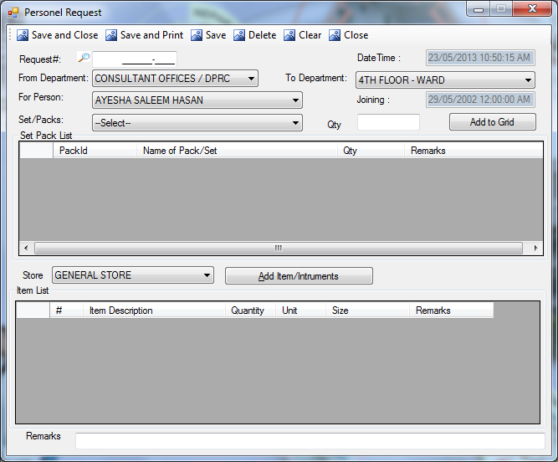
Description:
This screen is used by employees who want to make the personal request to the departments for the CSSD instruments.
Functional Information
- User will select his department from combo of From Department.
- User will select the Department from the combo of To Department, this combo is populated with the departments who create packets in TKC.
- User will select the person of the selected department from combo, system will pick the joining date of the selected department.
- User will select the Set/Packs from the combo.
- User will enter the Quantity and press Add to Grid button, this will add the item in the first grid.
- To add the items in the second grid, user will select the store from the combo, and press Add Item/Instrument button, this will open another support screen as described in figure(Add Items). All the added items will be displayed in the second grid.
- User can also add the remarks (if any).
- Unique Request # will be auto-generated, and Date/time will be picked by the system, upon saving the record.

PERSONAL ISSUANCE
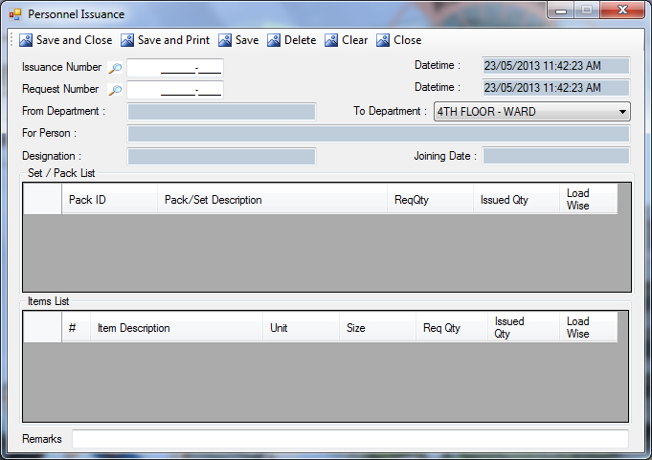
Description:
This screen is used to issue the items against personnel request.
Functional Information
- User will select the Request number from the lookup, which is populated with the values which are saved in patient request screen.
- Upon selection of the document from lookup, system will pick the information of the department, name , designation and joining date of the person who requested the CSSD items.
- System will pick the set/pack’s details and item details in the respective grids.
- User can also add remarks (if any)
- Unique Issuance Number will be auto-generated, and Date/time will be picked by the system, upon saving the record.

PATIENT/DEPARTMENTAL REQUEST
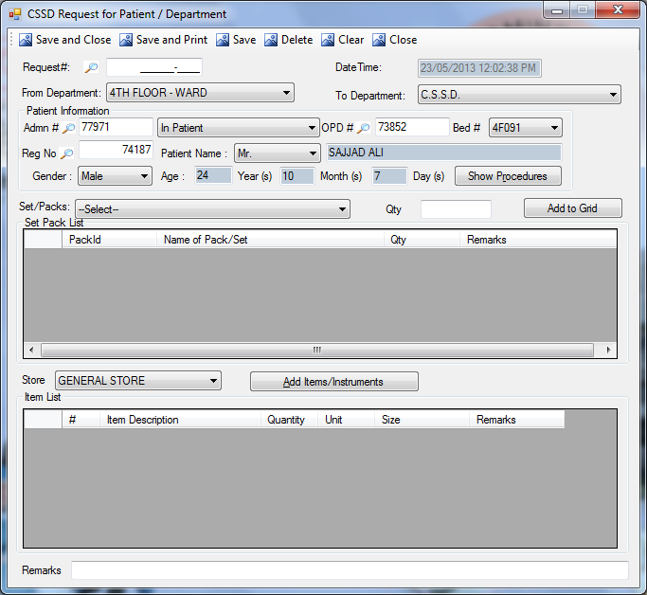
Description:
This screen is used to make the patient/departmental request to the departments for the CSSD instruments.
Functional Information
- User will select his department from combo of From Department.
- User will select the Department from the combo of To Department, this combo is populated with the departments who create packets in TKC.
- User will enter the patient information if the request is made specifically for patient, for this user will enter the admn#, or Reg# or OPD#, system will pick all the rest of the information automatically.
- User will select the Set/Packs from the combo.
- User will enter the Quantity and press Add to Grid button, this will add the item in the first grid.
- To add the items in the second grid, user will select the store from the combo, and press Add Item/Instrument button, this will open another support screen as described in figure(Add Items). All the added items will be displayed in the second grid.
- User can also add the remarks (if any).
- Unique Request # will be auto-generated, and Date/time will be picked by the system, upon saving the record.

PATIENT/DEPARTMENTAL ISSUANCE
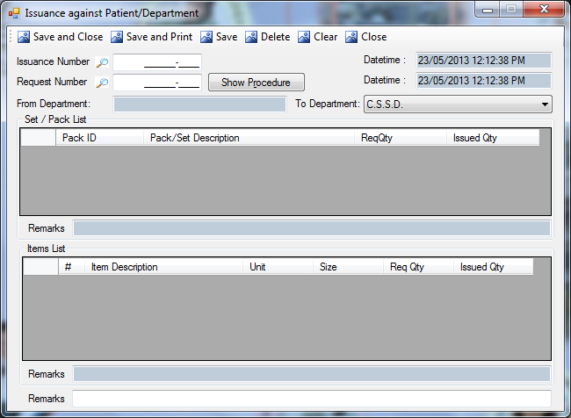
Description:
This screen is used to issue the items against patient/departmental request.
Functional Information
- User will select the Request number from the lookup, which is populated with the values which are saved in patient/departmental request screen.
- Upon selection of the document from lookup, system will pick the information of the department which requested the CSSD instruments.
- System will pick the set/pack’s details and item details in the respective grids.
- User can view the previous remarks and user can also enter remarks (if any)
- Unique Issuance Number will be auto-generated, and Date/time will be picked by the system, upon saving the record.

REQUEST RECEIVING LOOKUP
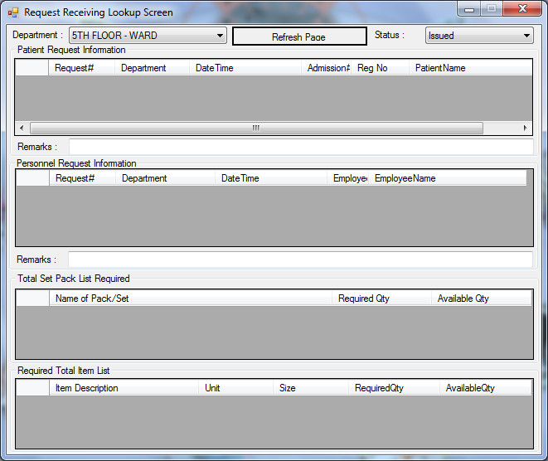
Description:
This screen is used to view the receiving history of the requests made by departments and employees.
Functional Information
- User can filter the demands by selecting department from combo, and by selection of the status i.e. pending or issued.
- Refresh page will clear all the filtration selection and refresh the screen.
- Patient’s Requests can be viewed from first grid.
- Personal/Departmental Requests can be viewed from second grid.
- User can also enter the remarks if any, if user press Refresh Page button, then user’s remarks will not get cleared.
- Upon selection of any of the request from first or second grid, pack/set details and item details will be displayed in last two grids

CSSD RECEIVING
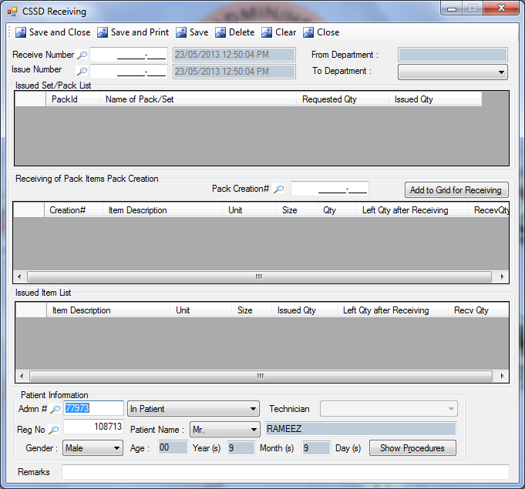
Description:
This screen is used to make the receiving against issued instruments.
Functional Information
- User will select the issue number from lookup, this will pick all the information against the entered issue number, like date of the document, departments, issued set/pack list and the patient details if the patient issuance number is called.
- Upon selection of any pack from first grid, its item details will be displayed in third grid.
- To received the item against issuance user will select the pack from lookup, then by pressing the button Add to Grid for Receiving, the pack will be added in the grid.
- User can also enter the remarks if any.
- By pressing save button the instrument will be received against the issuance.

BROKEN/MISSING ITEMS
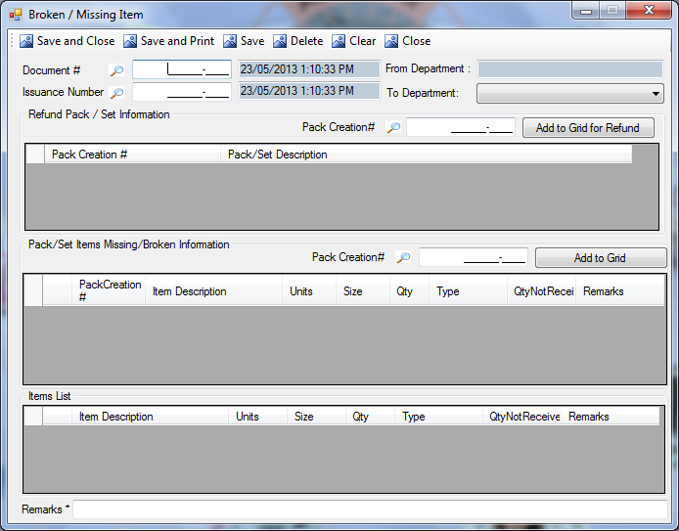
Description:
This screen is used to make the receiving of broken/missing items against issued number.
Functional Information
- User will select the issuance number from lookup, this will pick all the information against the entered issue number, like date of the document, departments.
- To refund the item against issuance user will select the pack from Pack Creation# lookup, then by pressing the button Add to Grid for Refund, the pack will be added in the grid.
- Add to Grid
- Item list will display the list of the items which are issued.
- User have to enter the remarks.
- By pressing save button broken/missing instrument refund will get created.

REPORTS

ITEM REPORTS(STORES)

STORE STOCK/ITEM DETAIL REPORT
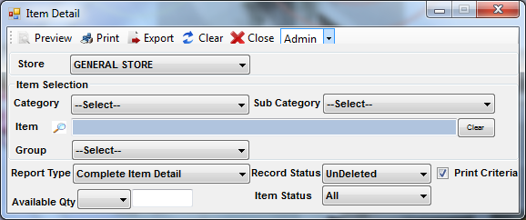
Description:
This screen is used to view the detailed reports of Items.
Functional Information
- User will select the Store from combo.
- To filter the report item wise, user can select the item by selecting Category and Sub-Category from combo. And user can also search the item from lookup. Clear button will clear the text field of item.
- User can also select the Report Type, Record Status, and item selection from combo.
- To enter the available quantity user will select the operational operator from combo and then he will enter the value in text field.

Report Preview:
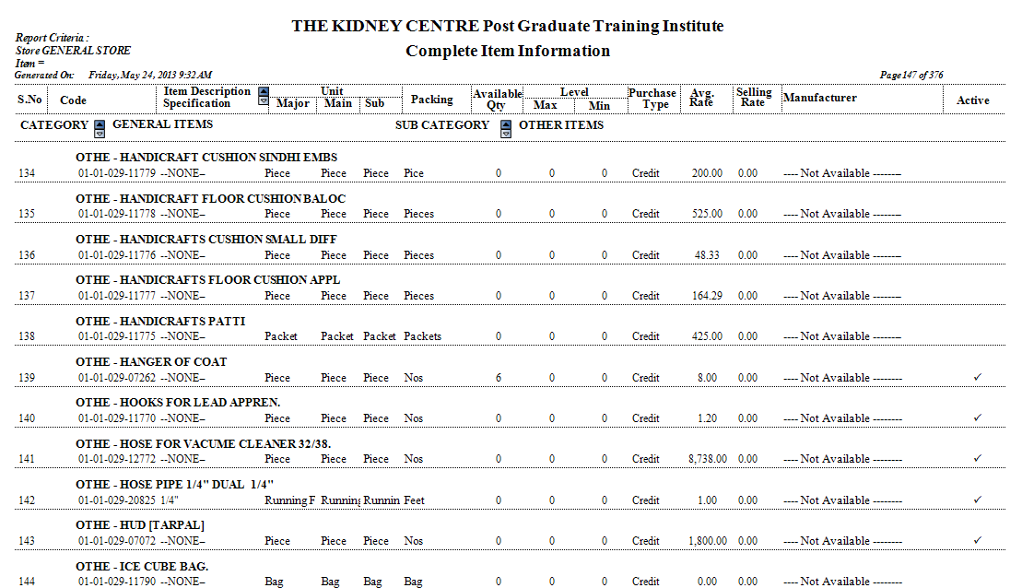

MAINTENANCE REPORTS

MAINTENANCE CONSUMPTION REPORT
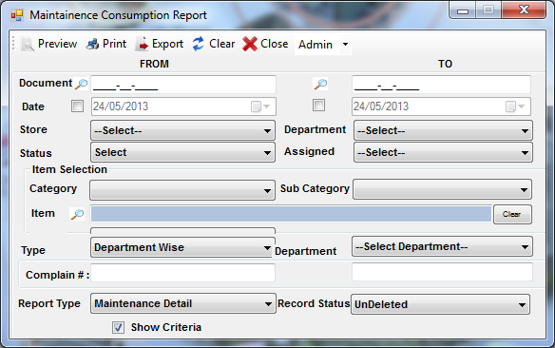
Description:
This screen is used to view the report of Maintenance Consumption.
Functional Information
- User can select Document No from the lookup in To and From panel.
- User can also select the To and From Date.
- User will select the Store, Department, Status and Assigned (person of the selected department) from combo.
- To filter the report item wise, user can select the item by selecting Category and Sub-Category from combo. And user can also search the item from lookup. Clear button will clear the text field of item.
- User can also select the Type and department from combo, user will enter the Complain# if the ‘Department Wise’ is selected from combo.
- User will also select the Record Type and Record Status from combo.

Report Preview:
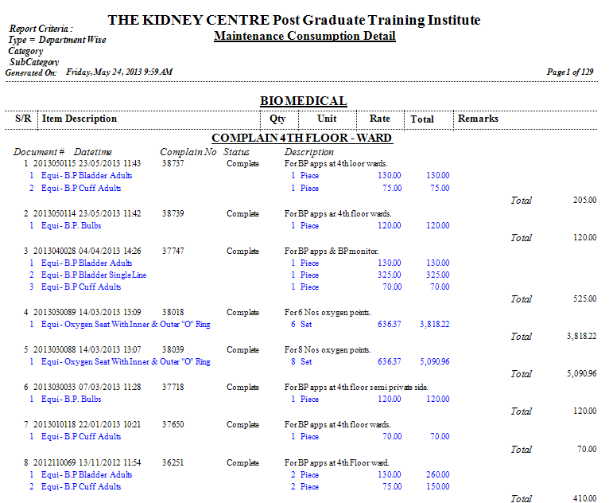

MAINTENANCE ISSUE REPORT
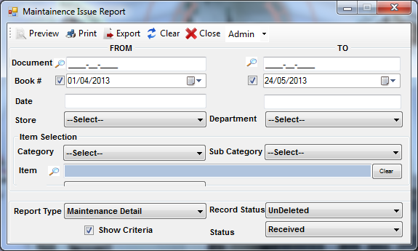
Description:
This screen is used to view the report of Maintenance Issuance.
Functional Information
- User can select Document No from the lookup in To and From panel.
- User can also select the To and From Date.
- User can enter the To and From Book #.
- User will select the Store and Department from combo.
- To filter the report item wise, user can select the item by selecting Category and Sub-Category from combo. And user can also search the item from lookup. Clear button will clear the text field of item.
- User can also select the Report Type, Record Status and status from combo.

Report Preview:
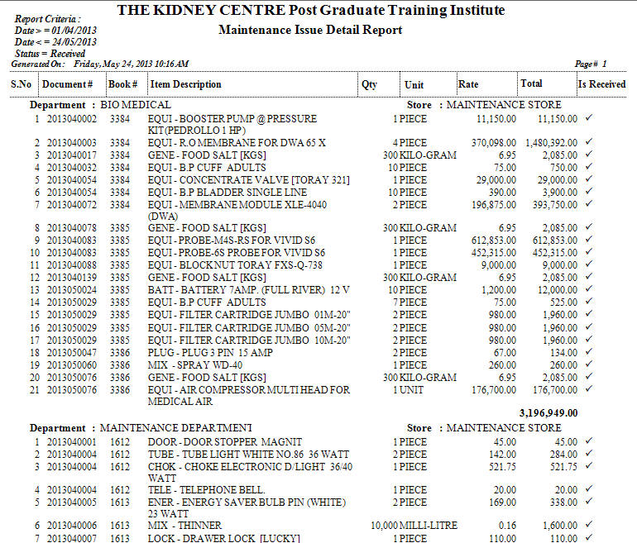

DEPARTMENTAL

DEMAND

DEMAND REPORT
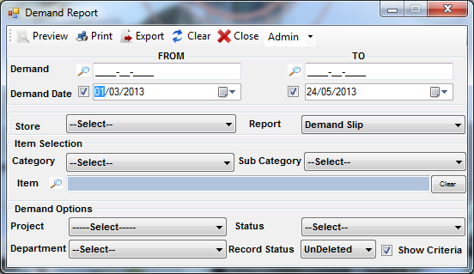
Description:
This screen is used to view the reports of Demands.
Functional Information
- User can select Demand No from the lookup in To and From panel.
- User can also select the To and From Demand Date.
- User can select the Store and Report Type from the combo.
- To filter the report item wise, user can select the item by selecting Category and Sub-Category from combo. And user can also search the item from lookup. Clear button will clear the text field of item.
- User can also select the demand options like Project Status, Department and Record Status from combo.

Report Preview:
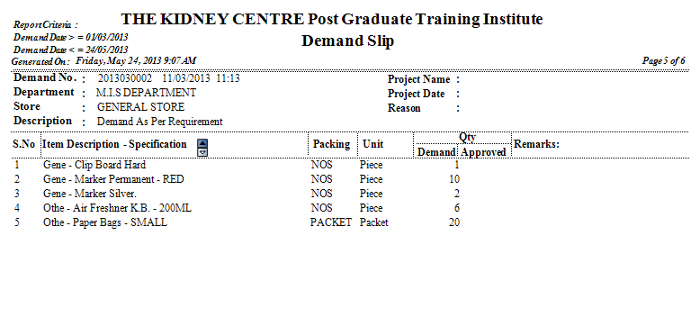

DEMAND RECEIVING REPORT
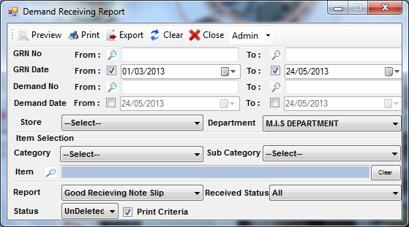
Description:
This screen is used to view the demand receiving reports.
Functional Information
- User will select GRN No from the lookup in To and From panel.
- User can also select the To and From GRN Date.
- User can select Demand No from the lookup in To and From panel.
- User can also select the To and From Demand Date.
- User can select the Store and Department from the combo.
- To filter the report item wise, user can select the item by selecting Category and Sub-Category from combo. And user can also search the item from lookup. Clear button will clear the text field of item.
- User can also select the Received Status, Select Report and Record Status from combo.

Report Preview:
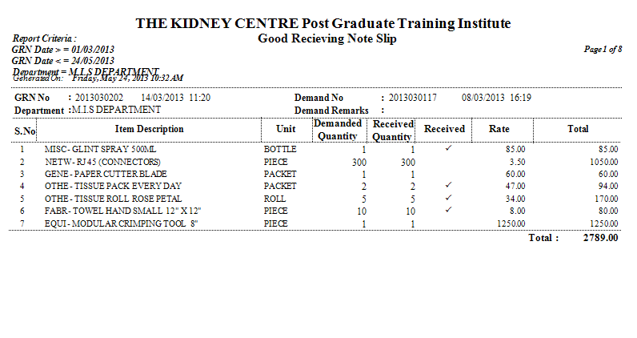

DEMAND REFUND (DEPARTMENTAL)
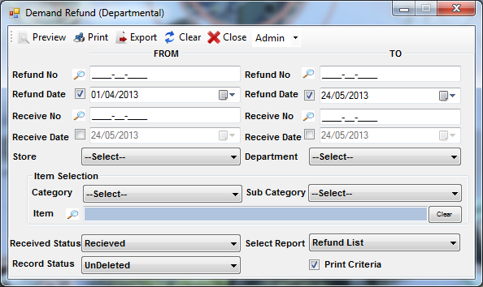
Description:
This screen is used to view the Departmental Refund reports.
Functional Information
- User will select Refund No from the lookup in To and From panel.
- User can also select the To and From Refund Date.
- User can select Receive No from the lookup in To and From panel.
- User can also select the To and From Receive Date.
- User can select the Store and Department from the combo.
- To filter the report item wise, user can select the item by selecting Category and Sub-Category from combo. And user can also search the item from lookup. Clear button will clear the text field of item.
- User can also select the Received Status, Select Report and Record Status from combo.

Report Preview:
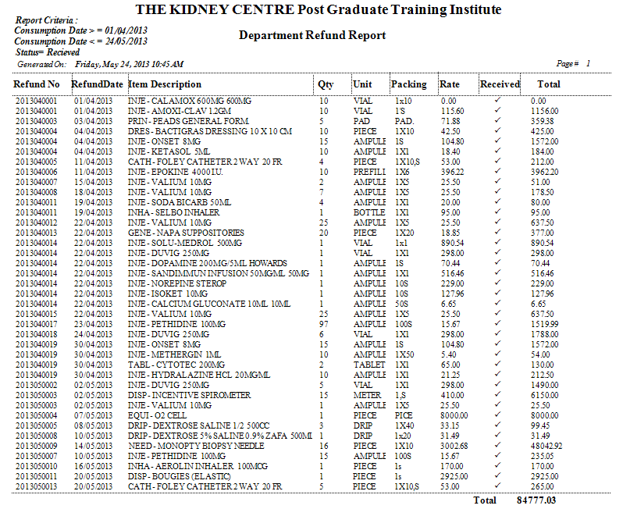

DEMAND STATUS REPORT
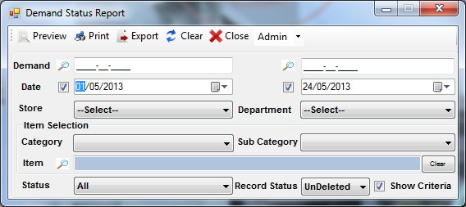
Description:
This screen is used to view the reports of demand status.
Functional Information
- User can select Demand No from the lookup in To and From panel.
- User can also select the To and From Date.
- User can select the Store and Department from the combo.
- To filter the report item wise, user can select the item by selecting Category and Sub-Category from combo. And user can also search the item from lookup. Clear button will clear the text field of item.
- User can also select the Status and Record Status from combo.

Report Preview:
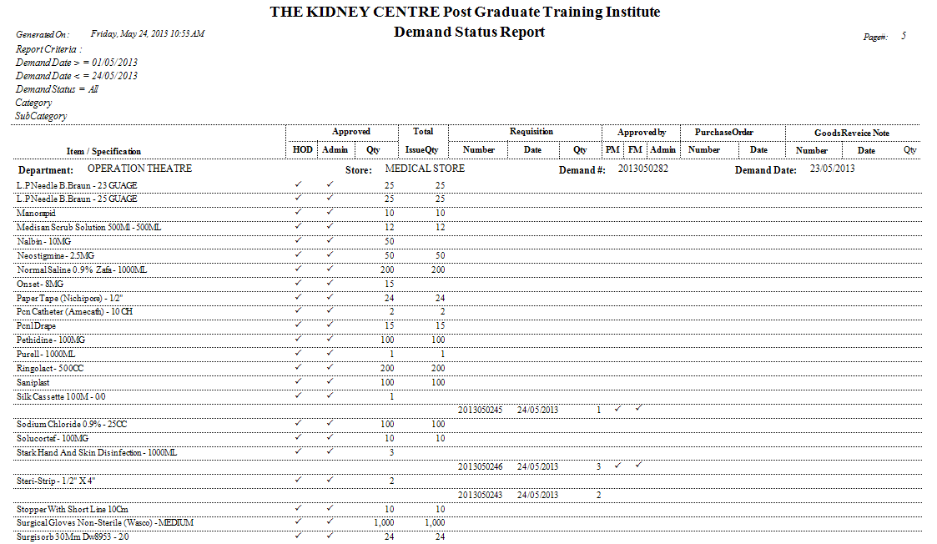

CONSUMPTION

DEPARTMENTAL COSUMPTION REPORT
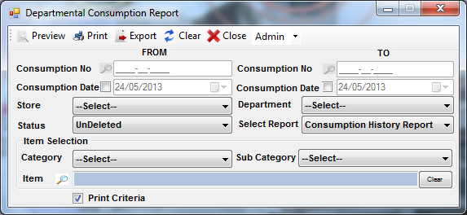
Description:
This screen is used to view the reports of departmental consumption.
Functional Information
- User can select Consumption No from the lookup in To and From panel.
- User can also select the To and From Consumption Date.
- User can select the Store and Department from the combo.
- User can select the Status and Select Report from combo.
- To filter the report item wise, user can select the item by selecting Category and Sub-Category from combo. And user can also search the item from lookup. Clear button will clear the text field of item.

Report Preview:
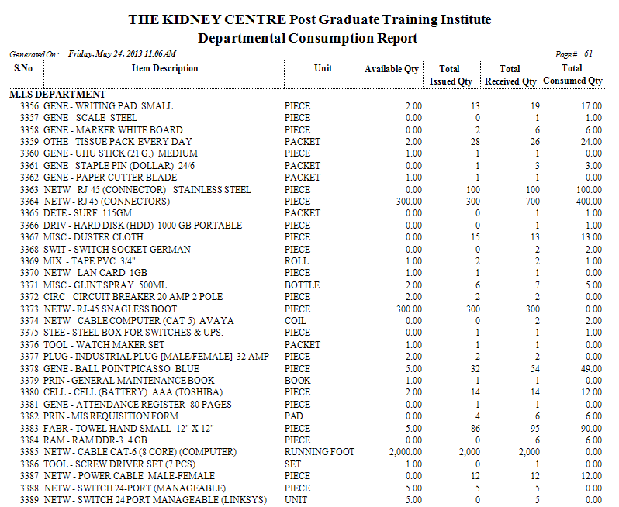

STOCK REPORTS

LEDGER REPORTS (DEPARTMENTS)
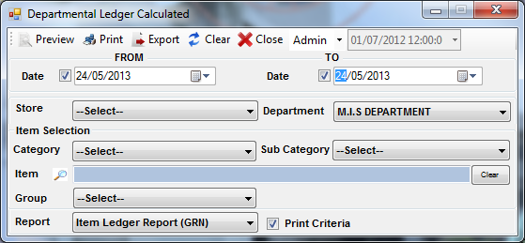
Description:
This screen is used to view the reports of departmental ledger.
Functional Information
- User can select the To and From Date.
- User can select the Store and Department from the combo.
- To filter the report item wise, user can select the item by selecting Category and Sub-Category from combo. And user can also search the item from lookup. Clear button will clear the text field of item.
- User can also select the Group and Report Type from combo.

Report Preview:
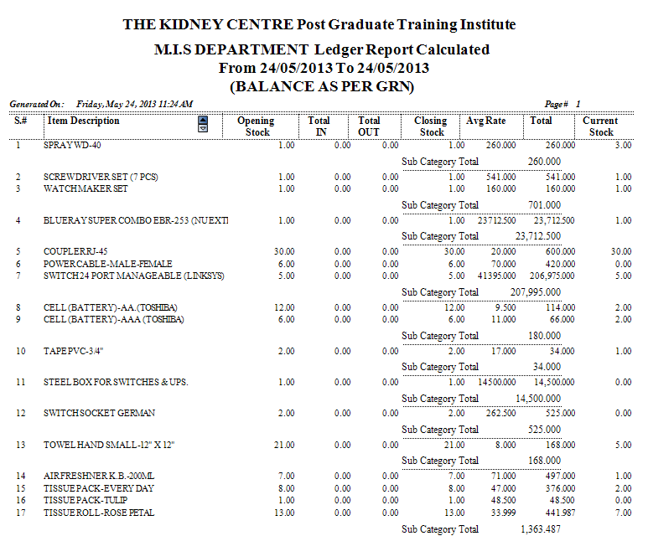

CURRENT STOCK (DEPARTMENTAL)
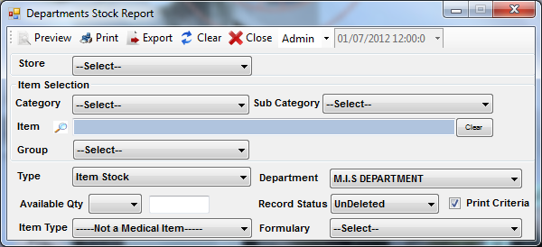
Description:
This screen is used to view the reports of departmental stock.
Functional Information
- User can select the Store from the combo.
- To filter the report item wise, user can select the item by selecting Category and Sub-Category from combo. And user can also search the item from lookup. Clear button will clear the text field of item. User can also select the Group from combo.
- User can also select the Type, Department, Record Status, Item Type, Formulary Item from combo.
- To enter the Available Qty, user will select the operational operator from combo and enter the value of the quantity in textbox.

Report Preview:
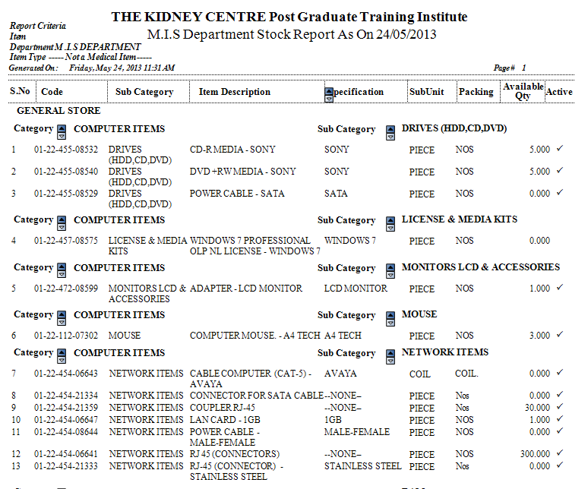

MIS SPECIAL

DEPARTMENTAL LEDGER
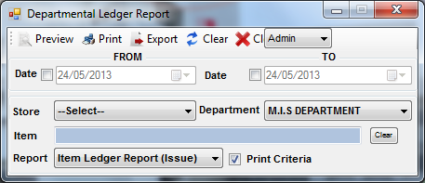
Description:
This screen is used to view the reports of departmental ledger.
Functional Information
- User can select the date in To and From panel.
- User can select the Store and Department from combo.
- To filter the report item wise, user will search the item from lookup. Clear button will clear the text field of item.
- User can select report from combo.

Report Preview:
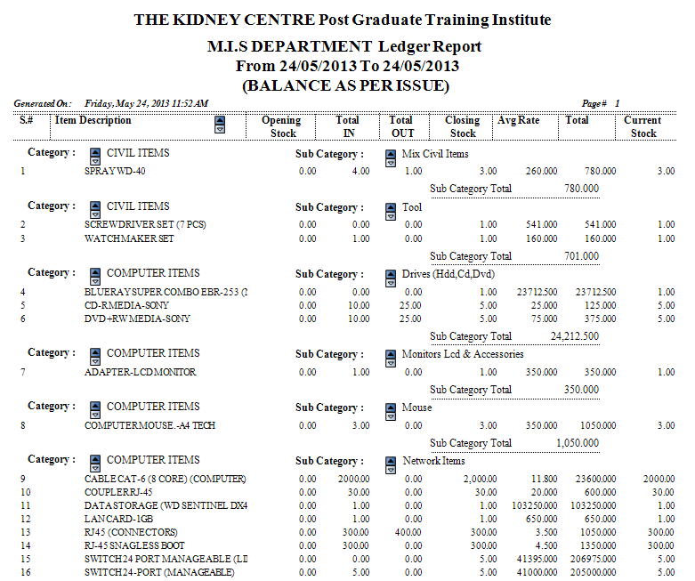

STORE LEDGER
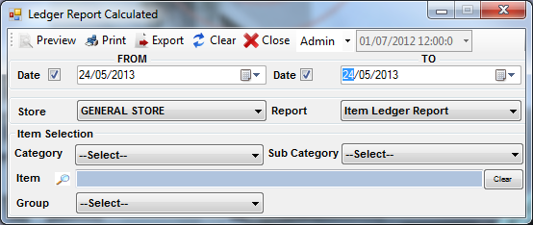
Description:
This screen is used to view the reports of store ledger.
Functional Information
- User can select the date in To and From panel.
- User can select the Store and Report from combo.
- To filter the report item wise, user can select the item by selecting Category and Sub-Category from combo. And user can also search the item from lookup. Clear button will clear the text field of item. User can also select the Group from combo.

Report Preview:
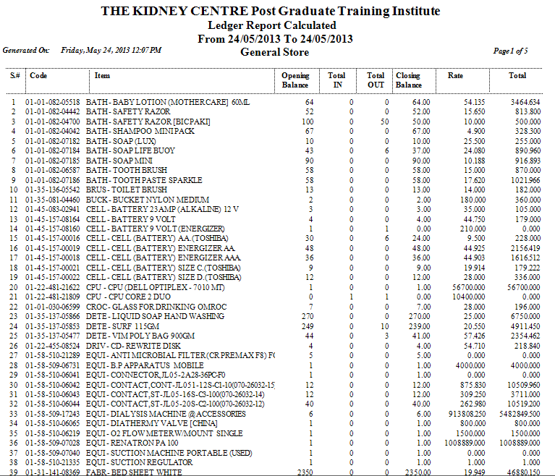

STORES

ISSUE REPORT
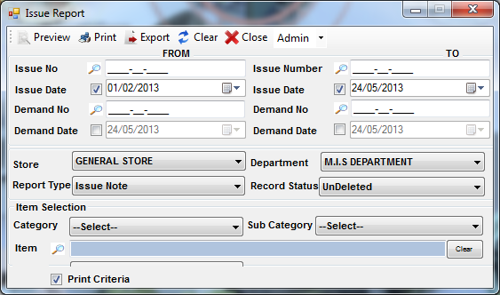
Description:
This screen is used to view the issuance reports.
Functional Information
- User will select Issue No from the lookup in To and From panel.
- User can also select the To and From Issue Date.
- User can select Demand No from the lookup in To and From panel.
- User can also select the To and From Demand Date.
- User can select the Store, Department, Report Type and Record Status from the combo.
- To filter the report item wise, user can select the item by selecting Category and Sub-Category from combo. And user can also search the item from lookup. Clear button will clear the text field of item.

Report Preview:
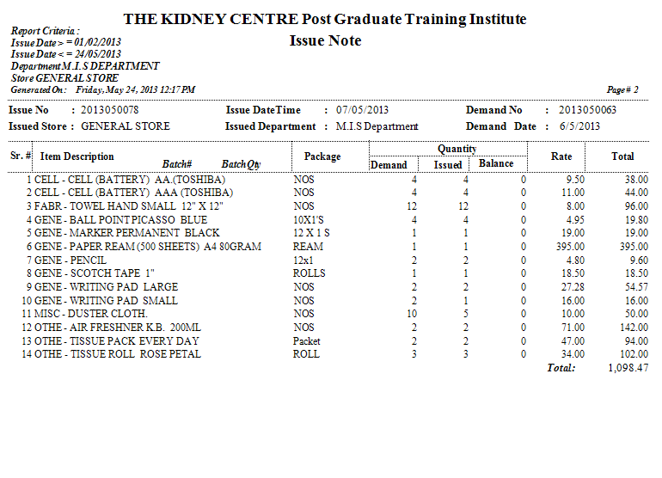

GOOD RECEIVING REPORT
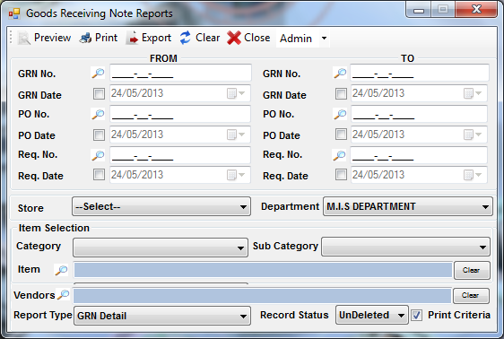
Description:
This screen is used to view the reports of departmental goods receiving.
Functional Information
- User can select GRN No from the lookup in To and From panel.
- User can also select the To and From GRN Date.
- User can select PO No from the lookup in To and From panel.
- User can also select the To and From PO Date.
- User can select Req. No from the lookup in To and From panel.
- User can also select the To and From Req. Date.
- User can select the Store, Department from the combo.
- To filter the report item wise, user can select the item by selecting Category and Sub-Category from combo. And user can also search the item from lookup. Clear button will clear the text field of item.
- User can also select the vendors from lookup.
- User can select the Report Type, Record Status from combo.

Report Preview:
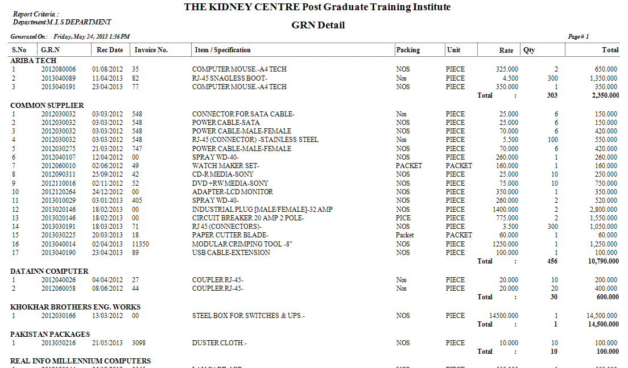

UNIFORM ISSUANCE SLIP
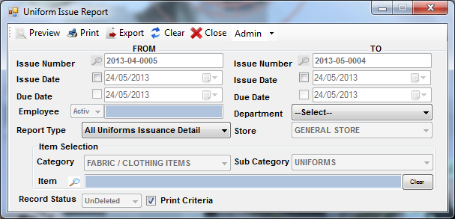
Description:
This screen is used to view the uniform issuance report.
Functional Information
- User can select Issue Number from the lookup in To and From panel.
- User can also select the To and From Issue Date.
- User can select the due date of the issuance of the uniform.
- User can select the Employee, Department Report Type and Store from the combo.
- To filter the report item wise, user can select the item by selecting Category and Sub-Category from combo. And user can also search the item from lookup. Clear button will clear the text field of item.
- User can select the Record Status from combo.

Report Preview:
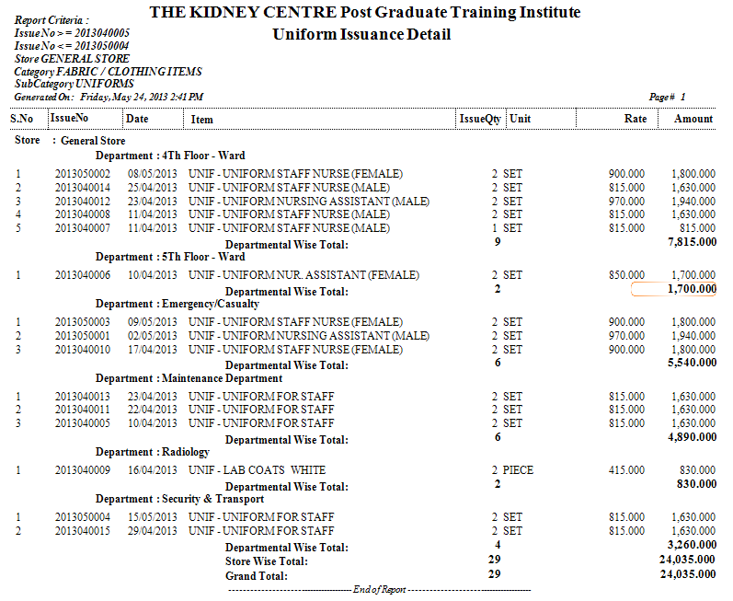

GOODS REFUND NOTE
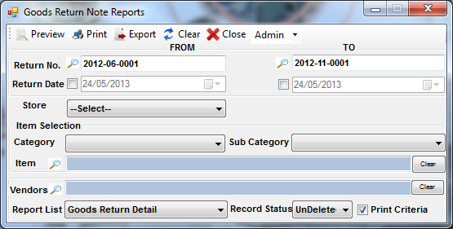
Description:
This screen is used to view the reports of goods return note.
Functional Information
- User can select Return No. from the lookup in To and From panel.
- User can also select the To and From Return Date.
- User can select the Store from the combo.
- To filter the report item wise, user can select the item by selecting Category and Sub-Category from combo. And user can also search the item from lookup. Clear button will clear the text field of item.
- User can select the vendors from combo. Clear button will clear the text field of vendors.
- User can select the Report List and Record Status from combo.

Report Preview:
